RECOMMENDATION FOR PLANNING AND DEVELOPMENT COMMITTEE

APPROVAL

DATE: 1 JUNE 2023
REF: SK
CHECKED BY: LH

APPLICATION REF: 3/2023/0068

GRID REF: SD 374244 441693

DEVELOPMENT DESCRIPTION:

LISTED BUILDING CONSENT TO INSTALL A PLAQUE IN THE ROSE GARDEN WITHIN THE
GROUNDS OF CLITHEROE CASTLE. ROSE GARDEN WITHIN CLITHEROE CASTLE GROUNDS CLITHEROE BB7 1AZ
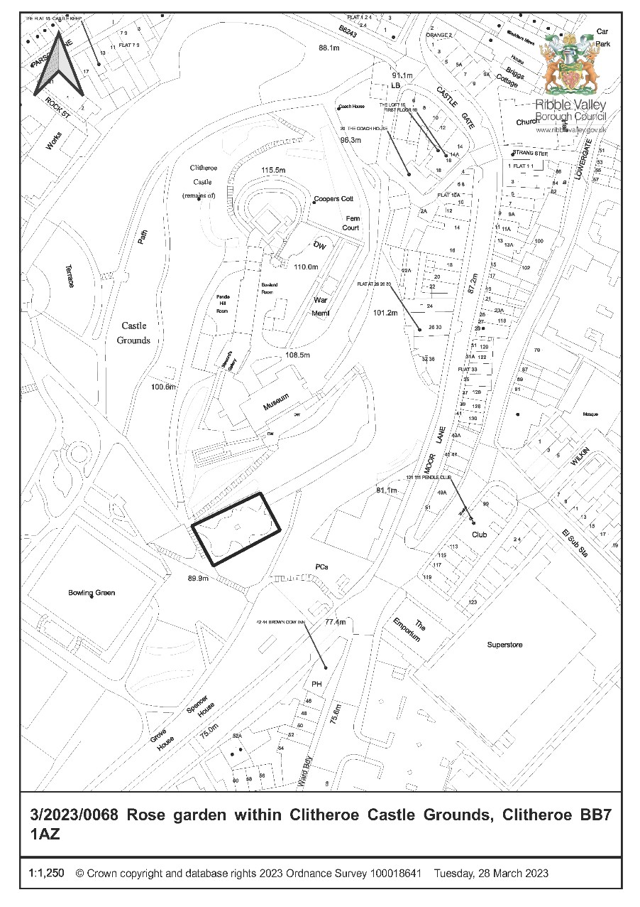
CONSULTEE RESPONSES/ REPRESENTATIONS MADE:

PARISH COUNCIL:

Clitheroe Town Council have raised no objections to the proposed development.

GARDENS TRUST:

The Gardens Trust have offered the following observations in relation to the proposal:

Thank you for consulting the Gardens Trust in its role as Statutory Consultee on the above application which affects Clitheroe Castle, a historic designed landscape of national importance which is included by Historic England on the Register of Parks and Gardens of Special Historic Interest at Grade II.

We have considered the information provided in support of the application and on the basis of this confirm we do not wish to comment on the proposals at this stage. We would however emphasise that this does not in any way signify either our approval or disapproval of the proposals.

THE COUNCIL FOR BRITISH ARCHAEOLOGY:

The Council for British Archaeology (CBA) have offered the following observations in relation to the proposal:

The CBA consider that these proposals have the potential to enhance public understanding and appreciation of Clitheroe's history and British political history more broadly, and could add to the Rose Garden's communal significance. It is our judgement that under paragraph 202 of the National Planning Policy Framework, this public benefit is sufficient to justify the proposals. The CBA therefore recommend that this application be approved.

ADDITIONAL REPRESENTATIONS:

One letter of representation has been received in respect of the proposal offering the following comments/observations:

- The location should be correctly referred to as the ‘Pinnacle Garden’.
- The submitted details do not include precise information in relation to the location of the plaque.
- The plaque may give rise to visual distraction of other features within the ‘Rose Garden’.
- The concept and proposals for the new plaque are excellent and will link the iconic site and Clitheroe’s first C20th elected member of parliament – where the adjacent pinnacle once stood, with all other locations relating to the ‘Pendle radicals’ project.

1. Site Description and Surrounding Area

1.1 The application relates to an area of natural stone walling located at the southern extents of the ‘Rose Garden’ located within the grounds of Clitheroe Castle (Grade II Park and Garden Designated Heritage Asset – List Entry: 1001361) adjacent the ‘Turret from the Houses of Parliament’ (Grade II Designated Heritage Asset – List Entry: 1071555) also known as the ‘Pinnacle’.

1.2 The synopsis of the listing description in respect of Clitheroe Castle Grounds (Grade II) reads as follows:

A castle mound, used as the grounds of a private residence, with garden terraces laid out in the early C19, the mound and adjacent land being developed for use as a public park in the 1920s.

DESCRIPTION LOCATION, AREA, BOUNDARIES, LANDFORM, SETTING The Castle and grounds of 6.8ha are situated on the western side of Clitheroe. The land falls steeply on all sides from the castle mound, down to level ground to the west and south, on which the grounds are laid out. The western boundary is formed by the railway line and the southern boundary is Eshton Terrace and the gardens of the houses, built in the 1840s, which stand along the north side of this road. The other boundaries are marked by the buildings on Parson Lane to the north-west, the buildings on Moor Lane to the north-east, and by Woone Lane to the east.

ENTRANCES AND APPROACHES The main entrance to the Castle grounds is the gateway at the southern end of Castle Street, which leads into the northern tip of the site. From the Castle Street gate a drive, laid out around 1830, leads up along the east side of the mound to Castle House. The original approach was very steep, taking a straight rather than curving line. A pair of stone gate piers mark the approximate site of a former gatehouse. There are also entrances from Moor Lane to the east, the west end of Eshton Terrace to the south, and the west end of Parson Lane to the west.

PRINCIPAL BUILDINGS The Castle (listed grade I), which is also a scheduled ancient monument (scheduled ancient monument) was noted in the Domesday Book and consists of a small C12 square tower keep, built on a steep crag. The keep survives today (1990s) as four walls, open to the elements, the result of considerable restoration work carried out in 1848.

GARDENS AND PLEASURE GROUNDS To the east of the stable buildings is a levelled area, held by a retaining wall along its eastern side, currently (1990s) used as the park depot and storage area. At the southern end of this terrace is the site of the former castle chapel, the Chapel of St Michael, now occupied by a toilet block. Below is a second terrace, laid out as gardens round the War Memorial. Both garden terraces were in place by 1844 (1st edition OS map published 1844).

At the northern end of the range of buildings is the keep. A walkway runs along the top of the encircling wall which encloses a small garden area within. A flight of steps leads down the wooded north slope of the mound through patches of exposed rock, the path having been laid out pre 1844 (OS).

To the west, a walk put in as part of the original public park improvements leads round the grassy lower slopes of the mound to the lower areas of the park. At the southern end of these western slopes, within a hedged enclosure, is the bandstand, an arc of associated terraced seating rising from it. The present structure, of the mid 1970s, replaces the original park bandstand which was destroyed by fire.

The southern slope of the mound is laid out with ornamental grounds including a walk parallel to the south front of Castle House, which forms part of the mid C19 improvements to the grounds. This leads west to a formal rose garden, the centrepiece of which is a pinnacle from the Houses of Parliament (listed grade II), presented to the Borough of Clitheroe by the local MP in 1937 to commemorate the coronation of George VI. This scheme replaced a bowling green, formed on a garden terrace constructed in the mid C19, the green being part of the scheme of conversion of the site for public use. South of the rose garden is an area laid out as a putting green. To the west, below and to the southwest of Castle House, is a square, hedge-enclosed bowling green with a shelter at its southern end, roughly occupying the area developed in the mid C19 as a kitchen garden. South of the green lie tennis courts, both facilities being part of the park developments in the 1920s.

1.3 With the listing description in respect of the ‘Turret from the Houses of Parliament’ (Grade II) or ‘Pinnacle’ reading as follows:

Used as the centrepiece of pond in rose garden to South of castle. Octagonal stone turret with 4 lions rampant with shields at base. Plinth. Lancet ornament with cusped heads, gargoyles, crocketed finials. Inscription records the presentation of the turret, which originally formed part of the parapet of the Houses of Parliament, erected 1840-54, and was presented to the Borough of Clitheroe by a local MP in 1937, in commemoration of the coronation of George VI.

2. Proposed Development for which consent is sought

2.1 This application is brought before Planning and Development Committee as the applicant is Ribble Valley BC.

2.2 The application seeks Listed Building Consent for the erection/mounting of an interpretation plaque upon the southern wall of the Rose Garden within the grounds of Clitheroe Castle. The submitted details propose that the plaque will measure 378mm in height, 297mm in width and 30mm in depth. The plaque will be fabricated from ‘Stantonmoor’ sandstone with sandblasted-etch lettering with the etching being filled with black and red weatherproof paint. It is proposed that the plaque will be affixed to the existing stone-built wall by 4 drill and dowel fixings which will be drilled with anchor resin to secure.

2.3 The submitted information in support of the application states the following:

The proposed plaque for David Shackleton is intended to be one of a series of Radical Trails plaques sited around the Pendle Hill area to celebrate people and places that highlight the radical history of this part of East Lancashire e.g suffragettes, writers, religious dissenters, outdoor campaigners etc. The Shackleton plaque will be the only plaque in Clitheroe and will mean the town is part of the trail which will be shown on a map and encourage visitors to explore the area.

Pendle Radicals is a Mid Pennine Arts project. It is part of the Pendle Hill Landscape Partnership, supported by National Lottery players through the Heritage Lottery Fund.

Shackleton’s relevance to Clitheroe is that he served as MP for the town and the old constituency from 1902-1190. He was Lancashire bore, a cotton worker and only the third
Labour MP in the country. He will also have a page on the Pendle Radicals website. As far is known, there is no other memorial to Shackleton in Clitheroe.

As he served in the Houses of Parliament, he has direct relevance to the Pinnacle and Rose Garden which also highlights another of the towns MP’s – William Brass, who gave the Pinnacle to the town and was MP only 12 years after Shackleton. Siting the plaque adjacent to the pinnacle will give visitors a chance to link the man and the Houses of Parliament and hopefully bring new visitors following the Radicals Trail to the Pinnacle and Clitheroe Castle.

3. Relevant Planning History

No recent planning history directly relevant to the determination of the current application.

4. Relevant Policies

Ribble Valley Core Strategy
Key Statement DS1: Development Strategy
Key Statement DS2: Sustainable Development
Key Statement EN5: Heritage Assets

Policy DMG1: General Considerations
Policy DME1: Protecting Trees & Woodland
Policy DME2: Landscape & Townscape Protection
Policy DME4: Protecting Heritage Assets

Planning (Listed Buildings and Conservation Areas) Act
National Planning Policy Framework (NPPF)

5. Assessment of Proposed Development

5.1 Principle of Development/ Impact on Heritage:

5.1.1 The application site lies within the grounds of Clitheroe Castle (Grade II Park and Garden Designated Heritage Asset – List Entry: 1001361) adjacent the ‘Turret from the Houses of Parliament’ (Grade II Designated Heritage Asset – List Entry: 1071555) also known as the ‘Pinnacle’. The site and surrounding Castle Grounds also lie within Clitheroe Conservation Area.

5.1.2. Given that the proposal affects a number of Designated Heritage Assets, significant regard must be given to the duties imposed under Section 66(1) of the Planning (Listed Building and Conservation Areas) Act 1990. With Key Statement
EN5 (Heritage Assets), Policy DME4 (Protecting Heritage Assets), Policy DMG1 (General Considerations) being primarily, but not solely engaged for the purposes of assessing the proposal. With Paragraphs 130, 134, 199, 200 and 202 of the National Planning Policy Framework (NPPF) also being of prime relevance.

5.1.3 In respect of the statutory duties imposed under the Section 66(1) of the Planning (Listed Building and Conservation Areas) Act 1990 in relation to the preservation of the special character of heritage assets, including their setting - the Act states that:

In considering whether to grant planning permission for development which affects a listed building or its setting, the local planning authority shall have special regard to the desirability of preserving the building or its setting or any features of special architectural or historic interest which it possesses.

5.1.4 Further to the above, due consideration must also be given in respect of the requirements of the NPPF insofar that in the determination of planning applications Local Planning Authorities should take account of:

- the desirability of sustaining and enhancing the significance of heritage assets and putting them to viable uses consistent with their conservation;
- the positive contribution that conservation of heritage assets can make to sustainable communities including their economic vitality; and
- the desirability of new development making a positive contribution to local character and distinctiveness.

5.1.5 Paragraphs 199, 200 and 202 of the NPPF are also relevant insofar that they state that:

Paragraph 199:
When considering the impact of a proposed development on the significance of a designated heritage asset, great weight should be given to the asset’s conservation (and the more important the asset, the greater the weight should be). This is irrespective of whether any potential harm amounts to substantial harm, total loss or less than substantial harm to its significance.

Paragraph 200:
Any harm to, or loss of, the significance of a designated heritage asset (from its alteration or destruction, or from development within its setting), should require clear and convincing justification. Substantial harm to or loss of:

- grade II listed buildings, or grade II registered parks or gardens, should be exceptional;
- assets of the highest significance, notably scheduled monuments, protected wreck sites, registered battlefields, grade I and II* listed buildings, grade I and II* registered parks and gardens, and World Heritage Sites, should be wholly exceptional.

Paragraph 202:
Where a development proposal will lead to less than substantial harm to the significance of a designated heritage asset, this harm should be weighed against the public benefits of the proposal including, where appropriate, securing its optimum viable use.

5.1.6 In parallel with the above national-level legislation and policy, Key Statement EN5 and Policy DME4 of the Ribble Valley Core Strategy are primarily, but not solely, engaged for the purposes of assessing the proposal. In this respect Key Statement EN5 states that:

There will be a presumption in favour of the conservation and enhancement of the significance of heritage assets and their settings. The Historic Environment and its Heritage Assets and their settings will be conserved and enhanced in a manner appropriate to their significance for their heritage value; their important contribution to local character, distinctiveness and sense of place; and to wider social, cultural and environmental benefits.

This will be achieved through:

- Recognising that the best way of ensuring the long term protection of heritage assets is to ensure a viable use that optimises opportunities for sustaining and enhancing its significance.
- Keeping Conservation Area Appraisals under review to ensure that any development proposals respect and safeguard the character, appearance and significance of the area
- Considering any development proposals which may impact on a heritage asset or their setting through seeking benefits that conserve and enhance their significance and avoids any substantial harm to the heritage asset.
- Requiring all development proposals to make a positive contribution to local distinctiveness/sense of place.
- The consideration of Article 4 Directions to restrict permitted development rights where the exercise of such rights would harm the historic environment.

5.1.7 With Policy DME4 stating, in respect of development within conservation areas or those affecting the listed buildings or their setting, that development will be assessed on the following basis:

1: CONSERVATION AREAS

Proposals within, or affecting views into and out of, or affecting the setting of a conservation area will be required to conserve and where appropriate enhance its character and appearance and those elements which contribute towards its significance. This should include considerations as to whether it conserves and enhances the special architectural and historic character of the area as set out in the relevant conservation area appraisal. development which makes a positive contribution and conserves and enhances the character, appearance and significance of the area in terms of its location, scale, size, design and materials and existing buildings, structures, trees and open spaces will be supported.

In the conservation areas there will be a presumption in favour of the conservation and enhancement of elements that make a positive contribution to the character or appearance of the conservation area.

2: LISTED BUILDINGS AND OTHER BUILDINGS OF SIGNIFICANT HERITAGE INTEREST

Alterations or extensions to listed buildings or buildings of local heritage interest, or development proposals on sites within their setting which cause harm to the significance of the heritage asset will not be supported. Any proposals involving the demolition or loss of important historic fabric from listed buildings will be refused unless it can be demonstrated that exceptional circumstances exist.

5.1.8 Policy DMG1 is also engaged in parallel with Key Statement EN5 and Policy DME4 insofar that the policy sets out general Development Management considerations, with the policy having a number of inherent criterion that are relevant to the assessment of the current proposal, which state:

In determining planning applications, all development must:

DESIGN

- Be of a high standard of building design which considers the 8 building in context principles (from the CABE/English Heritage building on context toolkit.
- Be sympathetic to existing and proposed land uses in terms of its size, intensity and nature as well as scale, massing, style, features and building materials.
- Consider the density, layout and relationship between buildings, which is of major importance. particular emphasis will be placed on visual appearance and the relationship to surroundings, including impact on landscape character, as well as the effects of development on existing amenities.

AMENITY

1. Not adversely affect the amenities of the surrounding area.

ENVIRONMENT

3. All development must protect and enhance heritage assets and their settings.

5.1.9 In considering the above local level adopted policies, as contained within the Ribble Valley Core Strategy, it is clear that they place a fundamental emphasis on the protection and enhancement of heritage assets and their setting. With the NPPF advising at paragraph 199 that when considering the impact of a proposal on the significance of a designated heritage asset, great weight should be given to the asset’s conservation.

5.1.10 Where significance is considered to be harmed or lost through the alteration or destruction of those assets or from development within their setting, paragraph 200 of the NPPF states there should be clear and convincing justification for this harm. Where that harm is considered to be less than substantial, paragraph 202 states this harm should be weighed against the public benefits of the proposal.

5.1.11 The introduction of a modern plaque into an historic area, including the proposed fixing of the sign into historic fabric, will result in some harm to the significance of the heritage assets listed at paragraph 5.1.1 above. However the small-scale nature of the proposal means that efforts have been made to mitigate for this harm and there is clear and convincing justification and resultant public benefits to be
had, as the proposal serves to enhance the understanding of the cultural history of the area (which provides public and cultural benefit).

5.1.12 The proposal is therefore considered to satisfy the aforementioned Planning (Listed Building and Conservation Areas) Act 1990, the NPPF and relevant Ribble Valley Core Strategy policies and is considered to be acceptable in principle.

5.2 Impact upon Residential Amenity:

5.2.1 Taking account of the nature of the proposal and its relative location/siting, it is not considered that the erection of the plaque will result in any measurable significant impacts upon residential amenities.

5.3 Visual Amenity/External Appearance

5.3.1 The proposed plaque will be fabricated from ‘Stantonmoor’ sandstone with sandblasted-etch lettering with the etching being filled with black and red weatherproof paint. In this respect the proposed plaque is typical in appearance of that of a common ‘interpretation panel’ and as such will not be read as being incongruous or anomalous when considering its siting within the ‘Rose Garden’.

5.3.2 Given the random coursing of the natural-stone wall upon which the plaque is to be mounted, whilst taking account of the proposed fixing method(s), the authority considers that the points of fixing should be located within the mortar-joints between the stonework. Particularly insofar that this will protect the integrity of the ‘stone-blocks’ of the walling. This will further ensure, that should the plaque be removed, that the holes left by the method of fixing can be successfully visually and physically remediated without affecting the fabric of the stonework.

5.3.3 As such and in respect of the above matter, the authority considers it appropriate to impose a condition that will require the submission of a detailed methodology for the fixing (including precise location) of the plaque, including the marking out of ‘drill-points’ to be agreed on site with officers prior to installation. It is also considered appropriate to impose a condition that requires a detailed methodology for the on-going maintenance and remediation/repair of the wall post-removal – should the plaque be removed at a future date to ensure the long-term protection of the integrity of the walling upon which it is to be mounted.

5.4 Landscape and Ecology:

5.4.1 No implications result from the proposed works.

6. Observations/Consideration of Matters Raised/Conclusion

6.1 In respect of the above material matters, whilst having significant regard to the duties imposed under Section 66(1) of the Planning (Listed Building and Conservation Areas) Act 1990, the proposed development is considered to be in broad compliance with Key Statement EN5 (Heritage Assets), Policy DME4 (Protecting Heritage Assets), Policy DMG1 (General Considerations) and Paragraphs 130, 134, 199, 200 and 202 of the NPPF.

6.2 As such, for the above reasons and having regard to all material considerations and matters raised that the application for Listed Building Consent is recommended for approval.

RECOMMENDATION: That the application for listed building consent be APPROVED subject to the imposition of the following condition(s):

- The development must be begun not later than the expiration of three years beginning with the date of this permission.

REASON: Required to be imposed pursuant to Section 18 of the Planning (Listed Building and Conservation Areas) Act 1990.

- The development must be begun not later than the expiration of three years beginning with the date of this permission.

REASON: Required to be imposed pursuant to Section 18 of the Planning (Listed Building and Conservation Areas) Act 1990.

- Prior to the commencement of development or any works associated with the consent hereby approved, a detailed methodology for the fixing/mounting (including precise location) of the plaque, shall have been submitted to and approved in writing by the Local Planning Authority. For the avoidance of doubt the submitted details shall include the marking out of ‘drill-points’ to be agreed on site prior to installation. The development shall be carried out in strict accordance with the approved details.

REASON: In order that the Local Planning Authority may ensure that the fixing of the plaque does not undermine the integrity of built-fabric inherent to a designated heritage asset.

- Prior to the commencement of development or any works associated with the consent hereby approved, a detailed methodology including the maintenance responsibilities, ongoing maintenance and remediation/repair of the wall post-removal shall have been submitted to and approved in writing by the Local Planning Authority. The development and future maintenance/removal of the plaque shall be carried out in strict accordance with the approved details.

REASON: In order that the Local Planning Authority may ensure the adequate maintenance of the plaque and that any subsequent removal does not undermine the integrity of built-fabric inherent to a designated heritage asset.

BACKGROUND PAPERS

https://webportal.ribblevalley.gov.uk/site/scripts/planx_details.php?appNumber=3%2F2023%2F 0068

