RECOMMENDATION FOR PLANNING AND DEVELOPMENT COMMITTEE
REFUSAL

DATE: | 8 FEBRUARY 2024
REF: | BT
CHECKED BY: | LH

APPLICATION REF: 3/2023/0216

GRID REF: SD 369836 444284

DEVELOPMENT DESCRIPTION:

ERECTION OF NEW STABLE BLOCK AND CHANGE OF USE OF LAND FOR ALL-WEATHER MANEGE FOR PRIVATE USE. PREVIOUSLY DISMISSED AT APPEAL
APP/T2350/W/21/3281836. KITCHENS CROSS LANE, BASHALL EAVES BB7 3NA

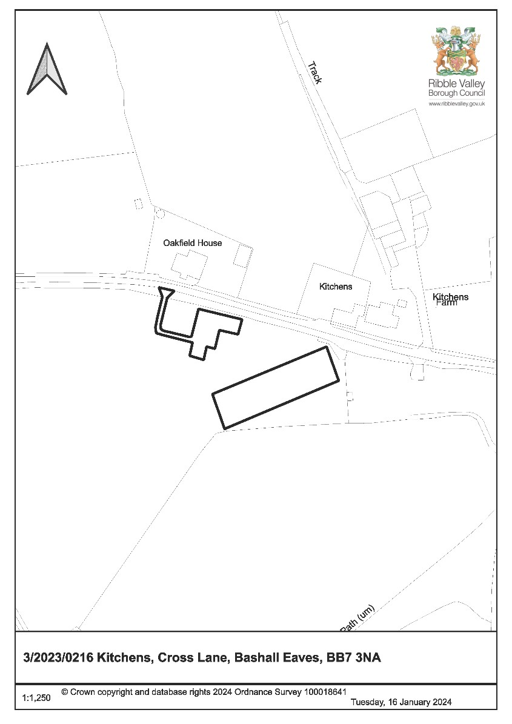
CONSULTEE RESPONSES/ REPRESENTATIONS MADE:

BASHALL EAVES AND MITTON PARISH COUNCIL:

Consulted 20/6/23 – no response received.

LANCASHIRE COUNTY COUNCIL HIGHWAYS:

No objections subject to conditions.

LANCASHIRE FIRE AND RESCUE SERVICE:

Require adherence to standing advice.

UNITED UTILITIES:

Initially requested for the provision of a detailed site layout plan which overlays the proven location of an affected water main in relation to the proposed development. No further response provided following additional consultation on amended plans.

ADDITIONAL REPRESENTATIONS:

Two letters of objection have been received in relation to the proposal. The concerns raised are summarised as follows:

- Large development in open countryside separate from the applicant’s property
- Scale of development seems excessive for intended private equestrian use and larger than similar developments in local area
- Clearly visible from the road and will fail to conserve the landscape
- Impact of the proposal upon flood risk
- Close proximity to neighbouring properties and concerns around impact upon residential amenity (odour emissions from muck store)
- Prominent and incongruous development in an open and undeveloped landscape
- Impact of the proposal upon highway safety

Introduction

1.1 The application was submitted as valid on 31 May 2023 with an eight week target date for determination of 10 July 2023. Following comments received from United Utilities on 14 July 2023 the applicant submitted additional information to the case officer in August 2023 and amended plans, but no time extension was agreed.

1.2 Once the target date has expired and where no extension of time is secured, applicants can exercise the right to appeal non-determination, which is the case here. Now that the Local Planning Authority (LPA) has received confirmation of this appeal being lodged, no decision can be made on the application. Instead, the LPA is required to assess the application and form a view / make a resolution on what decision it would have reached, and then duly notify the Planning Inspectorate of the resolution.

1.3 In accordance with the Council’s Scheme of Delegation, any application with an appeal against non-determination is required to be brought before Committee where timescales allow. Members are asked to consider whether or not they agree with the officer's assessment and recommended resolution to be presented to the Planning Inspectorate which is set out at the end of this report.

Site Description and Surrounding Area

2.1 The application relates to a land parcel comprising a grassed field situated in Bashall Eaves within the Forest of Bowland Area of Outstanding Beauty (National Landscape). The land parcel in question roughly comprises a triangular shaped piece of land bordered by a mixture of mature trees and hedgerows.

2.2 Access to the application site is from Cross Lane via an existing field gate access. The site is void of any development and is largely viewable within the public realm.

2.3 The residential property of Oakfield House lies directly opposite the application site on the Northern side of Cross Lane with the properties of Kitchens and Kitchen Farm sited adjacent to Oakfield House opposite to the North-eastern corner of the site.

Proposed Development for which consent is sought

3.1 Planning consent is sought for the construction of a stable building comprising four stables, a tack room and a feed store. The stable building would be ‘L-shaped’ measuring 15.1m x 13.2m. Additional works proposed include the construction of a 60m x 20m manège and the creation of a hardstanding area to facilitate access between the proposed stable building and the site’s existing access on Cross Lane which is also to be widened to improve access and egress to and from the site.

Relevant Planning History

3/2021/0697: Erection of new stable block and change of use of land for all-weather menage for private use. Resubmission of 3/2020/0482. (Refused and Appeal Dismissed Ref: APP/T2350/W/21/3281836)

3/2020/0482: Erection of new stable block and change of use of land for all-weather menage for private use. (Refused)

Relevant Policies

Key Statement DS1: Development Strategy Key Statement DS2: Sustainable Development
Key Statement EN2: Landscape
Key Statement EN4: Biodiversity and Geodiversity
Key Statement DMI2: Transport Considerations
Policy DMG1: General Considerations
Policy DMG2: Strategic Considerations
Policy DMG3: Transport & Mobility
Policy DME1: Protecting Trees & Woodland
Policy DME2: Landscape & Townscape Protection
Policy DME3: Site and Species Protection and Conservation

National Planning Policy Framework

Assessment of Proposed Development

6.1 Principle:

6.1.1 The application site lies outside of the Borough’s defined settlements. Policy DMG2 of the Ribble Valley Core Strategy allows for the provision of development outside the Borough’s defined settlement areas subject to a number of exceptions with one such exception being small scale recreational developments appropriate to a rural area.

6.1.2 In this instance the proposal relates to the keeping of horses for private use which could fall within the realm of a recreational development appropriate to a rural area.

6.1.3 However, the proposal would involve the addition of a sizeable stable building and hardstanding area to the site in addition to the construction of a manège comprising a ground area of 1200 square metres, all of which when taken collectively are considered to exceed the threshold of a small scale development.

6.1.4 In addition, with respect to development within National Landscapes (formerly known as Areas of Outstanding Natural Beauty) Policy DMG2 further states:

‘The most important consideration in the assessment of any development proposals will be the protection, conservation and enhancement of the landscape and character of the area…development will be required to be in keeping with the character of the landscape and acknowledge the special qualities of the AONB by virtue of its size, design, use of material, landscaping and siting.’

6.1.5 Given the scale and cumulative visual impact of the proposed development to be located within a greenfield site within the AONB/National Landscape, it is considered that the proposed development would read as an anomalous and harmful addition to the site that would fail to conserve or enhance the character of the surrounding National Landscape.

6.1.6 Further assessment with respect to the visual impact of the proposed development is covered in more detail in section 6.3 of this report.

6.1.7 Taking account of the above, the proposal fails to satisfy the requirements of Policy DMG2 and is therefore considered to be unacceptable in principle.

6.2 Residential amenity:
6.2.1 The applicant intends to utilise the site for private recreational use, which could be secured by condition on any permission granted. No concerns are raised with respect to private recreational use of the site however residential receptors lie within close proximity to the Northern boundary of the application site therefore appropriate controls with respect to noise management, odour and lighting would need to be secured by conditions on any permission granted.

6.3 Visual amenity:

6.3.1 Paragraph 135 (c) of the NPPF states:

‘Planning policies and decisions should ensure that developments are sympathetic to local character and history, including the surrounding built environment and landscape setting’.

6.3.2 Policy DMG1 of the Ribble Valley Core Strategy provides additional general design guidance as follows:

‘All development must be sympathetic to existing and proposed land uses in terms of its size, intensity and nature as well as scale, massing and style…particular emphasis will be placed on visual appearance and the relationship to surroundings, including impact on landscape character.’

6.3.3 With respect to development within the AONB, Paragraph 182 of the NPPF states:

‘Great weight should be given to conserving and enhancing landscape and scenic beauty in National Parks, the Broads and Areas of Outstanding Natural Beauty…development within their setting should be sensitively located and designed to avoid or minimise adverse impacts on the designated areas.’

6.3.4 Key Statement EN2 of the Core Strategy provides similar guidance:

‘The landscape and character of those areas that contribute to the setting and character of the Forest of Bowland Areas of Outstanding Natural Beauty will be protected and conserved and wherever possible enhanced. As a principle the Council will expect development to be in keeping with the character of the landscape, reflecting local distinctiveness, vernacular style, scale, style, features and building materials.’

6.3.5 In this instance, the application site lies outside of the Borough’s defined settlement areas and comprises a largely open field parcel void of any built form with the site being predominantly viewable within the public realm from Cross Lane and several other viewpoints on Rabbit Lane.

6.3.6 Numerous undeveloped field parcels equally void of any discernible built form encompass the application site which along with the application site collectively underpin the rural and unspoilt character of the surrounding National Landscape.

6.3.7 The proposed development would involve the addition of a stable building and hardstanding area to the site in addition to the construction of a manege. There would also be an additional requirement to widen the site’s existing vehicle access which would involve the loss of some hedgerow along the Northern perimeter of the site.

6.3.8 The proposed stable building would be relatively modest in terms of height and whilst it is noted that the footprint of the building has been reduced from the previously refused scheme, the building (which comprises a footprint of almost 100m2) would nonetheless read as an incongruous addition to the site in the context of the site’s openness. Furthermore, the stable building would be publicly viewable from Cross Lane and Rabbit Lane therefore its visual impact would not be inconspicuous.
6.3.9 In addition, the hardstanding area proposed would extend approximately 10 meters into the site from the site’s access at a width of approximately 9 metres with the hardstanding area further extending South-east into the site for an additional 35 – 40 metres to adjoin with the proposed stable building. As such, the overall area of hardstanding proposed to facilitate use of the site would have a further urbanising impact.

6.3.10 The proposed manège area would be a significant addition to the site covering a ground floor area of approximately 1200m2 and occupying the large majority of the site’s North-eastern corner.

6.3.11 Moreover, the site would accommodate vehicles and trailers and the removal of hedgerow required to facilitate access and egress to and from the site would carry an additional visual impact whilst increasing permeability into the site.

6.3.12 Whilst it is acknowledged that equestrian uses are generally befitting in rural locations, careful consideration still needs to be given with respect to their siting, scale and cumulative visual impact, particularly in areas such as the application site which forms part of the Forest of Bowland National Landscape.

6.3.13 Taking account of the above, it is considered that the proposed development, by virtue of its siting, scale and cumulative visual impact arising from the proposed stable building, areas of hardstanding, manège and loss of hedgerow would compromise the openness and unspoilt character of the application site which in turn would be harmful to the visual amenities of the area and character of the Forest Of Bowland National Landscape.

6.3.14 The proposed development would therefore fail to satisfy the requirements of Paragraphs 135 (c) and 182 of the National Planning Policy Framework and Key Statement EN2 and Policy DMG1 and EN2 of the Ribble Valley Core Strategy.

6.4 Highways and Parking:

6.4.1 Lancashire County Council have reviewed the proposal and have raised no issues with the proposed development, subject to the site’s existing access being widened in order to achieve a safe access into the site. They have also deemed the proposal to be acceptable with respect to manoeuvrability for vehicles within the site.

6.4.2 As such, conditions have been recommended with respect to widening the site access and use of the site being solely restricted to private recreational use.

6.4.3 Notwithstanding the position of the local highways authority, the removal of a section of hedgerow is considered to exacerbate the visual harm as previously referred to in this report.

6.5 Landscape / Ecology:

6.5.1 The application site is encompassed by hedgerows which provide connectivity to an adjacent Biological Heritage Site known as Braddup Wood South. It is noted that one of the grounds on which previous planning application 3/2021/0697 was refused on was that the impact upon habitat fragmentation and biodiversity had
not been considered. In addition, proposals for biodiversity enhancements had not been offered.

6.5.2 A preliminary ecological appraisal has been provided in support of the application which proposes 155m of hedgerow planting along the Southern boundary of the application site in addition to 32m of reinforcement hedgerow planting along the site’s Eastern boundary, creating a total of 187m of hedgerow.

6.5.3 The above measures would adequately compensate for the estimated 5m loss of hedgerow proposed for removal at the site’s access and would ensure that connectivity with the adjacent Biological Heritage Site is maintained. The compensatory measures proposed are therefore considered to be acceptable with respect to biodiversity enhancement.

6.5.4 The findings from the ecological survey also show that the proposed development would likely have no undue impacts upon any protected species, subject to appropriate measures being in place during works of construction. Mitigation measures in the form of onsite bird and bat boxes have also been proposed.

6.5.5 Undue impacts to the adjacent Biological Heritage Site Braddup Wood South arising from the proposed development have also been deemed as highly unlikely.

6.5.6 It was originally proposed to site the proposed manège closer to the South-eastern boundary of the application site which in turn presented potential implications with respect to the impact of the proposal upon mature trees which line the site’s Southeastern boundary. The proposed manège has since been relocated further into the site by approximately 8 metres in order to avoid conflict with a water main which runs along the South-eastern boundary of the application site.

6.5.7 Subsequent analysis shows that the relocated manège would be sited at a sufficient distance from the root protection areas of the aforementioned mature trees therefore no further concerns are raised with respect to impacts upon trees.

6.5.8 Taking account of the above, it is not considered that the proposed development would have any undue impact upon the ecology of the area and the development would satisfy policy DME3 of the Ribble Valley Core Strategy.

6.6 Other Matters:

6.6.1 Constraint analysis shows the presence of a water main which runs along the South-eastern boundary of the application site in close proximity to the location proposed for the manège.

6.6.2 United Utilities requested the provision of a detailed site layout plan showing the proven location of the affected water main overlayed in relation to the proposed development. Further correspondence was subsequently undertaken between the applicant and United Utilities in August 2023 which has been submitted in support of the application.

6.6.3 The aforementioned correspondence from United Utilities states that there will be a requirement for the applicant to locate the exact position of the water main through the use of hand dug witnessed trial holes which in turn would then allow the applicant to create a minimum buffer of 3 metres between the water main and proposed manège.

6.6.4 A revised site plan has since been submitted which shows the proposed manège as being sited at a minimum of 8 metres away from the affected water main. This was submitted to United Utilities for further consultation however no further response has been received to date. Nonetheless, as the plan indicates the development would not be in conflict with this water main, then this matter is considered to have been addressed from a planning perspective.

6.7 Observations/Consideration of Matters Raised/Conclusion:
6.7.1 The proposed development is not considered to be small scale and would fail to conserve or enhance the character of the surrounding National Landscape. The proposal would therefore fail to satisfy the requirements of Policy DMG2 and as such is considered to be unacceptable in principle.

6.7.2 In addition, the proposed development, by virtue of its siting, scale and cumulative visual impact would compromise the openness and unspoilt character of the application site which in turn would be harmful to the visual amenities of the area and character of the Forest of Bowland National Landscape.

6.7.3 The proposed development would therefore fail to satisfy the requirements of Paragraphs 135 (c) and 182 of the National Planning Policy Framework and Key Statement EN2 and Policy DMG1 of the Ribble Valley Core Strategy.

6.7.4 It is for the above reasons and having regard to all material considerations and matters raised, that should the authority have been in a position to make a decision on the application, that it would have recommended refusal on the basis of the conflicts with the development plan as outlined above.

RECOMMENDATION: The Local Planning Authority resolution is that had it been in a position to determine the application, the application would have been REFUSED for the following reason(s):

- The proposed development is not considered to be small scale and would fail to conserve or enhance the character of the surrounding National Landscape. The proposal would therefore fail to satisfy the requirements of Policy DMG2 of the Core Strategy and as such is considered to be unacceptable in principle.

- The proposed development, by virtue of its siting, scale and cumulative visual impact arising from the proposed stable building, areas of hardstanding, manège area and loss of hedgerow would compromise the openness and unspoilt character of the application site which in turn would be harmful to the visual amenities of the area and character of the Forest of Bowland National Landscape. The proposed development would therefore fail to satisfy the requirements of Paragraphs 135 (c) and 182 of the National Planning Policy Framework and Key Statement EN2 and Policy DMG1 of the Ribble Valley Core Strategy.

BACKGROUND PAPERS

Planning Application - Ribble Valley Borough Council

