

TREE WORK ASSESSMENT

DATE INSPECTED: |  |  |  |  |  |  |  | 21/04/2023
TPO: | N/A
CONSERVATION AREA: |  |  |  |  | Chatburn
APPLICATION NO: |  |  |  | 3/2023/0217
SPECIES: |  | Sycamore & Beech
BS5837 CAT: |  |  | B |  |  | ASSESSOR: |  |  | A Shutt
 |  |  |  |  |  | SIGNATURE: |  |  | L Hayes
VISUAL TREE ASSESSMENT / COMMENTS

Trees are of amenity value and are important within the village treescape. Landowner instructed a qualified Arboricultural Consultant to assess the conditions of the trees and produce a report.

Tree works form part of sound health and safety management of urban trees and works will not affect overall amenity value but will minimise risk of failure on high target areas, primarily Crow Trees Brow and garden and buildings.

T189
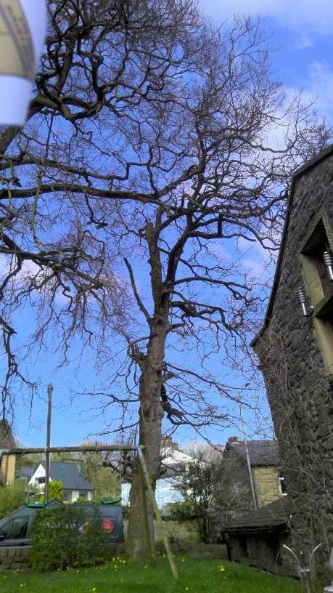

T190
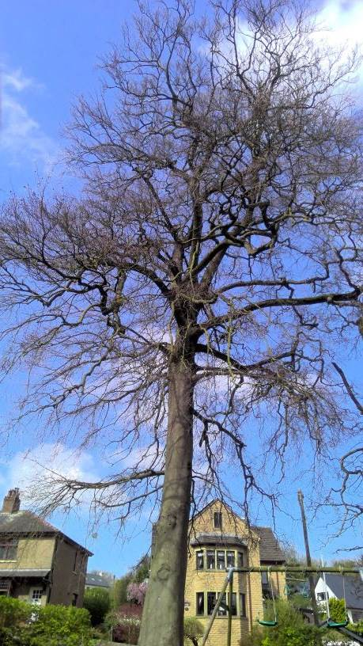

T191
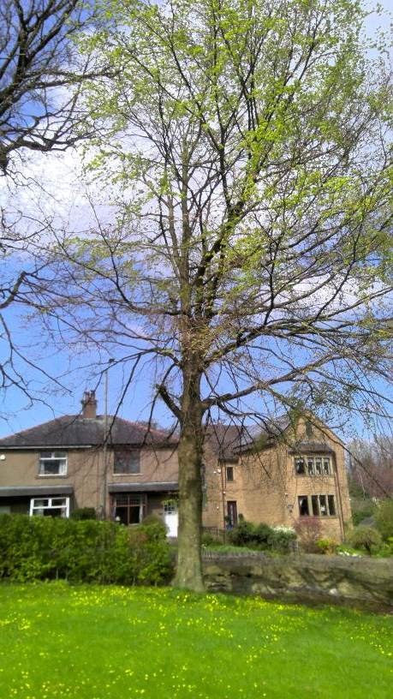

T194
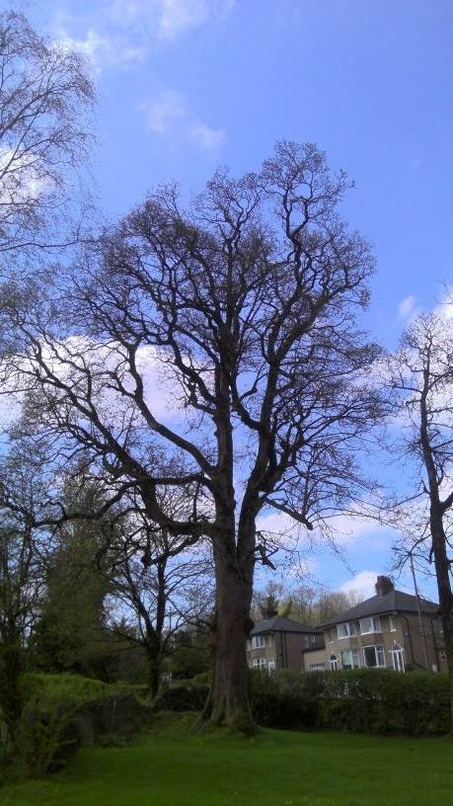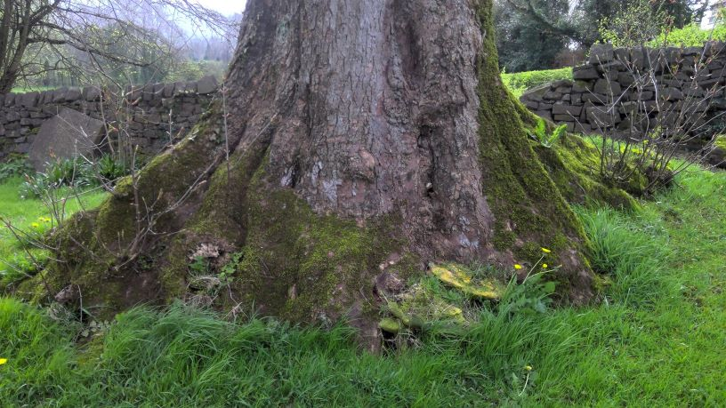

RELATED ISSUES: | YES |  | NO |  |  |  |  | YES | NO
Planning Application |  |  |  |  | Highway issue |  |  |  | 
Statutory Undertaker |  |  |  |  | Damage to property (proven) |  |  |  | 
Health & safety issues |  |  |  |  | Nuisance |  |  |  | 
Other (describe)* |  |  | 
AMENITY EVALUATION: |  | YES |  | NO
Carried out |  | 
Necessary |  |  |  | 

Application works appropriate? | YES 
Why?

Tree works form part of sound health and safety management of urban trees and works will not affect overall amenity value but will minimise risk of failure on high target areas, primarily Crow Trees Brow, gardens and buildings.

T194 Sycamore could almost be classed as a veteran due to size and features, the report recommends a more detailed inspection within 6 months due to a plethora of defects which the Council just wanted to emphasize due to the potential risk of failure onto high target areas.

Alternative works more appropriate? | NO 
Describe Alternative Works:

