

TREE WORK ASSESSMENT

DATE INSPECTED: |  |  |  |  |  |  |  | 31/03/2023
TPO: | No
CONSERVATION AREA: |  |  |  |  | Ribchester
APPLICATION NO: |  |  |  | 3/2023/0277
SPECIES: |  | Ash, sycamore, Goat Willow and London Plane
BS5837 CAT: |  |  | U |  |  | ASSESSOR: |  |  | A Shutt
 |  |  |  |  |  | SIGNATURE: |  |  | L Hayes
VISUAL TREE ASSESSMENT / COMMENTS

Ash and sycamore trees are growing out of access bridge foundations and are of poor form and condition, primarily due to multi-stem structure and ash dieback.

Trees also need to be removed so the access bridges foundations and integrity can be surveyed and repaired/replaced.

Goat willows have some branch failures that need to be made safe and the London planes apical stems have both failed and is unsuitable for retention in a high target area.

T1 &T2

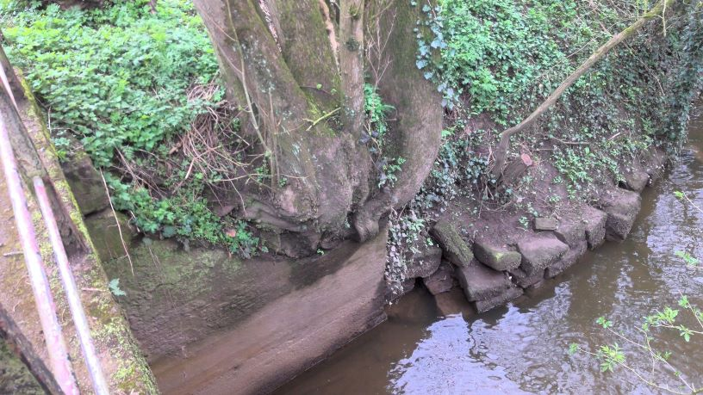
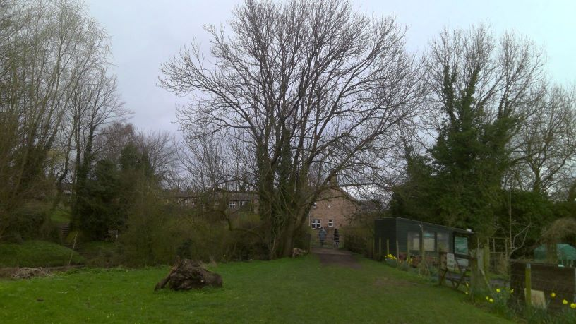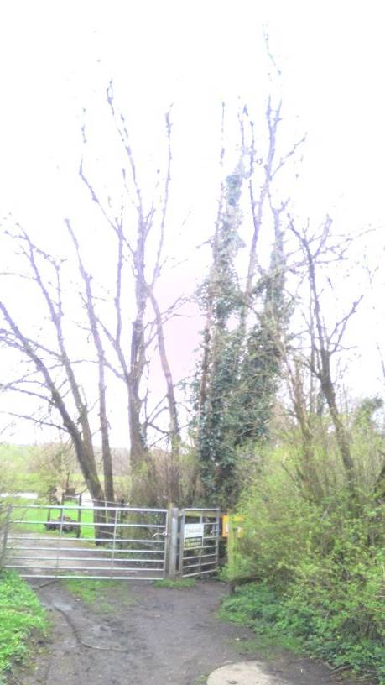
T4

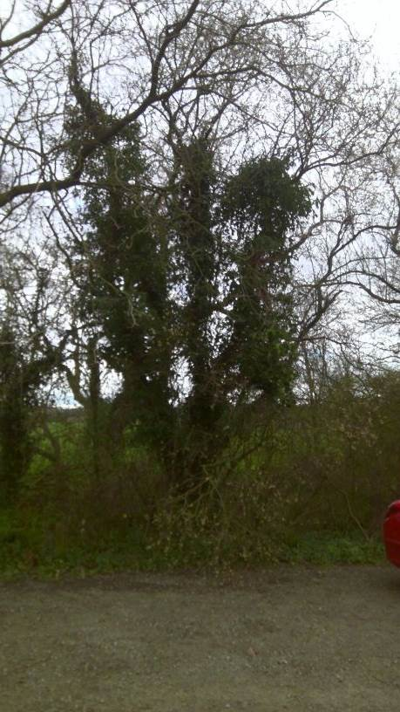

T5

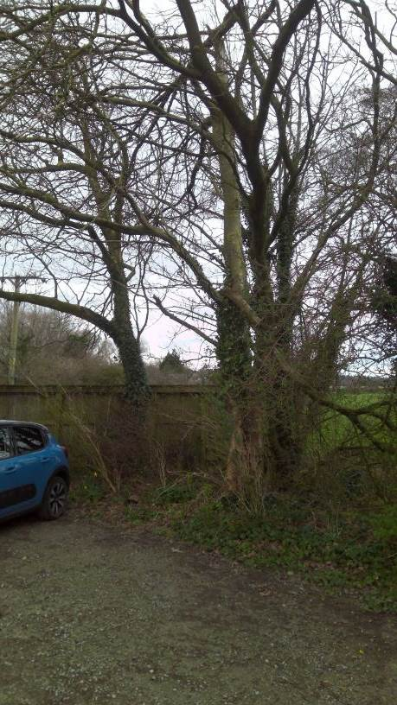

RELATED ISSUES: | YES |  | NO |  |  |  |  | YES | NO
Planning Application |  |  |  |  | Highway issue |  |  |  | 
Statutory Undertaker |  |  |  |  | Damage to property (proven) |  |  |  | 
Health & safety issues |  |  |  |  | Nuisance |  |  |  | 
Other (describe)* |  |  | 
AMENITY EVALUATION: |  | YES |  | NO
Carried out |  | 
Necessary |  |  |  | 

Application works appropriate? | YES 
Why?

T1 & T2 are of low amenity value and a TPO cannot be justified. T3, 4 & 5 risk of failure is unacceptable and a TPO cannot be justified.

Replanting will be carried out within both areas
Alternative works more appropriate? | NO 
Describe Alternative Works:

