Agenda Item 5d

RECOMMENDATION FOR PLANNING AND DEVELOPMENT COMMITTEE

**REFUSAL**

**DATE: 9 JANUARY 2025**

**REF: SK**

**CHECKED BY: LH**

**APPLICATION REF: 3/2023/0367**

GRID REF: SD 361426 440245

**DEVELOPMENT DESCRIPTION:**

CHANGE OF USE FROM FORMER AGRICULTURAL BUILDING TO ONE NEW DWELLING

HOUSE CLASS C3(A) FOLLOWING PART DEMOLITION OF RECENT STEEL FRAME

EXTENSION TO NORTH END AND ERECTION OF REPLACEMENT PITCHED ROOF TO NORTH END. RESUBMISSION OF 3/2022/0820. KNOTT FARM, CHIPPING ROAD, THORNLEY PR3 2TB.

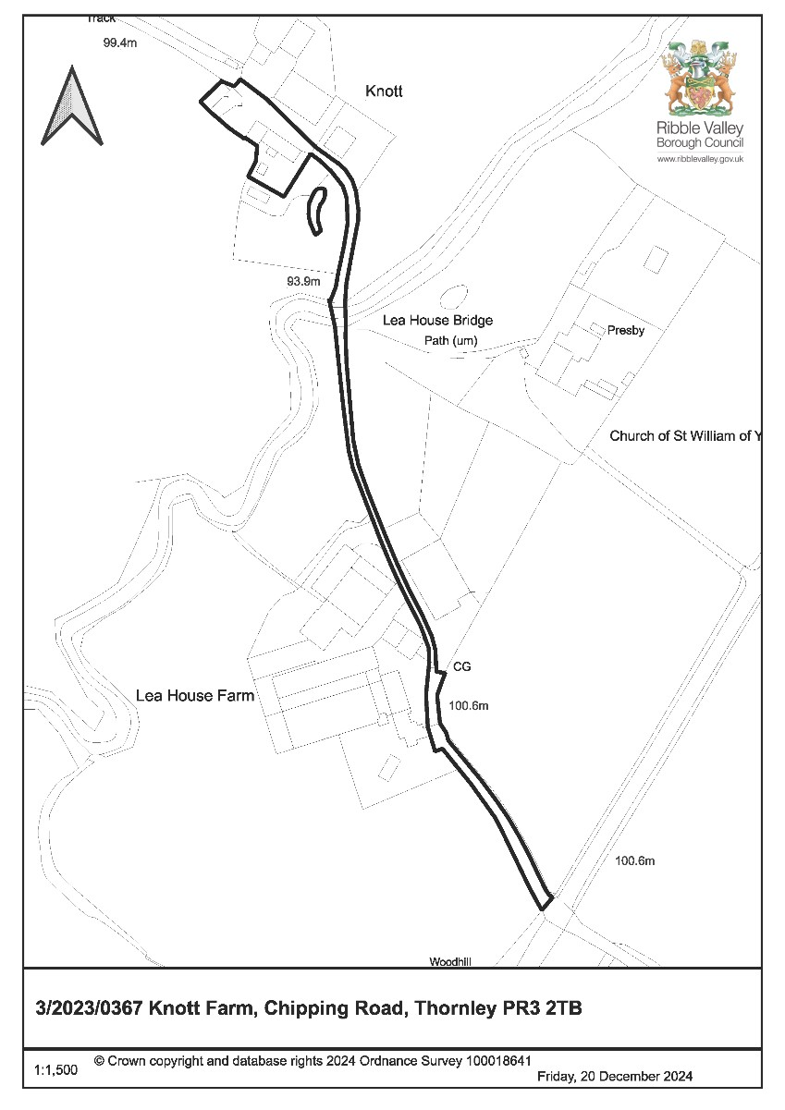

**CONSULTEE RESPONSES/ REPRESENTATIONS MADE:**

**PARISH COUNCIL:**

Thornley with Wheatley Parish Council have raised no objection to the proposal.

**LOCAL HIGHWAYS AUTHORITY (LANCASHIRE COUNTY COUNCIL HIGHWAYS):**

The Local Highways Authority have raised no objection to the proposal stating the following:

***No objection subject to conditions:***

*Lancashire County Council acting as the Local Highway Authority does not raise an objection regarding the proposed development and are of the opinion that the proposed development will not have a significant impact on highway safety, capacity or amenity in the immediate vicinity of the site subject to the following conditions being stated on any approval.*

***Site Access:***

*The LHA are aware that the proposed dwelling will continue to utilise an existing access track located off Chipping Road which is a C classified road subject to a 60mph speed limit. The access track, which is private and unadopted currently serves the site, Lee House Farm and Public Footpaths 3-41-FP64 and 3-12-FP38a.*

*The LHA have reviewed the supporting documents and have no objection to the use of the access. This is because the proposal will not intensify the use of the access with the existing building generating trips in its own right. Therefore, the LHA have no further comments to make.*

***Internal Layout:***

*The LHA have reviewed the supporting documents and understands that a parking plan has not been submitted showing that the site can provide 3 car parking spaces for the proposed 4 bed dwelling. However, the LHA are aware that there is ample space on site for the minimum parking requirements to be met and so the LHA will condition a parking plan is submitted prior to occupation*

The Local Highways Authority have further requested, should consent be granted, that conditions be imposed relating to the following matters:

* Submission of a Construction Management Plan
* Parking to be provided prior to occupation of the dwelling
* Provision of electric vehicle charging points to be provided

**ADDITIONAL REPRESENTATIONS:**

No representations have been received in respect of the proposal.

# 1. Introduction

1.1 Members will note the application is being brought before committee following receipt of an appeal against non-determination in respect of the application. As such Members are asked to consider whether or not they agree with the officer's assessment and recommended resolution to be presented to the Planning Inspectorate, which in this case is a recommendation for refusal.

# 2. Site Description and Surrounding Area

2.1 The application relates to an existing brick-built agricultural building associated with Knott Farm, Chipping Road, Thornley. The building forms part of an agricultural grouping of buildings including Knott farm Farmhouse. The application site lies outside of any defined settlement limits, being within an area that is within the Forest of Bowland national landscape.

# 3. Proposed Development for which consent is sought

3.1 The application seeks consent for the conversion of an existing agricultural building to that of a single residential dwelling. It is proposed that the dwelling will accommodate two bedrooms at first floor, with an additional bedroom being provided at ground floor with primary living accommodation including a tv/cinema room, livings room and kitchen/dining area.

# 3. Relevant Planning History

2022/0820:Change of use from former agricultural building to one new dwelling house Class C3(a) including part demolition of recent steel frame extension to north end, erection of replacement extension and raising roof ridge by one metre. (Withdrawn)

2022/0130:Amendment to planning permission 3/2020/0716 to allow alterations to internal layout to form utility room and bathroom with additional door and window openings to front and side elevations and enlargement of rear porch. (Approved)

2020/0716:Construction of single storey extension to side and single storey porch to rear. (Approved)

# 4. Relevant Policies

**Ribble Valley Core Strategy**

Key Statement DS1: Development Strategy

Key Statement DS2: Sustainable Development

Key Statement EN2: Landscape

Key Statement EN3: Sustainable Development and Climate Change

Key Statement EN4: Biodiversity and Geodiversity

Key Statement EN5: Heritage Assets

Key Statement DMI2: Transport Considerations

Policy DMG1: General Considerations

Policy DMG2: Strategic Considerations

Policy DMG3: Transport & Mobility

Policy DME1: Protecting Trees & Woodland Policy DME2: Landscape & Townscape Protection

Policy DME3: Site and Species Protection and Conservation

Policy DME4: Protecting Heritage Assets

Policy DME5: Renewable Energy Policy DME6: Water Management

Policy DMH3: Dwellings in the Open Countryside and AONB

Policy DMH4: The Conversion of barns and other Buildings to Dwellings

Policy DMB5: Footpaths and Bridleways

National Planning Policy Framework

# 5. Assessment of Proposed Development

5.1 Principle of Development:

5.1.1 Given the application relates to that of a conversion from a former agricultural building to that of a C3 residential planning unit, Policy DMH4 is primarily but not solely engaged for assessing the acceptability of the principle of the development. In this respect Policy DMH4 states:

*Planning permission will be granted for the conversion of buildings to dwellings where:*

1. *The building is not isolated in the landscape, i.e. it is within a defined settlement or forms part of an already group of buildings, and*
2. *There need be no unnecessary expenditure by public authorities and utilities on the provision of infrastructure, and*
3. *There would be no materially damaging effect on the landscape qualities of the area or harm to nature conservations interests, and*
4. *There would be no detrimental effect on the rural economy, and*
5. *The proposals are consistent with the conservation of the natural beauty of the area.*
6. *The proposals are consistent with the conservation of the natural beauty of the area.*

*The building to be converted must:*

1. *Be structurally sound and capable of conversion for the proposed use without the need for extensive building or major alternation, which would adversely affect the character or appearance of the building. the council will require a structural survey to be submitted with all planning application of this nature. this should include plans of any rebuilding that is proposed;*
2. *Be of a sufficient size to provide necessary living accommodation without the need for further extensions which would harm the character or appearance of the building, and*
3. *The character of the building and its materials are appropriate to its surroundings and the building and its materials are worthy of retention because of its intrinsic interest or potential or its contribution to its setting, and*
4. *The building has a genuine history of use for agriculture or another rural enterprise*

5.1.2 In relation to the above policy criterion, the building to which the application relates would not be considered to be ‘isolated in the landscape’ and currently forms part

of a grouping of buildings. The submitted information considers that the building is structurally sound, with no further extension being proposed. The authority additionally considers that the building and its materials are worthy of retention with the building also benefitting from a genuine history of use for the purposes of agricultural.

5.1.3 In respect of the above matters, members will note that the building would meet the criterion for being a building that is considered appropriate for residential conversion. However, the assessment of the visual impacts of the proposed conversion and associated proposed alterations will be assessed later within this report.

5.1.4 As such and taking account of the above matters, it is not considered that the principle of the redevelopment of the site for residential purposes, notwithstanding other development management considerations, would result in any significant measurable adverse conflict with Policy DMH4 of the Ribble Valley Core Strategy.

5.2 Impact upon Residential Amenity:

5.2.1 Given the building to which the application is located within close proximity of a nearby residential receptor (Knott Farm Farmhouse), consideration must be given in respect of the potential for the proposal to result in undue impacts upon the residential amenities of nearby residential occupiers.

5.2.2 In respect of the existing nearby residential receptor, the dwelling is located approximately 10m to the east of the building proposed to be converted to residential use. However, taking account of the orientation of the building to be converted in relation to the existing dwelling and the orientation and configuration of habitable room windows, it is not considered that the proposal will result in any measurable adverse impacts upon residential amenities by virtue of a loss of light, overbearing impact nor loss of privacy by direct over-looking.

5.2.3 As such, and taking account of the above matters, the proposal does not raise any significant direct conflicts with Policy DMG1 which seeks to ensure of adequate standards of residential amenity and protect against development(s) that would result in measurable detrimental impact(s) upon nearby existing residential amenities.

5.3 Visual Amenity/External Appearance

5.3.1 The submitted details propose a number of alterations to the existing building to facilitate its conversion to residential use. These can be summarised as follows:

North East Elevation:

* Introduction of 3 windows into existing ‘doors’ to create ‘stable’ door arrangement
* Insertion of window into existing opening at first floor
* Relocation of existing window at ground floor
* Introduction of two new windows on ‘rebuilt’ side extension

North West Elevation:

* Introduction of double door arrangement with one false door
* Introduction of single door with associated window

South East Elevation:

* Introduction of tri-fold door arrangement to serve dining room area

South West Elevation:

* Introduction of two bi-fold door openings and one window at ground floor
* Introduction of two windows at first floor
* Insertion of 5 velux conservation rooflights, 3 of which being on the primary roof with the remainder being on the roof of the extension to the ‘rebuilt’.

5.3.2 In respect of the proposed external alterations to the building, taking account of their configuration and cumulative nature, it is considered that these would significantly underline the existing inherent character of the building, resulting in a conversion that would have an overtly domestic appearance, being of detriment to the character and visual amenities of the area. As such the proposal would be in direct conflict with Policy DMH4 of the Ribble Valley Core Strategy which requires that buildings must be *‘capable of conversion for the proposed use without the need for extensive building or major alternation, which would adversely affect the character or appearance of the building’.*

5.3.3 With the proposal further resulting in subsequent conflict with Policy DMG2 which states that *‘development will be required to be in keeping with the character of the landscape and acknowledge the special qualities of the AONB by virtue of its size, design, use of material, landscaping and siting’.*

5.3.4 Members will also note that the submitted floorplans indicate a number of bi-fold and tri-fold doors opening up on to what is currently considered to be agricultural land. With no definitive details being provided in respect of the proposed residential curtilage to be associated with the proposed dwelling or as to where proposed parking provision would be accommodated.

5.3.5 As such no definitive assessment can be made in respect of the extents of the residential curtilage proposed. Nor its potential visual impact upon the character of the area. Particularly in relation to the potential suburbanising visual effect upon the landscape that may be resultant from the curtilage or any associated domestic paraphernalia.

5.3.6 As such and taking account of the above, it is considered that the proposal results in direct conflict with Key Statement EN2, and Policies DMG1, DMG2 and DMH4 of the Ribble Valley Core Strategy. Particularly insofar that the proposed conversion would result in a number of unsympathetic alterations, that would cumulatively undermine the inherent character of the existing building, by virtue of a resultant overtly domestic appearance, also being of significant detriment to the character and visual amenities of the area and that of the Forest of Bowland National Landscape.

5.4 Landscape and Ecology:

5.4.1 Given the application relates to the conversion of an existing agricultural building, the application has been accompanied by the submission of a Bat Survey to identify as to where the building is currently being utilised by roosting bats or as to whether the conversion of the building is likely to result in any adverse impacts upon protected species or species of conservation concern.

5.4.2 The submitted report in respect of bats concludes that *‘further surveys are required both to comply with national guidance and to ensure a thorough investigation in relation to use by bats. Surveys focussing on all potential roosts and bat access points should be carried out during the bat active season, ideally between May and August’.*

5.4.3 The report further recommends that these should be undertaken in three different survey visits including one dusk emergence and separate dawn re-entry surveys. Members will note that further surveys recommended within the report have not been undertaken and should have been undertaken prior to the submission of the application to allow for the authority to fully assess the potential impact(s) upon protected species resultant from the development.

5.4.4 As such and taking account of the above, the proposal results in significant direct conflict with Key Statement EN4 and Policy DME3 of the Ribble Valley Core Strategy and the requirements of the Wildlife and Countryside Act 1981 (as amended), insofar that the applicant has failed to adequately demonstrate that the proposal would not unduly impact upon protected species or their habitat.

5.5 Highway Safety and Accessibility:

5.5.1 The Local Highways Authority (LHA) have raised no objections to the proposal stating the proposal will not intensify the use of the access with the existing building generating trips in its own right. With the Local Highways authority further stating that adequate parking provision is available on site to support to the conversion to residential use.

5.5.2 The Local Highways Authority have further suggested, that should consent be granted, that conditions be imposed relating to the submission of a Construction Management Plan, that parking provision to be provided prior to occupation of the dwelling with the addition of electric vehicle charging point provision also to be provided.

5.5.3 As such and taking account that the Local Highways Authority have raised no objections in respect of the proposed development, the proposal is considered to align with the aims, objectives and requirements of Key Statement DMI2 and Policy DMG3 of the Ribble Valley Core Strategy insofar that the proposed development will not result in any significant measurable detrimental impact upon the safe operation of the immediate or wider highways network.

# 6. Observations/Consideration of Matters Raised/Conclusion

6.1 For the reasons outlined above, the application is recommended for refusal insofar that the applicant has failed to adequately demonstrate that the proposal would not unduly impact upon protected species or their habitat. With the proposal being further recommended for refusal in that the proposed conversion would result in a number of unsympathetic alterations, that would cumulatively undermine the inherent character of the existing building, by virtue of a resultant overtly domestic appearance, also being of significant detriment to the character and visual amenities of the area and that of the Forest of Bowland National Landscape.

RECOMMENDATION: The Local Planning Authority resolution is that had it been in a position to determine the application, the application would have been REFUSED for the following reason(s):

1. The proposal would result in direct conflict with Key Statement EN2, and Policies DMG1, DMG2 and DMH4 of the Ribble Valley Core Strategy. Particularly insofar that the proposed conversion would result in a number of unsympathetic alterations, that would cumulatively undermine the inherent character of the existing building, by virtue of a resultant overtly domestic appearance, also being of significant detriment to the character and visual amenities of the area and that of the Forest of Bowland National Landscape.

1. The proposal would result in direct conflict with Key Statement EN4 and Policy DME3 of the Ribble Valley Core Strategy and the requirements of the Wildlife and Countryside Act 1981 (as amended), insofar that the applicant has failed to adequately demonstrate that the proposal would not unduly impact upon protected species or their habitat.

BACKGROUND PAPERS

[https://webportal.ribblevalley.gov.uk/site/scripts/planx_details.php?appNumber=3%2F2023%2F 0367](https://webportal.ribblevalley.gov.uk/site/scripts/planx_details.php?appNumber=3%2F2023%2F0367)