

TREE WORK ASSESSMENT

DATE INSPECTED: |  |  |  |  |  |  |  | 05/07/23
TPO: | 92 – 1988 Langho Colony, Langho
CONSERVATION AREA: |  |  |  |  | No
APPLICATION NO: |  |  |  | 3/2023/0420
SPECIES:
BS5837 CAT: |  |  | B |  |  | ASSESSOR: |  |  | A Shutt
 |  |  |  |  |  | SIGNATURE: |  |  | LH
VISUAL TREE ASSESSMENT / COMMENTS

Trees are of amenity value, however they do require some management to clear from property and crown cleaning to reduce risk of damage to property and minimise dead wood failure.

Landowner has instructed a fully qualified Arboricultural Consultant to survey and write a comprehensive Tree Condition Report. Which clearly identifies the recommended works.

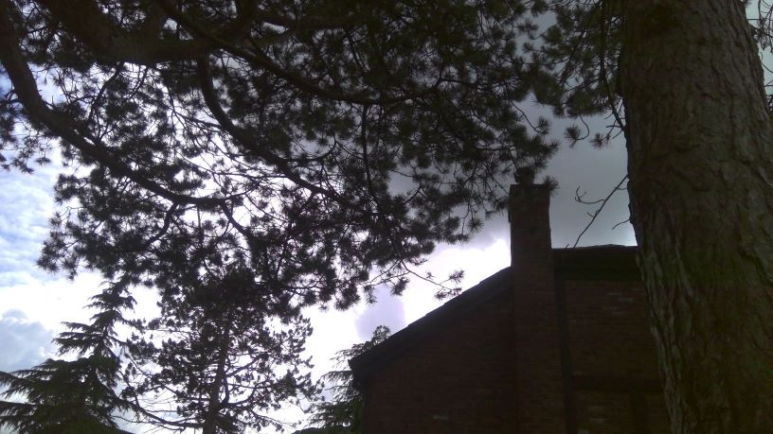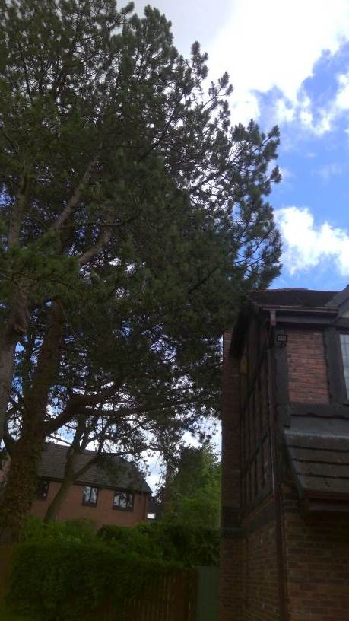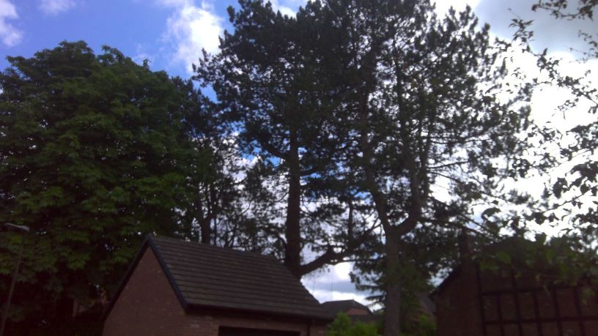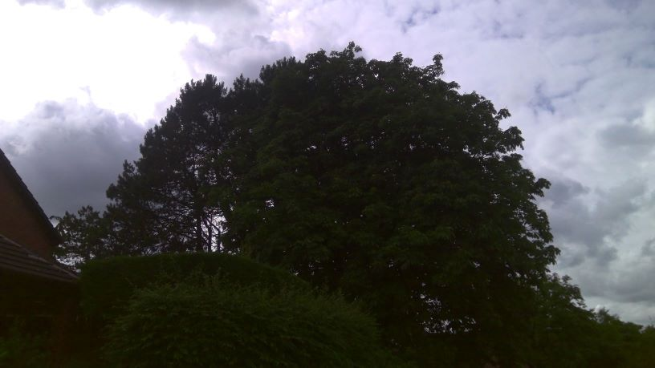

RELATED ISSUES: | YES |  | NO |  |  |  |  | YES | NO
Planning Application |  |  |  |  | Highway issue
Statutory Undertaker |  |  |  |  | Damage to property (proven)
Health & safety issues |  |  |  |  | Nuisance
Other (describe)*
Tree Management
AMENITY EVALUATION: |  | YES |  | NO
Carried out |  | N/A |  | N/A
Necessary |  | N/A |  | N/A

Application works appropriate? | YES
Why?

As above, landowner has had the trees surveyed by a fully qualified Arboricultural Consultant who has submitted a report and subsequent required recommendations.
The overall amenity value of the trees will not be affected and works form part of a sound Arboricultural Management Plan
Alternative works more appropriate? | NO
Describe Alternative Works:

