Agenda Item 5a
RECOMMENDATION FOR PLANNING AND DEVELOPMENT COMMITTEE

APPROVAL

DATE: 21 September 2023
REF: LW
CHECKED BY: LH

APPLICATION REF: 3/2023/0421

GRID REF: SD 365139 432087

DEVELOPMENT DESCRIPTION:

PROPOSED ALTERATIONS AND EXTENSION TO EXISTING DWELLING INCLUDING SINGLE STOREY REAR/SIDE EXTENSION, RAISING OF ROOF PITCHES TO REAR, NEW CHIMNEY, FENESTRATION CHANGES TO FRONT AND ROOFLIGHTS TO REAR AT FAIRFIELD FARM, LONGSIGHT ROAD, CLAYTON-LE-DALE, BB2 7JA.

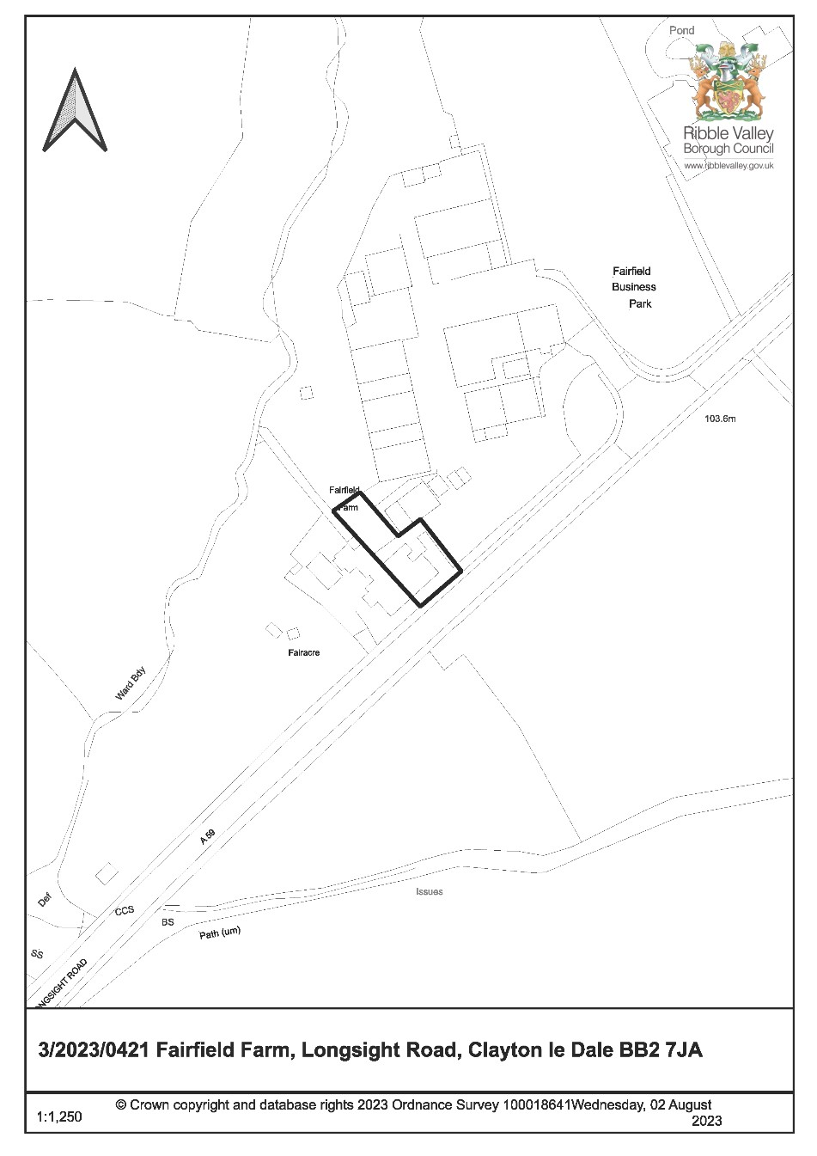
CONSULTEE RESPONSES/ REPRESENTATIONS MADE:

PARISH COUNCIL:

Clayton-le-Dale Parish Council were consulted on 22nd June 2023; however, no comments have been received in respect of the proposal.

LOCAL HIGHWAYS AUTHORITY (LANCASHIRE COUNTY COUNCIL HIGHWAYS):

Initial response raised objections due to the obstruction of the public rights of way network.

Re-consulted on 18th August 2023 following receipt of revised plans. Response received 12th September 2023 confirms no objection to the amended scheme.

LANCASHIRE COUNTY COUNCIL FOOTPATHS:

Lancashire County Council Footpaths were consulted on 9th August 2023; however, no response has been received in relation to the proposal.

ADDITIONAL REPRESENTATIONS:

No representations received.

Site Description and Surrounding Area

1.1 The application relates to a two-storey semi-detached dwelling, located to the northern side of Longsight Road. The property predominantly comprises of natural stone and render to the external elevations, along with natural slate roof tiles and dark brown uPVC windows.

1.2 The original property has been previously extended by way of a two-storey extension to its north-western rear elevation and single storey porch to the north-eastern side elevation.

1.3 The site is located within the open countryside, situated between the defined settlement areas of Osbaldeston and Copster Green on the A59 highway. The property itself shares a common boundary with the adjoined residential properties of Fair Acre and Flat at Fair Acre, whilst Fairfield Business Park lies immediately to the north-east of the application site.

1.4 An existing Public Right of Way (FP-03-13-001 Clayton-le-Dale) also passes immediately adjacent the north-eastern boundary of the dwelling, providing access to the woodland and open fields which border the property to the rear.

Proposed Development for which consent is sought

2.1 Consent is sought for numerous alterations to the existing dwellinghouse. The works proposed include the erection of a single storey side/ rear extension, new chimney to the north-eastern gable elevation, raising of the roof pitch to the rear, external fenestration changes and addition of rooflights to the existing utility.

2.2 The application is being brought to this Committee for a decision as the applicant is a Ribble Valley Borough Councillor.

Relevant Planning History

3/1998/0401: Alterations and extensions to first floor and ground floor to create larger bathroom, bedroom with en-suite, porch, inglenook fireplace (Approved)

Adjacent property

3/1988/0625: Conservatory extension at side of Fair Acre, Longsight Road, Claytonle-Dale (Approved)

3/1987/0602: Extension to form self-contained flat at Fair Acre, Longsight Road, Clayton-le-Dale (Approved)

3/1987/0245: Extension to form self-contained flat and first floor additional bedroom and study at Fair Acre, Longsight Road, Clayton-le-Dale (Refused)

Relevant Policies

Ribble Valley Core Strategy (Adopted Version)
Key Statement DS1 – Development Strategy
Key Statement DS2 – Presumption in Favour of Sustainable Development Key Statement DMI2: Transport Considerations

Policy DMG1 – General Considerations
Policy DMG2 – Strategic Considerations
Policy DMG3 – Transport and Mobility
Policy DMH5: Residential and Curtilage Extensions
Policy DMB5: Footpaths and Bridleways

National Planning Policy Framework

National Planning Practice Guide

Assessment of Proposed Development

5.1 Principle:

5.1.1 The application relates to a domestic extension and alterations to a residential property within the existing residential curtilage and is therefore considered acceptable in principle subject to an assessment of the material planning considerations.

5.2 Residential Amenity:

5.2.1 The single storey extension proposed to the side/ rear of the dwellinghouse would project 2m beyond the existing two storey rear extension and would be set approximately 4.6m from the common boundary with Fair Acre. Whilst it is acknowledged that no boundary treatment exists along this shared boundary, the proposal would comprise a relatively modest rearward projection and would not be sited directly adjacent any habitable room windows within the side elevation of Fair Acre. It is therefore not considered that the proposed development would result in any significant degree of overshadowing or loss of outlook in respect to this neighbouring property.

5.2.2 The proposed windows featured to the rear and north-eastern facing side elevations of the proposed single storey extension would provide similar views to those afforded by the existing window configuration to the side and rear elevations of the existing property and would not have a direct interface with any neighbouring residential properties. It is therefore not considered that these elements of the proposal would compromise the existing levels of privacy.

5.2.3 Furthermore, whilst the proposed full length glazing to the north-western facing side elevation of the extension would provide views towards an existing window featured within the side elevation of the Flat of Fair Acre, this neighbouring window does not serve a habitable room and is obscurely glazed. As such, it is not considered that the proposed glazing would result in any measurable harm upon the privacy of these neighbouring residents.

5.2.4 The proposed fenestration changes to the main dwellinghouse would also be sited in a similar position to the dwellings existing ground and first floor window openings and the addition of roof lights to the existing utility would not provide any new opportunities for direct overlooking or loss of privacy in this instance.

5.2.5 The proposed raising of the rear roof pitch and addition of the chimney would likely lead to additional occurrences of overshadowing, however these elements of the proposal would be sited towards the north-eastern side of the dwellinghouse and would therefore be adequately screened from the adjoined property of Fair Acre by the application dwelling itself. As such, any resultant overshadowing would primarily occur within the confines of the application site and the adjacent car parking area associated with the Fairfield Business Park. In this respect, the proposed works are not anticipated to result in any significant or measurable harm upon existing nearby residential amenities.

5.3 Visual amenity:
5.3.1 The original built form of the property has been substantially remodelled and extended throughout its history, with the property currently benefiting from an existing two-storey reverse gable extension to its rear elevation and single storey porch to the north-eastern side elevation. Whilst the principal elevation of the dwelling, for the most part, has retained its unassuming and largely rural character, the later additions to the side and rear of the original built form and use of more modern building materials has resulted in the dwelling having lost its rural vernacular towards the rear of the property.

5.3.2 Furthermore, whilst Fairfield Farm is a semi-detached property, forming the easterly dwelling of the semi-detached pair, the two residential properties are not characterised by a strong sense of uniformity. Although the front elevation of Fair Acre has retained its simple linear appearance, the dwelling as a whole has also undergone substantial alterations throughout its history, including alterations to the external fenestration design and the addition of a selfcontained flat to the rear and conservatory to its side elevation. The principal elevations of the two properties also appear somewhat dissimilar by virtue of their differing window designs and the partial rendering of the front elevation of Fairfield Farm. As such, it is not considered that the proposed works would significantly unbalance the pair of semi-detached properties to a degree that would warrant refusal.

5.3.3 The proposed development comprises a relatively modest single storey side/ rear extension which would project 3.2m from the side elevation and 2m from
the rear elevation of the existing two-storey addition, creating an L shaped wrap around extension. A flat roof form would be featured which would incorporate Velux rooflights and a green roof design, with the main access door to the property being located to the north-eastern side elevation and a set of sliding doors being installed to the rear.

5.3.4 The proposed extension would result in an increase of approximately 12% to the existing footprint of the dwelling which in turn would add an additional 30m2 of internal floor space to the property. As such, the proposal would appear wholly subservient to the main dwellinghouse by virtue of its modest proportions and design.

5.3.5 Further alterations to the dwelling include the raising of the rear roof pitch to create a second reverse gable roof form, construction of a new chimney to the north-eastern side elevation, external fenestration changes including the addition of narrow windows and a glazed panel to the front elevation and installation of roof lights to the existing utility.

5.3.6 The application site is located within a visually prominent location along the A59 highway, with a Public Right Of Way also passing immediately adjacent the dwelling on its north-eastern boundary, providing access to the woodland and open fields to the rear of the site. As such, all elevations of the host property are clearly visible from within the public realm.

5.3.7 In view of the above, minor amendments have been sought since the initial submission of the application in order to reduce the visual impact of the proposed additions, including a reduction in the width of the proposed chimney to the north-eastern gable elevation and revisions to the proposed narrow window openings.

5.3.8 Following these revisions, the width of the proposed chimney has been reduced from 2.7m to 2.1m and minor amendments have been made to the window proportions.

5.3.9 Whilst the narrow windows to the principal elevation of the main dwellinghouse and the north-eastern elevation of the proposed extension remain, it is not considered that the proposed openings would appear an overtly incongruous or anomalous addition to the host property when viewed in context with the existing built form within the immediate vicinity and therefore would not warrant the refusal to grant planning permission in this instance.

5.3.10 The proposed construction of a second reverse gable roof form to the rear of the property would also visually integrate with the existing reverse gable roof form of the two-storey rear extension and would therefore not appear an anomalous or out of keeping addition to the primary dwelling.

5.3.11 In addition to this, the proposal would incorporate materials that are consistent with the external appearance of the host property and the adjoined dwelling of Fair Acre, including natural stone, off-white render, and natural slate roof tiles.

5.3.12 In view of the above, it is therefore considered that the proposed development would visually integrate with the existing built form and would not be of significant detriment to the visual amenities of the application property or the surrounding area.

5.4 Ecology:
5.4.1 The application has been accompanied by a preliminary bat roost assessment report, dated 19th May 2023, with a daytime bat survey having been carried out at the application site on 2nd May 2023 and an emergence survey on 18th May 2023. No evidence was recorded to suggest bats were roosting within the building and no bats were observed or recorded using the building for roosting, with the property being assessed as offering negligible roosting potential.

5.4.2 However, it has been recommended that additional mitigation measures be implemented on site with regards to the provision of a bat box by way of a planning condition.

5.4.3 A cautionary approach is also advised and in the unlikely event that any bats are discovered, disturbed, or harmed during the development, all work must cease immediately, and further advice be sought from a licenced ecologist.

5.5 Highways:

5.5.1 LCC Highways had initially raised concerns in respect of the application insofar that the proposal would obstruct the Public Right Of Way network.

5.5.2 Further to this response, the profile of the proposed extension has been amended to accommodate the existing Public Right of Way (FP-03-13-001 Clayton-le-Dale). The plans now show that the proposed extension would maintain the current distance between the footpath and the existing property. As such it is not considered that the proposed works would result in any significantly detrimental impact upon the Public Right Of Way network compared to the current situation.

5.5.3 LCC Highways were re-consulted following receipt of the revised plans and raise no objections to the amended scheme.

5.5.4 The granting of any planning permission does not entitle a developer to obstruct a right of way and any proposed stopping-up or diversion of a right of way should be the subject of an Order under the appropriate Act. It is also advised that the applicant contacts Lancashire County Council’s Public Rights of Way section to discuss the proposal before any development works begin. A note to this effect can be added to the decision notice.

5.5.5 The works proposed would not result in an increase in the number of bedrooms at the application property nor would it involve any alterations to the existing parking arrangements. As such there is no need to secure additional parking.

- Observations/Consideration of Matters Raised/Conclusion:

  - The proposal would not result any undue impact upon the amenity of any neighbouring residents, nor is it considered that the proposal would be harmful to the visual amenities of the area, surrounding ecology or highway safety. The matter of the public footpath is considered to have been addressed with the revised plans received.

  - As such, for the above reasons and having regard to all material considerations and matters raised, the application is recommended for approval.

RECOMMENDATION: That planning permission be APPROVED subject to the following conditions:

- The development must be begun not later than the expiration of three years beginning with the date of this permission.

REASON: Required to be imposed by Section 51 of the Planning and Compulsory Purchase Act 2004.

- Unless explicitly required by condition within this consent, the development hereby permitted shall be carried out in complete accordance with the proposals as detailed on drawings:

  - Location Plan (dwg no.EX.00 Rev A)
  - Proposed Site Plan, Floor Plans, and Elevations (dwg no. PL.01 Rev C)
  - Proposed Roof Plan (dwg no. PL.02 Rev A)

REASON: For the avoidance of doubt and to clarify which plans are relevant to the consent.

- The materials to be used on the external surfaces of the development as indicated within the application form and on approved drawing(s) ‘Proposed Site Plan, Floor Plans and Elevations’ (dwg no. PL.01 Rev C) shall be implemented as indicated.

REASON: In order that the Local Planning Authority may ensure that the materials to be used are appropriate to the locality.

- The installation of a Greenwoods Ecohabitats Two Chamber Bat Box or Kent Bat Box shall be incorporated into the site during the construction stage of the development and made available for use before the extension(s) hereby approved is first brought into use and thereafter retained.

REASON: In the interest of biodiversity and to enhance roosting opportunities for species conservation concern and to minimise/ mitigate the potential impacts upon protected species resultant from the development.

INFORMATIVE:

The granting of any planning permission does not entitle a developer to obstruct a right of way. Any proposed stopping-up or diversion of a right of way should be the subject of an Order under the appropriate Act. The applicant is advised to contact Lancashire County Council’s Public Rights of Way section by email on PROW@lancashire.gov.uk, quoting the location, district and planning application number to discuss their proposal before any development works begin.

BACKGROUND PAPERS

https://webportal.ribblevalley.gov.uk/planningApplication/35442

This page is intentionally left blank

