TREE WORK ASSESSMENT

DATE INSPECTED: |  |  |  |  |  |  |  | 5 July 2023
TPO: | 38 – 1976 Longridge Road, Chipping
CONSERVATION AREA: |  |  |  |  | No
APPLICATION NO: |  |  |  | 3/2023/0504
SPECIES: |  | First Tree (T1) & Second Tree (T2) Horse Chestnut
BS5837 CAT: |  |  | T1 U T2 B/C |  |  | ASSESSOR: |  |  | A Shutt
 |  |  |  |  |  | SIGNATURE: |  |  | LH
VISUAL TREE ASSESSMENT / COMMENTS

Following from my site visit on 5 July 2023, there is not enough evidence to justify the felling of the Second Tree (T2), due to the amenity value, signs of good vigour, good reactive growth to historic defects, potential of altered exposure to the remaining group and the negative impact on the local treescape should this tree be removed.

A brief email has been submitted detailing “signs of honey fungus (Armillaria). This is a root rot disease and can affect the stability of the tree.” By Maple Dean Tree Services

Identifying the Rhizomorphs on site and under dead wood is not a sign that the tree and roots have been colonised and due to the importance of this protected tree, the Council require a full survey to be carried out on T2 so the Council can make an informed decision. It is advised a PICUS (P) or Resistograph (R) test be utilised as this will show the amount of decay present (P) or sound structural wood (R) present, which will evidence the decision.

T1 has low amenity value, however it has a very low risk of failure due to having no crown and is thriving as a habitat pole. The Council cannot refuse the felling works to this tree, however the replacement 2 alders will be conditioned as due to the stem being retained the replacement planting was not enforced.

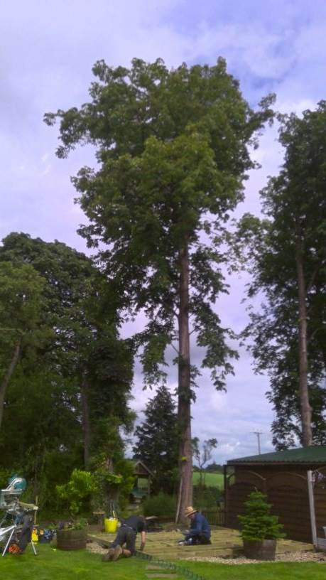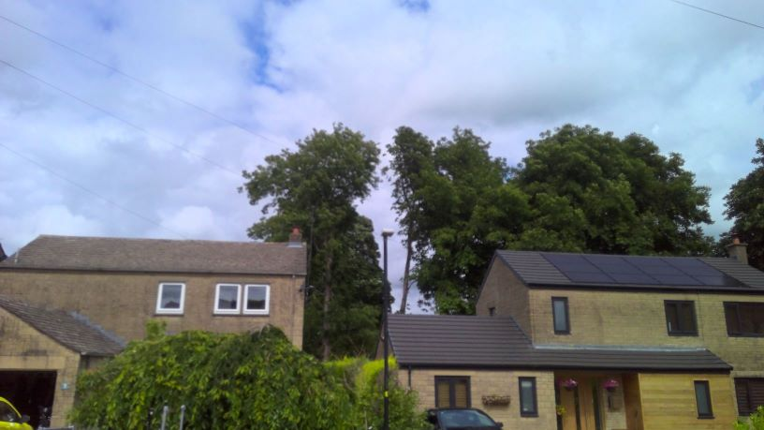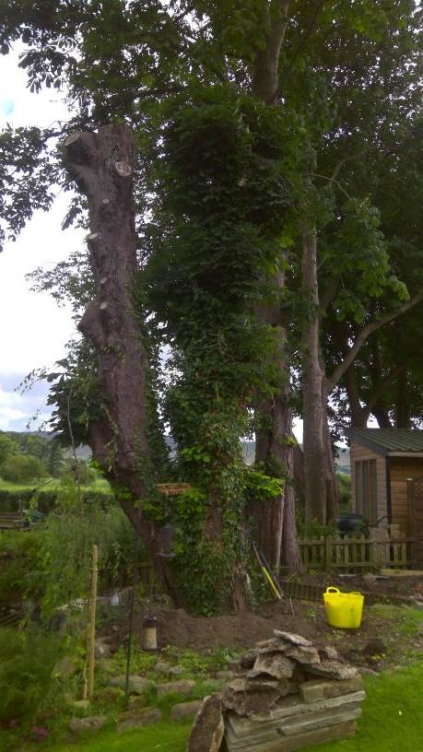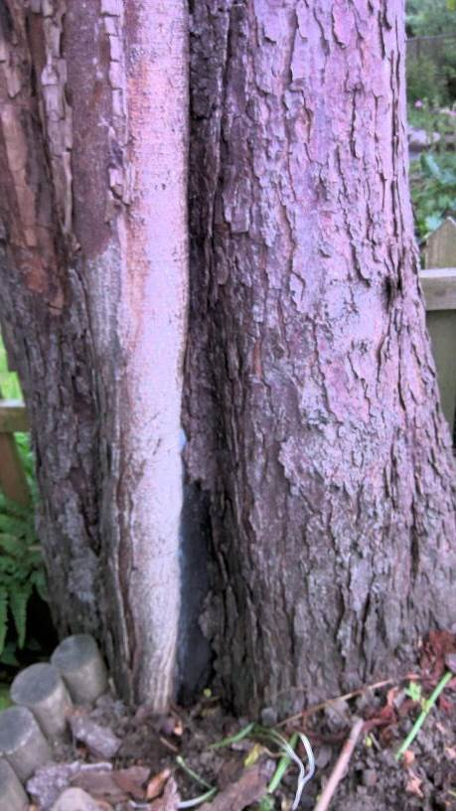

RELATED ISSUES: | YES |  | NO |  |  |  |  | YES | NO
Planning Application |  |  |  |  | Highway issue
Statutory Undertaker |  |  |  |  | Damage to property (proven)
Health & safety issues |  |  |  |  | Nuisance
Other (describe)*
Garden Management
AMENITY EVALUATION: |  | YES |  | NO
Carried out |  | N/A |  | N/A
Necessary |  | N/A |  | N/A

Application works appropriate? | YES & NO Split Decision
Why?

T1 Habitat Pole has no amenity value but good habitat and biodiversity value pre commencement survey for nesting birds and protected species will be conditioned.
Alternative works more appropriate? | YES
Describe Alternative Works:

T2 requires a full tree survey as mentioned above, preferably with a PICUS (P) or Resistograph (R) test be utilised as this will show the amount of decay present (P) or sound structural wood (R) present, which will evidence the decision to either safely retain, crown reduce by 15 - 20% to minimise failure and protect adjacent trees or fell and replace.

