RECOMMENDATION FOR PLANNING AND DEVELOPMENT COMMITTEE

**APPROVAL**

**DATE: 7 DECEMBER 2023**

**REF: EP**

**CHECKED BY: LH**

**APPLICATION REF: 3/2023/0664**

GRID REF: 369072 434193

**DEVELOPMENT DESCRIPTION:**

CONSTRUCTION OF TWO DUGOUT SHELTER BUILDINGS TO REPLACE THE EXISTING

TEMPORARY SHELTERS AT LANGHO SPORTS AND SOCIAL CLUB, DEWHURST ROAD, LANGHO BB6 8AF

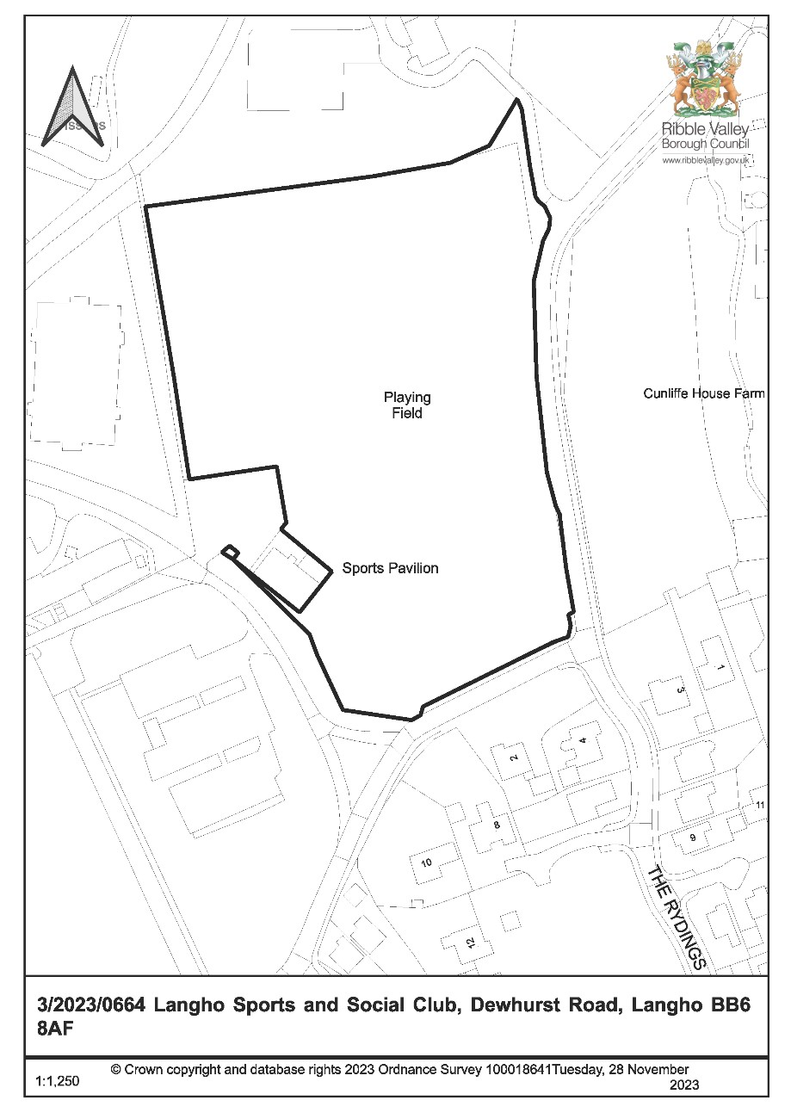

**CONSULTEE RESPONSES/ REPRESENTATIONS MADE:**

**PARISH COUNCIL:**

Wilpshire Parish Council have objected to the proposal on the following grounds.

* Permanent structures are not in keeping with the original covenants.
* Only temporary structures that can be removed with ease should be installed in case the football club is disbanded in the future.

**SPORT ENGLAND:**

Sport England initially objected to the proposal on the following grounds.

* The proposed development does not meet any of the exceptions to their Playing Fields Policy or to accord with paragraph 99 of the NPPF.

Sport England advised they would reconsider their position should amended/additional details be provided to address the following points.

* Provision of further information regarding the need for the dugout.
* Provision of a detailed plan showing locations of pitch markings relative to the proposed dugout.

The applicant provided the above details and Sport England have now withdrawn their objection on the basis that Exception 2 of their Playing Fields Policy has been met and the development accords with paragraph 99 of the NPPF. This is subject to a condition imposing the need for a construction management plan prior to commencement.

**ADDITIONAL REPRESENTATIONS:**

In excess of 50 letters of representation have been received objecting to the application on the following grounds:

* Breach of covenant due to erection of permanent structures and change of use.
* Lack of ecological surveys.
* Increase in anti-social behaviour.
* Increase in traffic as a result of use of the structures.
* Potential increase in commercial advertising
* Proposed development will trigger further applications to develop the site.
* Loss of public open space.

1. **Site Description and Surrounding Area**

* 1. The site is an existing football club with grass pitches, car parking and pavilion located on the Rydings to the south of the A59 Longsight Road. The application relates to an area of designated open space outside of the defined settlement limits of Langho approximately 1 kilometre to the North-west of Langho village centre. There are residential developments around the site largely to the to the south, along with Kemple View rehabilitation centre,

the sanctuary of healing is adjacent on Dewhurst Road and Longsight stables lies to the west.

1. **Proposed Development for which consent is sought**

* 1. The application seeks consent for the erection of two brick-built dugout shelter buildings to replace the existing temporary shelters to be sited towards the northern end of the site.

1. **Relevant Planning History**

3/2020/0315**:** Applications for full consent. Construction of an all-weather football pitch with boundary fencing and floodlights and an extension of existing car park. (refused).

1. **Relevant Policies**

**Ribble Valley Core Strategy**

Key Statement DS1: Development Strategy

Key Statement DS2: Sustainable Development

Key Statement EN4: Biodiversity and Geodiversity

Policy DMG1: General Considerations

Policy DMG2: Strategic Considerations

Policy DME1: Protecting Trees & Woodland

Policy DME3: Site and Species Protection and Conservation

Policy DMB3: Recreation and Tourism Development

Policy DMB4: Open Space Provision

National Planning Policy Framework (NPPF)

1. **Assessment of Proposed Development**

* 1. **Principle of Development:**

* + 1. Policy DMG2 of the Core Strategy States that *within the Tier 2 villages and outside the defined settlement areas development must meet at least one of the following considerations:*

* + - * 1. *The development should be essential to the local economy or social well being of the area.*
        2. *The development is needed for the purposes of forestry or agriculture.*
        3. *The development is for local needs housing which meets an identified need and is secured as such.*
        4. *The development is for small scale tourism or recreational developments appropriate to a rural area.*
        5. *The development is for small-scale uses appropriate to a rural area where a local need or benefit can be demonstrated.*
        6. *The development is compatible with the enterprise zone designation.*

* + 1. The proposed development is considered to comply with point 4 of the above policy in as much that the proposed dugouts are modest in terms of scale and are for recreational purposes associated with the playing field. Policy DMG2 also requires consideration of visual impact, which will be considered at 5.3 of this report.

* + 1. Policy DMB3 of the Core Strategy supports the expansion of recreational and leisure facilities. The proposed dugout shelters would improve the existing recreational facilities on the site, by replacing the current temporary facilities with a more permanent solution. Policy DMB3 also requires consideration of other matters which will be considered below.

* + 1. Policy DMB4 of the Core Strategy resists development proposals resulting in a loss of public open space including private playing fields which are in recreational use. This is consistent with paragraph 99 of the NPPF. As the development is on a playing field Sport England are a statutory consultee however following the submission of additional information by the applicant, namely a statement of need, they raise no objection subject to a condition to control the construction of the dugouts. As such the proposal satisfies policy DMB4 and the NPPF.

* 1. **Impact upon Residential Amenity:**

* + 1. The application site has a number of nearby residential properties including those at The Ryding’s and Cunliffe House Farm. These properties are in excess of 160 metres from the proposed development. Given the distance, there is no potential for loss of light or overbearing impact, as such no adverse harm is expected on residential amenity in this respect.

* + 1. The neighbouring property in closest proximity to the proposed development is Longsight House. There are an existing cluster of mature, protected trees to the North of the proposed development that will provide complete screening of the dugouts for the neighbouring receptors of Longsight House. Therefore, again there is no adverse impact on residential amenity expected in respect of loss of light or overbearing impact.

* + 1. It is recognised that the neighbouring receptors use the site for recreation given its status as public open space. The application does not seek to change the use of the site, or enclose the open space in any way, consequently it will remain available for use by the public.

* + 1. In respect of anti-social behaviour and potential noise disturbance, given there are existing shelters on site and this application does not seek to change the use of the site, it is not considered that the proposal would increase the risk of anti-social behaviour or result in an increase in noise levels as a result of the development. Whilst the concerns raised by third party objectors on this issue are noted, there is not considered to be any reasonable basis to refuse the application on noise or anti-social behaviour. Should any anti-social issues arise then this could be dealt with through other legislation or by the club operator or the police.

* + 1. As such with respect to residential amenity, and matters that are a material planning consideration, the development is considered to satisfy policy DMG1 of the Core Strategy as well as the NPPF and is acceptable.
  1. **Visual Amenity/External Appearance**

* + 1. The proposed dugout shelters would be constructed of red facing brick to the elevations with a timber carcass roof and integral timber benches. The clubhouse itself, as well as properties in the vicinity, are constructed of red facing brick and as such it is considered the development will integrate sufficiently into the area without harming the character.

* + 1. The proposed structures will each measure approximately 5.4m by 1.8m with a maximum height of 2.4m. Whilst the proposed shelters are larger than the existing temporary structures, they are still considered modest in respect of their overall height and footprint when viewed in context with the whole site. The proposed structures will not host a prominent position given their siting to the North of the playing field and given the presence of other buildings nearby. In addition, the site is not within an Area of Outstanding Natural Beauty (AONB) or conservation area and so is not subject to any special landscape or heritage protection. As such the visual impact is considered to be acceptable to allow the club to improve its facilities in accordance with policies DMG1, DMG2 and DMB3 of the Core Strategy.

* 1. **Landscape and Ecology:**

* + 1. It is recognised that a number of letters of representation raised concerns over the lack of an ecological survey as part of the submission. The Council’s countryside officer has reviewed the details submitted. Due to the proposed development being replacement shelters and taking into consideration the size of the structures, being situated on a well maintained public open space and sports pitches, it is considered that the requirement for a phase one habitat study cannot be justified.

* + 1. The Council’s countryside officer is satisfied that there would be a sufficient distance of over 10m between the proposed development and the protected trees to the North. As such, no arboricultural assessment is required and no harm to the trees is identified.

* 1. **Highway Safety and Accessibility:**

* + 1. LCC Highways have not been consulted in relation to the proposal given the development does not involve a change of use or intensification of the use of the land. It is not considered that the proposed development will have an impact on highway safety or amenity and satisfies policies DMG1 and DMB3.

* 1. **Other Matters:**

* + 1. The council are aware of a section 106 agreement on the application site that restricts the use of the land so that it remains as public open space. This application does not seek to change the use of the land and the introduction of two permanent dugouts would not prevent the use of the site for recreation purposes or prevent members of the public using the space.

* + 1. Nonetheless, the granting of any permission does not give the applicant the automatic right to implement the consent should it result in a breach of any section

106 agreement or similar. This is a separate legal matter. For the avoidance of doubt, for the reasons above, there is not considered to be a breach of the section 106 agreement.

* + 1. A number of letters of representation have been received raising concerns over future development at the site and a potential increase in commercial advertisement as a result of the application at hand being approved. Future development at the site requiring planning permission or advertisement consent will be assessed accordingly on a case-by-case basis. Therefore, this is not a justified reason to refuse the application.

1. **Observations/Consideration of Matters Raised/Conclusion**

* 1. By virtue of the proposed developments modest scale, considered siting and design it is not considered that there would be any unacceptable harm on either visual or residential amenity, or on the use of the site as a recreational / playing field facility.

* 1. Therefore the application is recommended for approval subject to conditions.

RECOMMENDATION: That the application be APPROVED subject to the following conditions:

* + - 1. The development must be begun not later than the expiration of three years beginning with the date of this permission.

REASON: Required to be imposed by Section 51 of the Planning and Compulsory Purchase Act 2004.

* + - 1. Unless explicitly required by condition within this consent, the development hereby permitted shall be carried out in complete accordance with the proposals as detailed on drawings:

Location Plan

Langho FC The Rydings Proposed Site Plan

Playing Field Site Boundary

Proposed Senior Pitch Dugouts 20-008

REASON: For the avoidance of doubt and to clarify which plans are relevant to the consent hereby approved.

* + - 1. The materials to be used on the external surfaces of the development as indicated on the Application Form and as shown on the approved plans shall be implemented in accordance with the approved details.

REASON: In order that the Local Planning Authority may ensure that the materials to be used are appropriate to the locality and respond positively to the inherent character of the area.

* + - 1. No development shall commence until the following details are submitted to and approved in writing by the Local Planning Authority (after consultation with Sport England):

* + - * 1. the works/contractors’ compound (including any buildings, moveable structures, works, plant, machinery, access and provision for the storage of vehicles, equipment and/or materials); and
        2. a scheme for the removal of the works/contractors' compound and the restoration of the land on which it is situated.

The works/contractors’ compound shall not be provided and used on the site other than in accordance with the approved details and shall be removed and the land on which it is situated restored in accordance with the approved details before first use of the development hereby approved.

REASON: To protect the playing fields/sports facilities from damage, loss or availability of use.

BACKGROUND PAPERS

https://webportal.ribblevalley.gov.uk/site/scripts/planx_details.php?appNumber=3%2F2023%2F 0664