Agenda Item 5c

RECOMMENDATION FOR PLANNING AND DEVELOPMENT COMMITTEE

**APPROVE LISTED BUILDING CONSENT**

**DATE: 19 October 2023**

**REF: BT**

**CHECKED BY: LH**

**APPLICATION REF: 3/2023/0681**

**DEVELOPMENT DESCRIPTION:**

LISTED BUILDING CONSENT FOR REMOVAL OF EXISTING ROOF AND REPLACEMENT WITH NEW PREFABRICATED TRUSSED RAFTERS AND WELSH BLUE SLATES. NEW CAST IRON RAINWATER GOODS AND NEW ELECTRICAL WIRING AND FITTINGS.

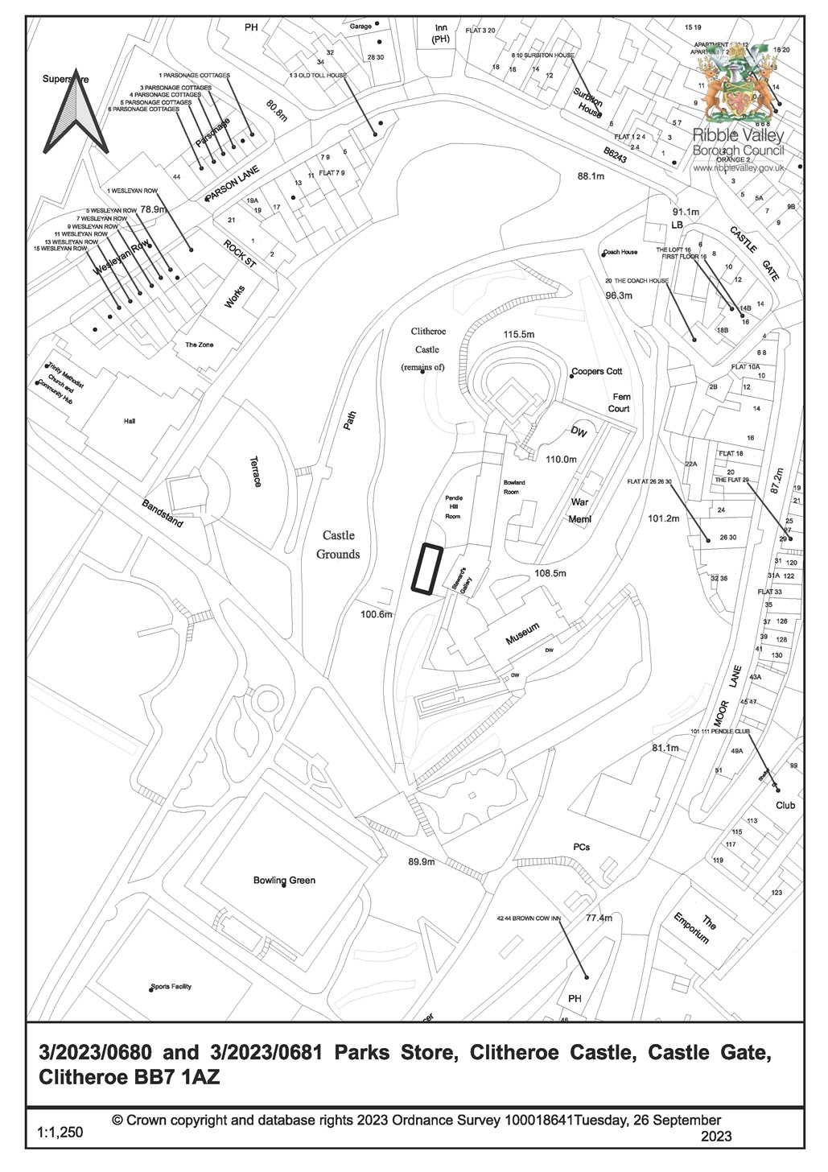

**CONSULTEE RESPONSES/ REPRESENTATIONS MADE:**

**TOWN COUNCIL:** None received**.**

**ADDITIONAL REPRESENTATIONS:** None received.

# 1. Site Description and Surrounding Area

1.1 This Listed Building Consent application is submitted by Ribble Valley Borough Council in relation to proposed works at the Council owned parks store building located at Clitheroe Castle.

1.2 The building is located to the rear of the Stewards Gallery at a lower land level than the main castle buildings, adjacent to the access track which leads to the rear of Castle Hill.

1.3 The building has been constructed into the sloping ground at this part of the castle grounds with a lower ground floor accessible from the lower end and the main entrance situated on the upper ground floor level.

# 2. Proposed Development for which consent is sought

1.4 The application proposes the replacement of the roof which currently consists of plain roof tiles and concrete ridge tiles. It is understood that the existing roof, which incorporates traditional purlins and rafters, was constructed in the lates 1950/ early 1960s following a fire.

1.5 The existing roof is showing signs of wear with numerous broken/ slipped tiles. Additionally, the roof trusses appear to be under strain.

1.6 The proposed development involves the complete removal of the roof to involve replacement prefabricated trussed rafters, Welsh blue slates for the roof covering and new cast iron rainwater goods.

3.  **Relevant Planning History**

None

# 4. Relevant Policies

Planning (Listed Buildings and Conservation Areas) Act 1990.

Clitheroe Conservation Area Appraisal

Ribble Valley Core Strategy:

Key Statement EN5– Heritage Assets

Policy DMG1– General Considerations

Policy DME3: Site and Species Protection And Conservation

Policy DME4– Protecting Heritage Assets

NPPF

NPPG

# 5. Assessment of Proposed Development

5.1 Impact upon the special architectural and historic interest of the listed building, the setting of listed buildings, the character and appearance of Clitheroe Conservation Area, the setting of the scheduled monument and the character of the historic park and garden

5.1.1 The building is not listed individually although it is treated as listed due to its location within the curtilage of Clitheroe Castle. The building is identified as a building of townscape merit with the Clitheroe Conservation Area Appraisal.

5.1.2 The proposed works appear to be necessary to ensure the proper preservation of the building, its continued use and to ensure the continued effectiveness of the roof covering.

5.1.3 Section 16 of the Planning (Listed Buildings and Conservation Areas) Act 1990 requires that in considering whether to grant listed building consent for any works the local planning authority or the Secretary of State shall have special regard to the desirability of preserving the building or its setting or any features of special architectural or historic interest which it possesses.

5.1.4 Section 66 of the Planning (Listed Buildings and Conservation Areas) Act 1990 requires that in considering whether to grant planning permission or permission in principle for development which affects a listed building or its setting, the local planning authority or, as the case may be, the Secretary of State shall have special regard to the desirability of preserving the building or its setting or any features of special architectural or historic interest which it possesses.

5.1.5 Section 72 of the Planning (Listed Buildings and Conservation Areas) Act 1990 requires that in the exercise, with respect to any buildings or other land in a conservation area, of any functions under or by virtue of the planning acts, special attention shall be paid to the desirability of preserving or enhancing the character or appearance of that area.

5.1.6 NPPF paragraph 199 requires that when considering the impact of a proposed development on the significance of a designated heritage asset, great weight should be given to the asset’s conservation (and the more important the asset, the greater the weight should be). This is irrespective of whether any potential harm amounts to substantial harm, total loss or less than substantial harm to its significance.

5.1.7 Ribble Valley Core Strategy Policy DME4 states that in considering development proposals the council will make a presumption in favour of the conservation and enhancement of heritage assets and their settings. Alterations or extensions to listed buildings or buildings of local heritage interest, or development proposals on sites within their setting which cause harm to the significance of the heritage asset will not be supported. Proposals within, or affecting views into and out of, or affecting the setting of a conservation area will be required to conserve and where appropriate enhance its character and appearance and those elements which contribute towards its significance. This should include considerations as to whether it conserves and enhances the special architectural and historic character of the area as set out in the relevant conservation area appraisal. Development which makes a positive contribution and conserves and enhances the character, appearance and significance of the area in terms of its location,

scale, size, design and materials and existing buildings, structures, trees and open spaces will be supported.

5.1.8 Ribble Valley Core Strategy Policy DMG1 states that in determining planning applications, all development must:

Design:

* be of a high standard of building design which considers the 8 Building in Context Principles (from the CABE/English Heritage Building on Context

Toolkit.

* be sympathetic to existing and proposed land uses in terms of its size, intensity and nature as well as scale, massing, style, features and building materials.

Environment:

* protect and enhance heritage assets and their settings.

5.1.9 The proposed works will not harm the historic fabric. It is understood that the existing roof covering and structure, featuring traditional purlins and rafters with intermediate trusses, were installed as replacements following a fire in the late 1950s or early 1960s. This incident necessitated the reconstruction of the walls and the installation of the present roof structure and covering. The proposed prefabricated trussed rafters have been designed to accommodate the load requirements of the original specification, which will be Welsh Blue slates to ensure that this can be utilised as the preferred material for the new roof covering. This along with the installation of new cast iron rainwater goods is considered to be more in keeping with the heritage asset.

5.1.10 The works will not be incongruous or conspicuous or harm the special architectural and historic interest of the building, the setting of listed buildings, the character and appearance of Clitheroe Conservation Area, the setting of the scheduled monument or the character of the historic park and garden.

# 6. Observations/Consideration of Matters Raised/Conclusion

6.1 Taking into account the above considerations it is recommended that the application is approved, subject to the following conditions.

**RECOMMENDATION:** That planning permission be APPROVED subject to the following conditions:

1. The proposed development must be begun not later than three years from the date of this permission.

REASON: Required to be imposed by Section 18 of the Planning (Listed Buildings and Conservation Areas) Act 1990.

1. The development hereby permitted shall be carried out in accordance with the following approved plans and documents:

Park Store Location Plan

Park Store Proposed Plan

REASON: To define the permission and in the interests of the proper development of the site

1. The external facing materials, detailed on the submitted application form, namely natural Welsh Blue Slate, shall be used and no others substituted.

REASON: To ensure that the materials used are visually appropriate to the locality.

1. Before the commencement of any works, full details of the proposed rainwater goods, including the eaves detail, to be used on the building shall have been submitted to and been approved in writing by the Local Planning Authority. All works undertaken on site should be strictly in accordance with the approved details.

REASON: In the interests of the character and appearance of the building

BACKGROUND PAPERS

[Planning Application - Ribble Valley Borough Council](https://webportal.ribblevalley.gov.uk/planningApplication/35698)

This page is intentionally left blank