RECOMMENDATION FOR PLANNING AND DEVELOPMENT COMMITTEE

**APPROVAL**

**DATE: 7 December 2023**

**REF: WH**

**CHECKED BY: LH**

**APPLICATION REF: 3/2023/0707**

GRID REF: SD 364160 431150

**DEVELOPMENT DESCRIPTION:**

APPLICATION TO REGULARISE MIXED BUILDING USE PERMITTING RETAIL WITH

ASSOCIATED BAR SERVING ALCOHOL, AND OCCUPATIONAL DWELLING (SUI GENERIS) AT 1 LOWER LANE, LONGRIDGE PR3 3SL

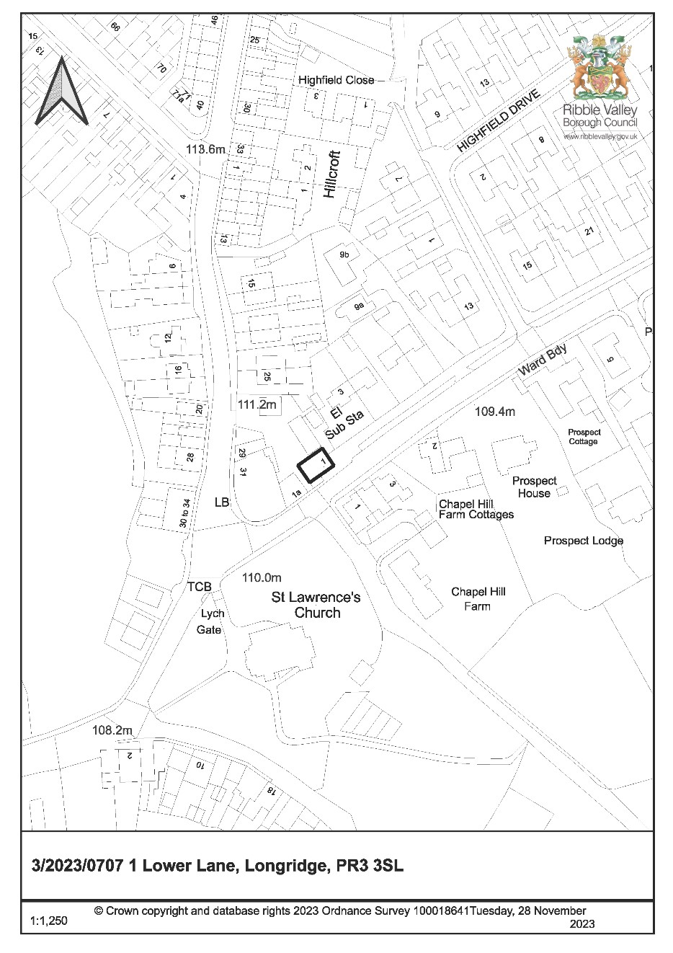

**CONSULTEE RESPONSES/ REPRESENTATIONS MADE:**

**TOWN COUNCIL:**

No representations received in respect of the application.

**LANCASHIRE COUNTY COUNCIL HIGHWAYS:**

The Highways Development Control Section have offered the following observations:

Lancashire County Council acting as the Highway Authority does not raise an objection regarding the proposed development, subject to the matter of the events being controlled, and are of the opinion that the proposed development will not have a significant impact on highway safety, capacity or amenity in the immediate vicinity of the site.

**ADDITIONAL REPRESENTATIONS:**

136 letters of representation have been received in support of the application, raising the following material considerations:

* Shop/bar is an asset to the local community and provides an important local meeting place
* There are no adverse impacts on the amenity or quality of life of adjacent residents • There is no unacceptable impact on the local highways network
* The property always abides to its opening and closing times.

13 letters of representation have been received objecting to the application, raising the following material considerations:

* Primary activity is a bar, and not that of a retail store and interior design service
* Noise and music results in unacceptable impact on amenity and quality of life of adjacent residents
* Originally submitted acoustic report contains a number of factual errors
* ‘Flexible arrangement’ with regard to opening hours
* Required information not submitted with application
* Lack of parking results in inappropriate on-street parking, and subsequently an adverse impact on the local highways network.

Members will additionally note that the correspondence has been received from Nigel Evans MP. The correspondence reads as follows and was forwarded along with an objection from a local resident:

‘*I am writing on behalf of a number of my constituents, whom are residents of Lower Lane. My constituents have contacted me with regards to a planning application by DMD Designs in Longridge. An example of this correspondence is attached below for your perusal.*

*In light of the issues raised I would greatly appreciate if these concerns could be taken into consideration during the decision making process’.*

The Council do not consider the above to represent a letter of objection but rather a request that material considerations raised by members of the public as part of the consultation process are taken into account within the decision-making process.

# Site Description and Surrounding Area

1.1 The application relates to a detached property at 1 Lower Lane, Longridge. The property presently has consent as a ‘live-work’ unit with the ground floor permitted as an interior design shop/service and living accommodation permitted to the first floor, located within the roof-space.

1.2 The site sits within the settlement boundary of Longridge and is accessed immediately off Lower Lane. There is no off-street car parking associated with the property, and whilst the predominate nature of the area is residential it is noted there are a number of other uses immediately present – most notably an accountants and funeral directors. St Lawrence’s Church also sits south of the site.

# Proposed Development for which consent is sought

2.1 The application seeks to change the use of the building so that it is Sui Generis mixed use comprising of retail and interior design service with bar serving alcohol at ground floor, and occupational dwelling at first floor. This would effectively regularise a use that had been operating in this manner since approximately Spring 2021 until August 2023 when a temporary stop notice was served. It is noted that no external alterations are proposed.

# Relevant Planning History

3/2022/0795:Variation of condition 4 of planning permission 3/2019/1131 to a mixed use premises – Withdrawn

3/2019/1131:Change of use of retail premises to live/work unit with residential facility for one person – Approved with Conditions

# Relevant Policies

**Ribble Valley Core Strategy**

Key Statement DS1 – Development Strategy Key Statement DS2 – Sustainable Development

Key Statement DMI2 – Transport Considerations

Key Statement EC1 – Business and Employment Development

Key Statement EC2 – Development of Retail, Shops and Community Facilities and Services

Policy DMG1 – General Considerations

Policy DMG2 – Strategic Considerations

Policy DMG3 – Transport & Mobility

Policy DME4 – Protecting Heritage Assets

Policy DMB1 – Supporting Business Growth and the Local Economy

Policy DMR2 – Shopping in Longridge and Whalley

National Planning Policy Framework (NPPF)

National Planning Practice Guidance (NPPG)

Longridge Neighbourhood Plan

Technical Guidance to National Planning Policy Framework

# Assessment of Proposed Development

5.1 Principle of Development:

5.1.1 The site lies within the settlement boundary of Longridge and is proposing a Sui Generis mixed-use property incorporating retail and interior design services as well as a bar on the shop floor for the sale and consumption of drinks on the premises. As such the proposal is required to be compliant with Policies DMB1 and DMR2 of the Core Strategy (CS). There is no change to the previously permitted first floor living accommodation unit which is occupied by the owner of the business who works at the premises as such this element does not require further consideration.

5.1.2 CS Policy DMB1 states that *proposals that are intended to support business growth and the local economy will be supported in principle. Development proposals will be determined in accordance with the Core Strategy and detailed policies of the LDF as appropriate.*

5.1.3 The proposal seeks to expand an existing (permitted) retail use and interior design facility with a bar. The supporting Planning Statement explains that the business is based on the ‘dual or complementary uses of product sales and sales of beverages from the bar… the proposal does not seek to establish a typical ‘drinking establishment’…the bar is very much integrated into the shop floor where the interior design items are displayed and sold. The bar is only open when the shop is open, since they share the same entrance and premises…the bar also serves as an informal meeting place for members of the local community, providing social benefits for the people that live nearby’. In this sense, the proposal is considered compliant with the above policy, as it would sustain and support the growth of an existing business, and subsequently the local economy.

5.1.4 CS Policy DMR2 states that *proposals for new small scale shopping developments including existing facilities will be approved on sites which are physically closely related to existing shopping facilities. All proposed shopping developments will be subject to other relevant policies in the plan and the Borough Council will have particular regard to the effect of the proposals on the character and amenities of the centre and the consequences in respect of vehicular movement and parking.*

5.1.5 The small-scale retail aspect is already permitted and was considered in a previous application to satisfy Policy DMR2. The retail sales area has been reduced to accommodate the bar, however remains accessible and available for customers to utilise. The proposal would continue to satisfy this policy.

5.1.6 It is noted that some of the objections refer to non-compliance with the Longridge Neighbourhood Plan – specifically Policy LNDP10 which states that within Longridge main centre a number of development for town centre uses will be supported including drinking establishments. However this policy does not preclude the provision of drinking establishments in areas outside of the main centre, as such there is no conflict.

5.1.7 Furthermore the provisions of the NPPF (paragraph 87) are a consideration, in which it is stated that *local planning authorities should apply a sequential test to planning applications for main town centre uses which are neither in an existing centre nor in accordance with an up-to-date plan. Main town centre uses should be located in town centres, then in edge of centre locations; and only if suitable sites are not available (or expected to become available within a reasonable period) should out of centre sites be considered.*

5.1.8 A bar is considered a main town centre use, however there is no physical separation with the retail element and the business is based on these being dual or complementary uses. As such it would not be reasonable to apply a sequential test and there is no undue additional impact on the vitality of Longridge town centre as a result of the proposal.

5.1.9 Given the above the proposal is considered to be compliant with the relevant development plan policies and as such the principle of development is supported.

5.2 Impact upon Residential Amenity:

5.2.1 As per Core Strategy Policy DMG1, *development must:*

1. *Not adversely affect the amenities of the surrounding area.*
2. *Provide adequate day lighting and privacy distances.*
3. *Have regard to public safety and secured by design principles.*
4. *Consider air quality and mitigate adverse impacts where possible.*

5.2.2 In this sense, it is not considered there would be any impact on the residential amenity of adjacent neighbours by way of overlooking, appearing dominant or overbearing, overshadowing or loss of light as no external changes nor changes to the footprint are proposed.

5.2.3 However, it is necessary to assess whether the introduction of a bar element would result in an unacceptable impact on amenity and quality of life for adjacent residents by way of noise, both from noise inside the premises including the playing of live and amplified music, and from comings and goings as people leave the premises. Noise is also mentioned in the National Planning Policy Framework (NPPF), which requires planning decisions to mitigate and reduce to a minimum potential adverse impacts resulting from noise from new development – and avoid noise giving rise to significant adverse impacts on health and the quality of life.

5.2.4 For clarity, the closest residences are 1-3 Chapel Hill Farm Cottages (over the road approx. 15m), 1A Lower Lane (south adjacent to the premises) and 3 Lower Lane (north approx. 20m).

5.2.5 It is also pertinent to note that many of the objections raised noise issues as a material consideration with regard to the determination of this planning application, citing concerns with the noise levels experienced when the premises has been operating with the bar in particular when there have been private functions and music.

5.2.6 The proposed hours of use of the ground floor retail/interior design/bar are 08.00 – 20.00 Monday to Saturday and 08.00 – 17.00 on Sunday and Bank Holiday. These are the same hours as were permitted by the Council (Planning) for the retail and interior design use previously, and similar to those permitted by the Council (Licensing) for a premises licence for the supply of alcohol on the premises (10.00 – 20.00 Mon – Sat and 10.00 – 17.00 on Sunday and bank holiday).

5.2.7 The Planning Statement explains that the bar occasionally provides entertainment, usually in the form of one vocalist with an acoustic instrument. Entertainment is generated from inside the building with its double glazed windows and the building does not feature any windows that can be opened, and the front door – the access point for customers – is always closed except when customers enter or exit the building. The officer’s site visit confirmed that the property has no opening windows.

5.2.8 The applicant was invited to submit a Noise Impact Assessment in order to aid the Local Authority in assessing whether the noise impact is considered to be acceptable. Two assessments have been submitted and have been assessed internally by the Council’s Environmental Health department.

5.2.9 Environmental Health have considered the impact calculations in the assessment, and recalculated the figures by adjusting attenuation levels, and have advised that levels are considered low enough with the windows and doors shut, however to account for breakout noise when the door open for access and egress which will inevitably occur in a bar, conditions are recommended including the installation of a sound limiter device and door closing mechanism.

5.2.10 Upon assessment, your officers consider that the amenity impact on local residents by way of noise would be acceptable, subject to the imposition of numerous conditions which are outlined at the end of this report.

5.3 Highway Safety and Accessibility:

5.3.1 Following consultation with the LHA (LCC Highways), no objection was raised although they have recommended a restriction on the number of planned events/functions, as without a designated car parking area the concern is that customers would park on Lower Lane close to the junctions of Chapel Hill, Highfield Drive and adjacent the private driveways. This has been reflected in the drafted conditions outlined at the end of this report.

5.4 Heritage:

5.4.1 As the application offers no external alterations, it is not necessary to assess on points of design nor on points of the impact on the historic environment, although Officers note that the site does sit within the St Lawrences Church Conservation Area and within close proximity to said church.

# Observations/Consideration of Matters Raised/Conclusion

6.1 For the reasons outlined above the proposed development is considered to be compliant with the relevant Policies within the Core Strategy, the Longridge Neighbourhood Plan

and the NPPF, subject to conditions to ensure appropriate mitigation and controls are in place.

6.2 As such the proposal is recommended to be approved, subject to the following conditions.

RECOMMENDATION: That the application be APPROVED subject to the following conditions:

1. Unless explicitly required by condition within this consent, the development hereby permitted shall be carried out in complete accordance with the proposals as detailed on drawings:

Plans and Elevations Dwg no 3154 001

Location Plan produced 04-09-23 @ 1:1250

REASON: For the avoidance of doubt and to clarify which plans are relevant to the consent.

1. The residential accommodation hereby approved shall be restricted to occupation by one resident at any one time and who works on the premises.

REASON: In the interests of the amenities of the area and of the residential amenities of the occupier of the unit.

1. The bar hereby approved shall only be in use in conjunction with the display of retail products at ground floor and which are available to purchase whenever the bar is in use.

REASON: To clarify the scope of the permission and prevent the bar from becoming the sole use to ensure that the development remains compatible with the character of the area, to protect residential amenity and to protect the vitality of the town centre.

1. The use of the premises hereby approved shall be restricted to the following hours:-

Monday - Saturday, 08:00 to 20:00

Sunday/Bank Holiday, 08:00 to 17:00

REASON: To ensure that the development remains compatible with the character of the area and to minimise the risk of noise pollution that may cause nuisance and harm the amenity and/or health of occupiers of nearby buildings.

1. Live or amplified music or musical instruments shall not be played outside of the following hours:

Monday - Saturday, 16:00 to 20:00

Sunday/Bank Holiday, 14:00 to 17:00

No live or amplified music shall be played at any time in any external areas.

REASON: To minimise the risk of noise pollution that may cause nuisance and harm the amenity and/or health of occupiers of nearby buildings.

1. There shall be no more than 12 organised events (including private parties) in any one year, and no more than 4 organised events within any given 28-day period.

REASON: Reducing the frequency of organised event reduces the chance that a highway safety issue will arise as the premises does not offer any off-street car parking

1. Prior to the playing of any live or amplified music or musical instruments, the front door as identified on plan reference Plans and Elevations Dwg no 3154 001 shall be fitted with a door-closer / self-closing device, which is to be retained in perpetuity.

When live or amplified sound or musical instruments are being played the front door shall be kept closed except for access and egress of patrons.

REASON: To minimise the risk of noise pollution that may cause nuisance and harm the amenity and/or health of occupiers of nearby buildings.

1. Prior to the playing of any live or amplified music or musical instruments, details of a sound limiter device capable of controlling the level of sound emitted, shall be submitted to and approved in writing by the Local Planning Authority.

The details shall include specifications of the limiter device which demonstrate that noise levels generated from the sound system shall not exceed background noise level as agreed by the Local Authority at each of the following octave frequency bands a minimum: 63Hz, 125Hz, 250Hz, 500Hz, 1 KHz, 2 KHz, 4 KHz, and 8 KHz when measured at the nearest noise sensitive residential properties.

The limiter device shall be installed and set up in accordance with the approved specifications / noise levels prior to the playing of any live or amplified music or musical instruments, and shall thereafter be retained at the approved level.

Any live or amplified sound or musical instruments shall be routed through the limiter at all times in accordance with the approved specifications / noise levels. There shall be no live music or musical instruments on the premises which can by-pass the noise limiter.

REASON: To minimise the risk of noise pollution that may cause nuisance and harm the amenity and/or health of occupiers of nearby buildings.

1. Notwithstanding the provisions of the Town and Country Planning (General Permitted Development) Order 2015 (or any Order revoking or re-enacting that Order, with or without modification), no new windows/dormer windows/rooflights shall be inserted or constructed at any time in any elevation of the building without express planning permission first being obtained.

REASON: To ensure any replacement windows are appropriate to minimise the risk of noise pollution that may cause nuisance and harm the amenity and/or health of occupiers of nearby buildings.

1. There shall not be any filling or emptying of bottle bins between the hours of 20:00 and 09:00 on any day.

REASON: To minimise the risk of noise pollution that may cause nuisance and harm the amenity and/or health of occupiers of nearby buildings.

BACKGROUND PAPERS

[https://webportal.ribblevalley.gov.uk/site/scripts/planx_details.php?appNumber=3%2F2023%2F 0707](https://webportal.ribblevalley.gov.uk/site/scripts/planx_details.php?appNumber=3%2F2023%2F0707)