

TREE WORK ASSESSMENT

DATE INSPECTED: |  |  |  |  |  |  |  | 18/10/2023
TPO: | 135 – 1994 Old Print Works, Barrow
CONSERVATION AREA: |  |  |  |  | No
APPLICATION NO: |  |  |  | 3/2023/0714
SPECIES: |  | Ash
BS5837 CAT: |  |  | U |  |  | ASSESSOR: |  |  | A Shutt
 |  |  |  |  |  | SIGNATURE: |  |  | LH
VISUAL TREE ASSESSMENT / COMMENTS

Large, mature (borderline veteran) Ash tree protected and retained as part of the Barrow Brook development. Unfortunately, the tree has succumbed to ash dieback (Hymenoscyphus fraxineus) and has lost more than 30% of its crown. This has affected the amenity value and will eventually kill the tree leading to unpredictable shedding of branches.

The tree is situated in a high target area compromising cul-de-sac, houses, woodland walk and green exercise equipment, frequently populated by children (den building) and other members of the public.

This is a significant loss in amenity value for the local treescape but by retaining the stem and conditioning replacement planting the loss will be mitigated as much as possible.
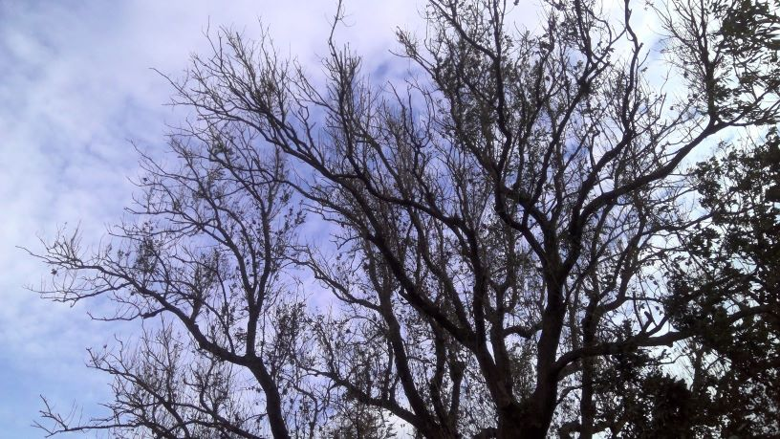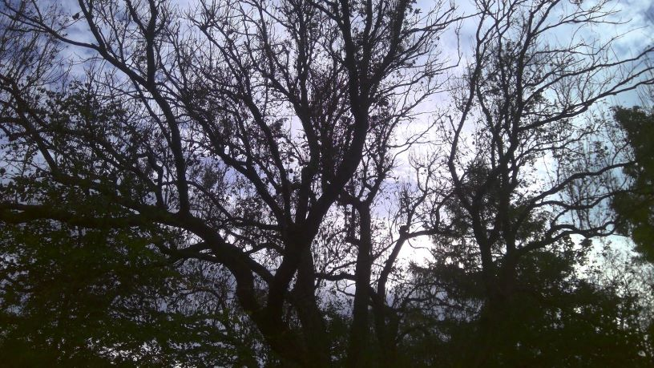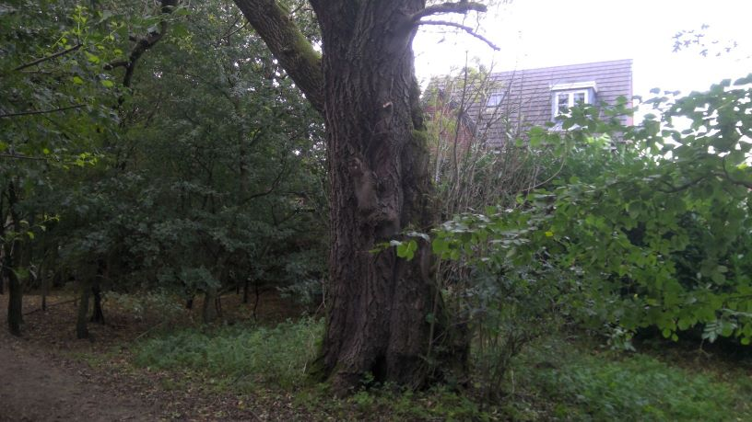

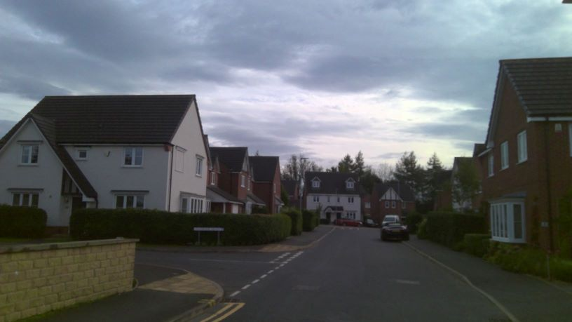

RELATED ISSUES: | YES |  | NO |  |  |  |  | YES | NO
Planning Application |  |  |  |  | Highway issue |  |  |  | 
Statutory Undertaker |  |  |  |  | Damage to property (proven) |  |  |  | 
Health & safety issues |  |  |  |  | Nuisance |  |  |  | 
Other (describe)* |  |  | 
AMENITY EVALUATION: |  | YES |  | NO
Carried out |  | N/A |  | N/A
Necessary |  | N/A |  | N/A

Application works appropriate? | YES 
Why?

T169 has succumbed to ash dieback and requires removal to a monolith stem to minimise probability of failure and allow the tree to be safely dismantled prior to the branches becoming too brittle.

By monolithing T169, the large tree stump will become a natural sculpture/habitat pole and enhance biodiversity in the area. Replacement planting within the woodland will also be conditioned.
Alternative works more appropriate? | NO 
Describe Alternative Works:

