RECOMMENDATION FOR PLANNING AND DEVELOPMENT COMMITTEE

APPROVAL

DATE: 11 January 2024
REF: LW
CHECKED BY: LH

APPLICATION REF: 3/2023/0801

GRID REF: SD 359714 436150

DEVELOPMENT DESCRIPTION:

PROPOSED STORAGE CONTAINER ADJACENT TO MARDALE PAVILION. CAR PARK MARDALE ROAD, LONGRIDGE, PR3 3EU
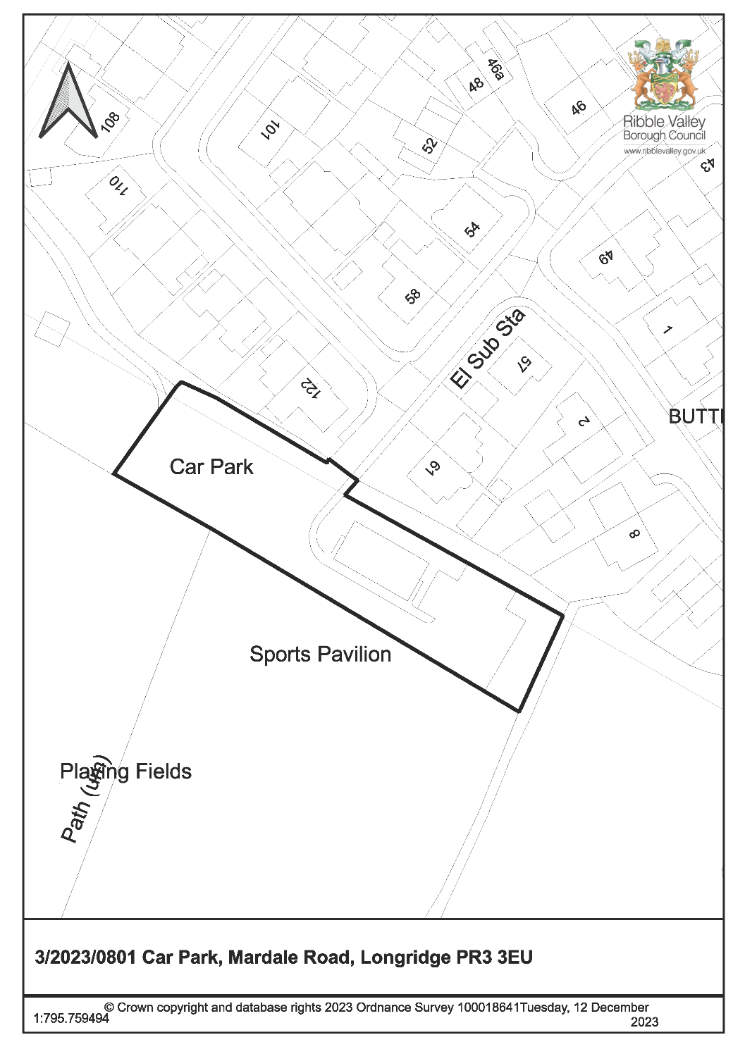

CONSULTEE RESPONSES/ REPRESENTATIONS MADE:

PARISH COUNCIL:

Longridge Town Council were consulted on 8th November 2023; however, no comments have been received in respect of the proposal.

ADDITIONAL REPRESENTATIONS:

No representations received.

1. Site Description and Surrounding Area

1.1 The application relates the Mardale Road Car Park situated adjacent the Mardale Sports Pavilion at the southern end of Mardale Road. The site is located on land designated as open countryside, just beyond the defined settlement limits of Longridge which terminates immediately to the north of the site. The surrounding area to the north and east of the application site comprises largely of residential properties, whilst to the south is an area of public open space consisting of a playing field and grass football pitches.

2. Proposed Development for which Consent is Sought

2.1 The application seeks planning consent for the erection of a metal storage container adjacent to the Pavilion to be used by Longridge Juniors Football Club to store kit and equipment.

3. Relevant Planning History

3/2022/1164: Proposed two single storey extensions situated on the side elevations of the existing changing pavilion (Approved).

3/1998/0350: Construction of Changing Rooms (Approved)

3/1995/0240: Extension to existing car park (Approved)

4. Relevant Policies

Ribble Valley Core Strategy (Adopted Version)
Key Statement DS1 – Development Strategy
Key Statement DS2 – Presumption in Favour of Sustainable Development

Policy DMG1 – General Considerations
Policy DMG2 – Strategic Considerations
Policy DMB3 – Recreation and Tourism Development
Policy DMB4 – Open Space Provision

Longridge Neighbourhood Development Plan
Policy LNDP12 – Protecting and Enhancing Local Green Spaces
Policy LNDP13 – Protecting and Enhancing Local Open Spaces

National Planning Policy Framework (NPPF)

National Planning Practice Guide (NPPG)

5. Assessment of Proposed Development

5.1 Principle:

5.1.1 Policy DMG2 of the Core Strategy states that within Tier 2 villages and outside the defined settlement areas development must meet at least one of the following considerations:

- The development should be essential to the local economy or social wellbeing of the area;
- The development is needed for the purposes of forestry or agriculture;
- The development is for local needs housing which meets and identified need and is secured as such;
- The development is for small scale tourism or recreational developments appropriate to a rural area;
- The development is for small scale uses appropriate to a rural area where a local need or benefit can be demonstrated;
- The development is compatible with the enterprise zone designation.

5.1.2 The proposed development is considered to comply with criterion no.4 of the above policy in as much that the proposed storage container would be modest in terms of size and scale and would be for recreational purposes associated with the Pavilion and playing field.

5.1.3 The proposed storage container would not result in the loss of any playing field land nor impact on its use, being sited on an area of grass situated between the existing hardstanding of the car park and the tree/hedge line, therefore protecting important recreational and sporting land. Moreover, the proposal is to provide enhanced storage to support the continued use of the sports pitches by Longridge Juniors Football Club. The development therefore satisfies Policy DMB4 of the Core Strategy, the Longridge Neighbourhood Plan and the NPPF and NPPG in respect of protecting open space and playing field provision.

5.2 Residential amenity:

5.2.1 A number of residential properties adjoin the northern boundary of the site with their rear elevations and gardens facing the existing Pavilion building and associated car park.

5.2.2 The proposed storage container would have a maximum height of 2.62m and would be sited approximately 10m from the common boundary with the neighbouring properties to the north. As such, there is not considered to be any potential for loss of light or overbearing impact upon any nearby residential receptors.

5.2.3 Furthermore, there is no proposal for the use of the site – including comings and goings – to intensify as the development relates solely to the provision of a storage building. It is therefore not anticipated that the proposed works would directly result in any additional noise or disturbance to neighbouring residents.

5.3 Visual amenity:
5.3.1 The proposed storage container would measure approximately 6.1m by 2.4m with a maximum height of 2.6m and would therefore appear modest in respect to their overall height and footprint when viewed in context with the site as a whole.

5.3.2 The precise colour of the proposed container is currently unknown and as such, it is recommended that a condition be attached to any subsequent approval requiring precise details/ specifications to be submitted to and approved in writing by the Local Planning Authority.

5.3.3 Furthermore, the development would not take a visually prominent position within the landscape, given its siting towards the south-eastern extent of the car park, between the existing hardstanding and tree/hedge line which marks the eastern boundary of the site. The proposal would also be visually screened by the existing Pavilion building upon entry into the site from Mardale Road.

5.3.4 There would also be no impact upon the nearby public footpath which runs across a portion of the car park, away from the existing Pavilion.

5.3.5 In addition, the site is not situated on land designated as an Area of Outstanding Natural Beauty (AONB) or Conservation Area and so is not subject to any special landscape or heritage protection.

5.3.6 Accordingly, the visual impact of the works proposed is considered to be acceptable to allow Longridge Juniors Football Club to improve its facilities in accordance with Policies DMG1, DMG2, and DMB3 of the Core Strategy.

5.4 Ecology:
5.4.1 The proposed structure would be sited within close proximity to the existing tree/hedge line which marks the eastern boundary of the site. However, the proposal comprises a storage container and would not involve any digging or excavation works that would impact the current surface of the site. It is therefore not anticipated that the proposal would result in any undue impact upon the ecological importance of the site.

5.5 Highways:

5.5.1 Lancashire County Council Highways have not been consulted in relation to the proposal, however the development would not involve a change of use or intensification of the use of the site, nor would it result in the loss of any parking spaces. As such, it is not anticipated that the proposal would result in any inacceptable impact upon highway safety or parking.

6 Observations/Consideration of Matters Raised/Conclusion:

6.1 The proposal would not result any undue impact upon the amenity of any neighbouring residents, nor is it considered that the proposal would be harmful to the visual amenities of the surrounding area, ecology, or highway safety.

6.2 As such, for the above reasons and having regard to all material considerations and matters raised, the application is recommended for approval.

RECOMMENDATION:

That planning permission be APPROVED subject to the following conditions:

Time Scale for Implementation of Consent
1. The development must be begun not later than the expiration of three years beginning with the date of this permission.

Reason: Required to be imposed by Section 51 of the Planning and Compulsory Purchase Act 2004.

Approved Plans and Documents

2. Unless explicitly required by condition within this consent, the development hereby permitted shall be carried out in complete accordance with the proposals as detailed on drawings:

Location Plan (1:1250)
Proposed Development (1:500)
Proposed Development (1:200)
Proposed Elevations (1:50)

Reason: For the avoidance of doubt and to clarify which plans are relevant to the consent.

Materials
3. Notwithstanding the submitted details, details of all materials to be used on the external surfaces of the development hereby approved shall have been submitted to and approved in writing by the Local Planning Authority before their use in the proposed development. The approved materials shall be implemented within the development in strict accordance with the approved details.

Reason: In order that the Local Planning Authority may ensure that the materials to be used are appropriate to the locality and respond positively to the inherent character of the area.

BACKGROUND PAPERS

https://webportal.ribblevalley.gov.uk/planningApplication/35816

