RECOMMENDATION FOR PLANNING AND DEVELOPMENT COMMITTEE

REFUSAL

DATE: 11 JANUARY 2024
REF: WH
CHECKED BY: LH

APPLICATION REF: 3/2023/0833

GRID REF: SD 372802 437458

DEVELOPMENT DESCRIPTION:

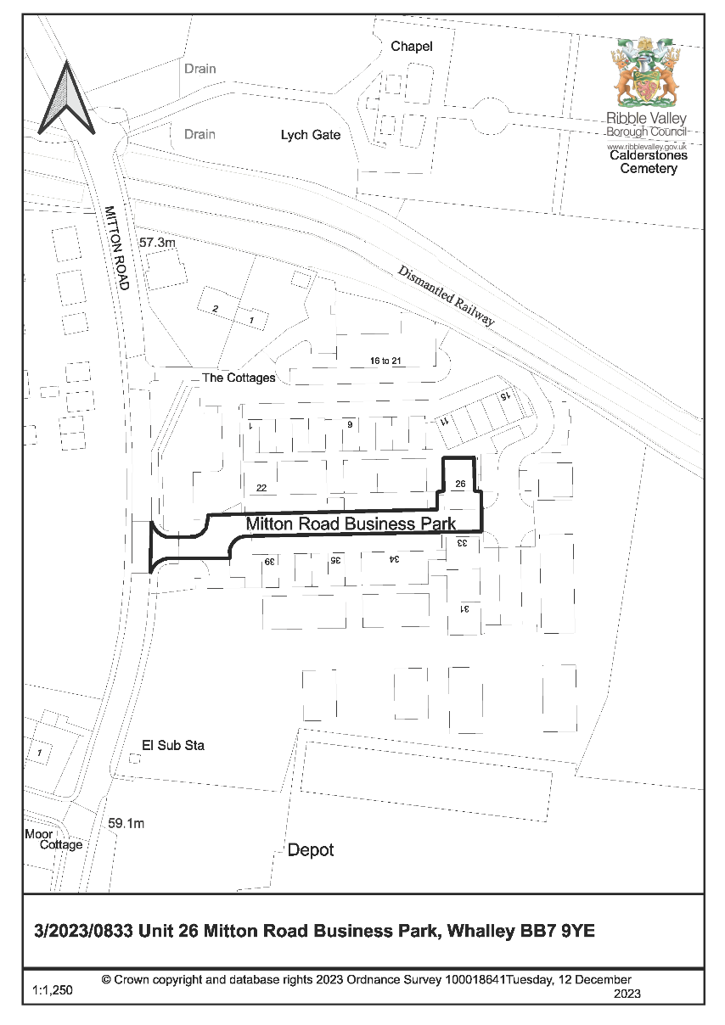
APPLICATION FOR CHANGE OF USE OF PART OF CLASS B2/B8 UNIT (GENERAL INDUSTRY/STORAGE) TO SUI GENERIS MIXED USE (RETAIL, WAREHOUSE, PHOTO STUDIO, SORTING/OFFICE). RESUBMISSION OF APPLICATION 3/2023/0541. UNIT 26 MITTON ROAD BUSINESS PARK WHALLEY BB7 9YE
CONSULTEE RESPONSES/ REPRESENTATIONS MADE:

WHALLEY PARISH COUNCIL:

The Parish Council object and remain concerned over businesses on the Mitton Road Business Park changing status from industrial to retail and the potential for traffic generation which was never intended when the business park commenced. Whilst the proposals appear to be reduced from the previous application this remains a 7 day per week business and thus would inevitably see a significant increase in traffic. Mitton Road is already heavily trafficked. The applicant refers to similarities with a number of other businesses but the Parish Council challenges this assertion since the business named are generally in established retail outlets in centre locations.

LOCAL HIGHWAYS AUTHORITY (LANCASHIRE COUNTY COUNCIL HIGHWAYS):

No objection, subject to the imposition of conditions relating to:

- The implementation of parking and turning facilities according to plan.
- The development shall only operate by appointments only and shall be restricted to one appointment on site at any one time.
- The retail use approved shall only be used ancillary to the existing commercial unit at the site and shall not be used by way of sale or sub-letting to form separate commercial enterprises.

ADDITIONAL REPRESENTATIONS:

No letters of representation have been received.

The application was subject to a call-in request from Cllr Wilkins-Odudu.

1. Site Description and Surrounding Area

1.1 The site is comprised of Unit 26 at Mitton Road Business Park, used until recently as a B2/B8 (general industry / storage) unit and now occupied by Old Coach House Antiques for the storage, display and retail sale of furniture, household goods and antiques (the use applied for in this application). The unit is located directly off the main spine road within the business park and incorporates 2no. entrances to the front elevation – 1 being a vehicular/loading access and the other being a pedestrian access. In front of the unit lies an area of hardstanding suitable for car parking.

1.2 Mitton Road Business Park sits adjacent to an area of predominately housing referred to as Nethertown and approximately 1.1km north/north-west of Whalley.

2. Proposed Development for which consent is sought

2.1 Whilst no external changes are proposed, the application seeks to change the use of the unit so that it can accommodate a retail area (26sqm) and a ‘photo’ area (approximately 35sqm) on half of the ground floor, with the other half of the ground floor being retained as industrial/warehouse space (99sqm). The mezzanine floor would comprise of industrial/warehouse space (60sqm) to include the sorting of goods and an office.

2.2 The proposed hours are Monday-Friday 8am to 6pm, Saturdays 9am to 4:30pm and Sundays and Bank Holidays 10am to 4pm. The application is a resubmission of previously refused application reference 3/2023/0541.

2.3 It should be noted that officers are aware that, at present, the use of the areas labelled ‘retail area’, ‘photo area’ as well as approximately half of the space of the ‘industrial/warehouse space’ on the ground floor are being used for the retail sale of goods. Whilst the plans submitted with this application does not reflect the above use, given the open plan layout of the unit it would be difficult to ensure that retail sale activities did not stray into other areas.

3. Relevant Planning History

3/2023/0541:
Application for change of use of class B2/B8 unit (general industry/storage) to Sui Generis Mixed Use (retail, warehouse, photo studio, sorting/office). Proposed opening hours Monday - Friday 8.00am - 6.00pm, Saturdays 9.00am to 4.30pm, Sundays and Bank Holidays 10.00am to 4.00pm (Refused)

4. Relevant Policies

Ribble Valley Core Strategy:

Key Statement DS1: Development Strategy
Key Statement DS2: Sustainable Development
Key Statement EC1: Business and Employment Development
Key Statement EC2: Development of Retail, Shops and Community Facilities

Policy DMG1: General Considerations
Policy DMG2: Strategic Considerations
Policy DMG3: Transport & Mobility
Policy DMB1: Supporting Business Growth and the Local Economy
Policy DMR1: Retail Development in Clitheroe
Policy DMR2: Shopping in Longridge & Whalley

National Planning Policy Framework (NPPF)

5. Assessment of Proposed Development

5.1 Principle of Development:

5.1.1 The wider site at Mitton Road Business Park is allocated within the Local Plan as a committed employment site, with the existing units being granted planning permission for B1 (now Class E(g)), B2 and B8 employment generating uses.

5.1.2 The submitted details propose a Sui Generis use which would deviate from that of the originally consented use because it would allow for retail functions to occur at the premises online and from visiting members of the public.

5.1.3 As per CS Policy DMB1, proposals for the development, redevelopment or conversion of sites with employment generating potential in the plan area for alternative uses will be assessed with regard to the following criteria:

1. The provisions of policy DMG1, and
2. The compatibility of the proposal with other plan policies of the LDF, and
3. The environmental benefits to be gained by the community, and
4. The economic and social impact caused by loss of employment opportunities to the Borough, and
5. Any attempts that have been made to secure an alternative employment generating use for the site (must be supported by evidence (such as property agents details including periods of marketing and response) that the property/ business has been marketed for business use for a minimum period of six months or information that demonstrates to the council’s satisfaction that the current use is not viable for employment purposes.)

5.1.4 It is acknowledged that the plans, compared to the previously refused application, reduce the area of floorspace titled “retail” to approximately a quarter of the ground floor unit only. However, the area titled “photo area” also effectively serves as a retail function and as previously indicated the open plan layout means it is difficult to distinguish between the different areas at ground floor meaning that effectively a larger portion of the building, particularly at ground floor, would essentially be for retail use.

5.1.5 It is understood that the unit would be open for members of the public to visit anytime during opening hours either to pick up goods they have seen and bought online or to come into the shop to browse or buy. The supporting information and photographs supplied including the business flyers that were distributed to local residents recently suggest that retail is the primary activity, and this is not a compatible use within the business park. It also prevents the unit being let for employment generating uses that require a business park location e.g. due to noise, odour, away from passing trade.

5.1.6 Policy DMB1 considers material considerations which might exist to justify the loss of employment generating uses. However, there are no identified environmental benefits gained by the community, and the economic impact of losing this unit for its intended employment purpose is considered more harmful than the benefits of allowing this business to operate here. It is understood that the unit was not vacant for a significant period of time before the new use began to operate and so there is no evidence that no demand exists for a Class B1(g), B2 or B8 use or that the unit is not viable for such uses.

5.1.7 There is some sympathy with the applicant who feels this location is better suited to their business needs due to size, space to unload furniture and parking availability, and it was these things that their previous premises did not have which prompted them to move. However, whilst that particular location was unsuitable that does not mean all town centre locations are unsuitable, or that premises with unrestrictive uses outside of town centres could not be utilised by the applicant. Many retail operators particularly in town centres experience similar challenges. Nor does it justify the loss of an employment unit for alternative purposes.

5.1.8 There are no specific merits of this particular case that justify allowing this activity on the site, and indeed allowing this retail activity outside of a town centre, or even edge of centre, which Policies DMR1 and DMR2 aim to achieve. The overall function of the unit is considered to be in conflict with the ambitions of the business park.

5.1.9 Therefore it is considered that the principle of the use of the building for this purpose would result in a significant direct conflict with the adopted development plan for the borough and is not acceptable in principle.

5.2 Impact on Residential Amenity

5.2.1 Due to the location of the unit within the business park away from neighbouring residential properties there are no concerns in this regard.

5.3 Highways and Parking

5.3.1 Following consultation with LCC Highways, no objection was raised subject to the imposition of a number of conditions as below:

- The implementation of parking and turning facilities according to plan.
- The development shall only operate by appointments only and shall be restricted to one appointment on site at any one time.
- The retail use approved shall only be used ancillary to the existing commercial unit at the site and shall not be used by way of sale or sub-letting to form separate commercial enterprises.

5.3.2 An updated Proposed Site Plan has been provided which shows that the unit forecourt can provide 5 car parking spaces (the forecourt is currently not marked out). However, based on the actual area of forecourt available and considering that it is likely for these spaces to be taken up by larger vehicles or by vehicles needing manoeuvring space for furniture, the amount of space available is considered to realistically accommodate four vehicles. This is a shortfall in spaces when applying the LHAs parking guidance as defined within the Joint Lancashire Structure Plan, and on this basis LCC Highways are requesting a condition limiting customers by appointment only.

5.3.3 LCC Highways are also requesting a condition limiting the retail use to ancillary only. However as previously stated in this report, it is considered that retail is the primary activity. Whilst theoretically both aspects (appointment only and ancillary retail use) could be conditioned, having regard to the nature of the business it is considered that neither condition would be appropriate or suitable to impose.

5.3.4 However, even without limiting these activities, having regard to the parking available to the front of the unit and the presence of other spaces nearby within the business park, it is not considered that the proposed use would result in overriding highway safety concerns sufficient to justify a refusal of the application on this basis, and the development is not considered to be in conflict with Policy DMG3 of the Ribble Valley Core Strategy.

6. Observations/Consideration of Matters Raised/Conclusion

6.1 For the reasons outlined above the proposed development is considered to be in direct conflict with Policies DMB1, DMR1 and DMR2 of the Ribble Valley Core Strategy insofar that approval would result in the loss of an employment generating uses within a defined employment site through the introduction of a use which is considered to be primarily retail. There are no material considerations in this case to justify the harm resulting from a loss of employment use or allowing a retail use in an out-of-centre location.

RECOMMENDATION: That the application be REFUSED for the following reason(s):

- The proposal would result in the loss of an employment generating uses within a defined employment site through the introduction of a use which is primarily retail. There are no material considerations in this case to justify the harm resulting from a loss of employment use or allowing a retail use in an out-of-centre location. As such the application fails to satisfy Ribble Valley Core Strategy Policies DMB1, DMR1 and DMR2.

BACKGROUND PAPERS

https://webportal.ribblevalley.gov.uk/site/scripts/planx_details.php?appNumber=3%2F2023%2F0833

