RECOMMENDATION FOR PLANNING AND DEVELOPMENT COMMITTEE
REFUSAL

DATE: 8 FEBRUARY 2024
REF: BT
CHECKED BY: LH

APPLICATION REF: 3/2023/1004

GRID REF: SD 373563 444056

DEVELOPMENT DESCRIPTION:

DEMOLITION OF EXISTING DWELLING. CONSTRUCTION OF REPLACEMENT TWOSTOREY DWELLING WITH ROOMS IN THE ROOFSPACE, SINGLE-STOREY ANNEX AND
RELOCATION OF SITE ACCESS. RESUBMISSION OF 3/2023/0759. THE HAWTHORNS, WEST BRADFORD ROAD, WADDINGTON. BB7 3JE
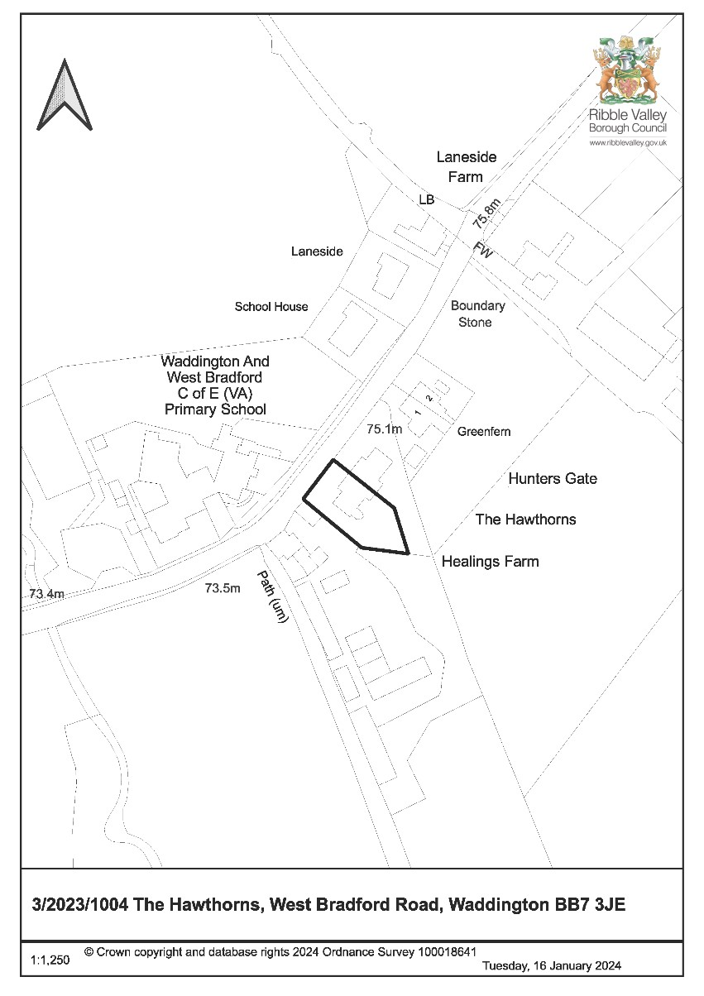
CONSULTEE RESPONSES/ REPRESENTATIONS MADE:

WADDINGTON PARISH COUNCIL:

Consulted 21/12/23 – no response received.

LANCASHIRE COUNTY COUNCIL HIGHWAYS:

No objections subject to conditions.

UNITED UTILITIES:

No objections subject to adherence with standing advice.

ADDITIONAL REPRESENTATIONS:

One representation received citing the drainage details as being incorrect and expressing concerns about foul water disposal from the proposed dwelling.

The application is before this Committee following a ward member request from Councillor S Cowman.

Site Description and Surrounding Area

1.1 The application relates to a link-detached property in Waddington. The property comprises a slated gabled roof, stone and rendered elevations and timber and UPVC windows. The North-eastern portion of the property comprises a single storey flat roof integral garage which adjoins to an identical integral garage feature serving the adjoining neighbouring property of Hunters Gate which largely bears the same physical appearance as the application property.

1.2 The front North-western elevation of the property faces into West Bradford Road with a front driveway providing off-street parking. The property comprises a sizeable rear garden area which extends South-eastwards towards open countryside. The application property sits amongst a small cluster of residential dwellings on the Eastern outskirts of Waddington with the wider area comprising a mixture of woodland, agricultural land and open countryside.

Proposed Development for which consent is sought

2.1 Consent is sought for the demolition and replacement of the application property with a new three storey four bedroom dwelling with integral single garage and detached annex. Additional works include the creation of two parking bays to the front of the proposed dwelling and associated landscaping works.

Relevant Planning History

3/2023/0759: Demolition of existing dwelling. Construction of replacement two-storey dwelling with rooms in the roofspace, single-storey annex and relocation of site access (Refused)

3/2023/0142: Demolition of existing dwelling. Creation of two new semi-detached dwellings with associated access, parking and garden areas (Refused)

Relevant Policies

Ribble Valley Core Strategy (Adopted Version)

Key Statement DS1: Development Strategy
Key Statement DS2: Sustainable Development Key Statement DMI2: Transport Considerations
Policy DMG1: General Considerations
Policy DMG2: Strategic Considerations
Policy DMG3: Transport & Mobility
Policy DME3: Site and Species Protection and Conservation
Policy DMH3: Dwellings in the Open Countryside and AONB
Policy DMB5: Footpaths and Bridleways

National Planning Policy Framework

National Planning Practice Guidance

Assessment of Proposed Development

5.1 Principle:

5.1.1 The application property is situated outside of the defined settlement of Waddington and as such lies within the open countryside. Policy DMH3 of the Core Strategy regards the rebuilding or replacement of existing dwellings within the open countryside as permissible provided that the residential use of the existing property has not been abandoned and that there are no adverse impacts to the surrounding landscape or requirements to extend an existing curtilage as a result of the development.

5.1.2 In this instance, the proposal involves the replacement of an existing dwelling of which the residential use has not been abandoned. In addition, it is not considered that there would be any adverse impacts upon the surrounding landscape and no extension of the site’s existing curtilage is proposed.

5.1.3 As such, the proposal satisfies the requirements of Policy DMH3 of the Core Strategy and is therefore considered to be acceptable in principle subject to an assessment of additional material planning considerations.

5.2 Residential amenity:

5.2.1 The North-eastern side elevation of the proposed dwelling would face towards the adjacent South-western side elevation of Hunters Gate however the North-eastern side elevation of the proposed dwelling would comprise a featureless gable and as such would not provide any new opportunities for overlooking towards the adjacent neighbouring property.

5.2.2 A sufficient separation distance would otherwise be in place between the Northeastern and South-western elevations of the proposed dwelling and Hunters Gate respectively so as to ensure no loss of outlook to the adjacent neighbouring property.

5.2.3 In addition, the proposed annex building would be sited well away from the adjacent neighbouring property and would solely provide views into the rear garden area of the application site.

5.2.4 The original conception of the proposal included a dormer and projecting balcony element to the rear of the proposed dwelling. It was conveyed to the applicant that this aspect of the proposal would not be supported due to the fact that the projecting balcony feature would likely compromise the privacy of the adjacent neighbouring property of Hunters Gate.

5.2.5 A revised scheme has since been agreed with the applicant with the previously proposed dormer and balcony component removed from the rear roof slope of the proposed dwelling.

5.2.6 Accordingly, it is not considered that the proposed development as shown on the revised plans would have any undue impacts upon neighbouring amenity.

5.3 Visual amenity:
5.3.1 Paragraph 135 (c) of the NPPF states:

‘Planning policies and decisions should ensure that developments are sympathetic to local character and history, including the surrounding built environment and landscape setting’.

5.3.2 In addition, Policy DMG1 of the Ribble Valley Core Strategy states:

‘All development must be sympathetic to existing and proposed land uses in terms of its size, intensity and nature as well as scale, massing and style…particular emphasis will be placed on visual appearance and the relationship to surroundings, including impact on landscape character.’

5.3.3 The proposed development would involve the demolition and replacement of the application property with a detached three storey dwelling. A detached annex building is also proposed for the rear garden area of the replacement dwelling.

5.3.4 A similar development was proposed under previous planning application 3/2023/0759 which was partially refused on the basis of cumulative visual impact arising from the collective scale, bulk and massing of the dwelling and annex building proposed.

5.3.5 Amendments have been made to the design of the development previously refused under application 3/2023/0759. These changes include a reduction to the height of the replacement dwelling previously proposed and the omission of previously proposed projecting front and rear gable features. The footprint of the previously proposed annex building proposed has also been reduced.
5.3.6 Notwithstanding these changes, the original conception of the current proposal retained a front porch feature previously proposed under application 3/2023/0759 which was deemed to exacerbate the bulk and massing of the previously refused dwelling. The original conception of the current proposal also included a dormer and projecting balcony element to the rear of the proposed dwelling.

5.3.7 It was conveyed to the applicant that the aforementioned aspects of the proposal would not be supported as proposed due to their collective bulk, massing and incongruity within the existing street scene. Further concerns were also raised with respect to the footprint size of the proposed annex building.

5.3.8 A revised scheme has since been agreed with the applicant with the previously proposed dormer and balcony component removed from the rear roof slope of the proposed dwelling.

5.3.9 Further reductions have also been made to the width and projection of the proposed front porch feature and the footprint of the proposed annex building has also been further reduced.

5.3.10 Removal of the previously proposed rear dormer and projecting balcony feature along with the reduction of the proposed front porch feature has subsequently reduced the collective bulk and massing of the proposed dwelling.

5.3.11 The additional reduction to the footprint of the annex building has further reduced the cumulative visual impact of the proposed development and the annex building as revised is now considered to fall within the threshold of modest accommodation that would be capable of integration into the host dwelling in the event of changes to future circumstances.

5.3.12 Furthermore, the height of the proposed dwelling has been reduced from the previously refused scheme and the application’s street scene drawing shows that the dwelling as proposed would appropriately integrate into the existing street scene with respect to its height, width and spatial layout.

5.3.13 Moreover, the proposed dwelling and annex building would be detailed in stone, slate and timber casement windows which would largely reflect the rural vernacular of dwellings and other built form within the locality.

5.3.14 Taking account of the above, it is not considered that the proposed development would be harmful to the visual amenities of the immediate or wider area. The proposed development would therefore satisfy the requirements of Paragraph 135 (c) of the NPPF and Policies DMG1 and DMH5 of the Core Strategy.

5.4 Highways and Parking:

5.4.1 Lancashire County Council have reviewed the proposal and have raised no issues with the proposed development subject to the imposition of conditions with respect to the site’s access, visibility splays and materials. A condition has also been recommended with regards to the maintenance of the Public Right Of Way adjacent to the application site.

5.4.2 Notwithstanding the above, it is not considered that the proposed development would have any undue impacts upon highway safety.

5.5 Landscape / Ecology:

5.5.1 Preliminary bat roost surveys carried out at the application property on 19/8/21 and 7/2/23 found no evidence of any bat related activity and the application property was observed to hold a low level of bat roost potential however a recommendation was made to carry out a precautionary emergence survey between the months of May and August prior to works on the property’s roof and soffits to confirm absence of roosting bats.

5.5.2 Notwithstanding this, no further bat survey work has been provided in support of the current proposal.

5.5.3 Policy DME3 of the Ribble Valley Core Strategy states that development proposals that are likely to adversely affect protected wildlife species will not be granted planning permission. Paragraph 186a) of the NPPF states that if significant harm to biodiversity resulting from development cannot be avoided, adequately mitigated or, as a last resort, compensated for, then planning permission should be refused. In addition, Regulation 9 of the Conservation of Habitats and Species Regulations 2017 places a duty on local planning authorities to deliberate as to whether there is a reasonable likelihood of protected species being present and affected by a proposed development.

5.5.4 Whilst the preliminary bat surveys submitted to date indicate that the application site has low roosting potential for bats, it nonetheless recommends that a further survey be carried out during the bat season (typically April – September, potentially extending into March and October dependent on weather). The initial survey that was conducted is two and a half years old and so is considered out of date. The second survey that was conducted was outside of the bat season. Therefore neither can be relied upon which is why a new survey is required.

5.5.5 Under these circumstances the Council’s advice to applicant’s as set out within the adopted local validation checklist on page 40 is as follows:

Where a preliminary assessment is conducted outside of the optimum survey period which identifies potential risk to protected species / priority habitat and recommends additional survey work, in most cases the Local Planning Authority is unable to positively determine any application until the results of further survey work are known. Therefore, applicants are strongly advised to hold off making their application until the further survey has been conducted and can be included in the application submission.

5.5.6 In light of the risk presented by the proposal, the strict protection afforded to bats, and that additional surveys needed are not submitted, officers are not satisfied that the regulations would not be breached by the proposal. Circular 06/2005 advises that ecological surveys should only be left to a planning condition in exceptional circumstances, which do not exist here. Without them, the true impact of the proposal on bat species is unknown and therefore, the acceptability of any suggested mitigation may not be sufficient. This same conclusion was reached by a Planning Inspector in a recent Ribble Valley BC appeal decision.

5.5.7 For the above reasons, in the absence of the necessary survey, it cannot be determined that the proposal would not adversely affect protected species, specifically bats. The proposal would therefore conflict with policy DME3, paragraph 186 of the NPPF and Regulation 9 of the Conservation of Habitats and Species Regulations 2017. Should this application be refused, the applicant has the right to submit a new application with the further survey once this has been carried out to address these concerns.

5.6 Other Matters:

5.6.1 It is noted that public footpath FP0343023 is currently routed along the Southwestern boundary of the site. The proposed replacement dwelling and annex building would not directly impact on this route.

5.6.2 The proposed site plan indicates the public footpath would be 2m wide, suggesting this is a proposed widening of the existing footpath. This was also picked up by LCC Highways. In the event of any works to the public footpath, details of the surface construction will need to be submitted for approval and they will need to tie into the existing construction and provide adequate edge restraint along the site boundary.

5.6.3 These works will require the temporary closure of the footpath for the safety of the users. This must be agreed with Lancashire County Council Public Rights of way team in advance of any works.

5.7 Observations/Consideration of Matters Raised/Conclusion:

5.7.1 The provision of a replacement dwelling for the proposal site accords with Policy DMH3 of the Core Strategy and as such is considered to be acceptable in principle.

5.7.2 The replacement dwelling would not unduly impact upon the amenity of any neighbouring residents and would sufficiently integrate into the application site without harming the visual amenities of the immediate area or wider landscape.

5.7.3 Nothstanding the above, there is insufficient information submitted on the roosting potential of the site for bats, therefore it cannot be established that the proposed development would have no adverse impact upon protected species. As this information is required prior to making a decision on the application, and cannot be provided at the current time, officers are unable to support the development proposed.

RECOMMENDED: That planning permission be refused for the following reason:

1. The proposal is in conflict with Policy DME3 of the Ribble Valley Core Strategy, paragraph 186 of the NPPF and Regulation 9 of the Conservation of Habitats and Species Regulations 2017 insofar that the applicant has failed to provide adequate information in relation to the potential impact of the proposed development upon protected species. There are no material considerations in this instance to justify allowing the proposal which is in conflict with this policy/legislation.

BACKGROUND PAPERS

Planning Application - Ribble Valley Borough Council

