RECOMMENDATION FOR PLANNING AND DEVELOPMENT COMMITTEE

**APPROVAL**

**DATE: 30 MAY 2024**

**REF: LW**

**CHECKED BY: LH**

**APPLICATION REF: 3/2024/0096**

GRID REF: SD 360226 436864

**DEVELOPMENT DESCRIPTION:**

PROPOSED REPLACEMENT BOUNDARY FENCING USING 2.0M / 2.4M HIGH WELDED MESH FENCING. CREATION OF NEW VEHICULAR ACCESS FROM LITTLE LANE, TWO PEDESTRIAN GATES FROM PRESTON ROAD (NON-AUTOMATED), ONE AUTOMATED VEHICLE AND PEDESTRIAN GATE FROM PRESTON ROAD AND ONE AUTOMATED PEDESTRIAN GATE FROM EXISTING BARRIER CAR PARK AREA. LONGRIDGE HIGH

SCHOOL, PRESTON ROAD, LONGRIDGE PR3 3AR

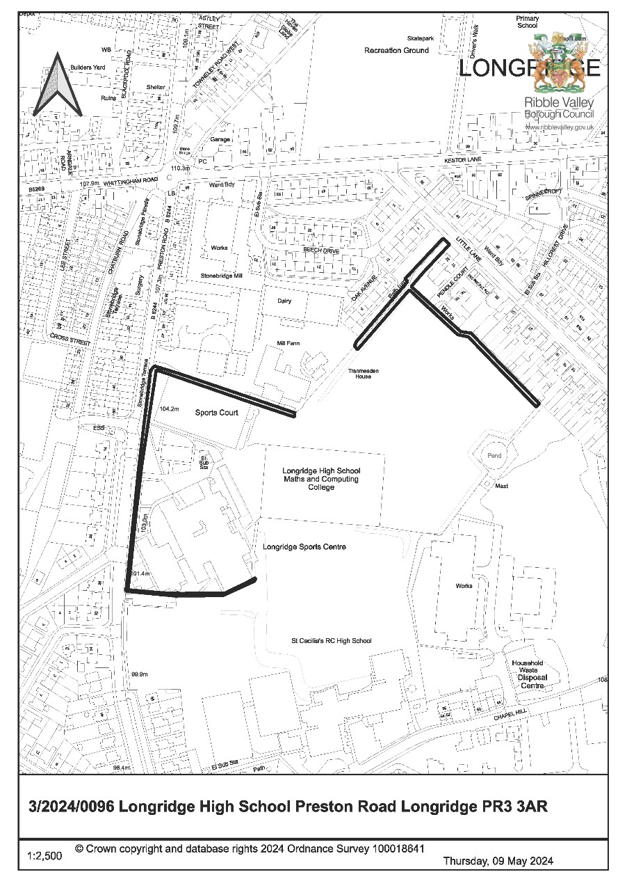

**CONSULTEE RESPONSES/ REPRESENTATIONS MADE:**

**PARISH COUNCIL:**

A consultation response from Longridge Town Council was received on 12th April 2024 objecting to the proposed development with concerns that surrounding neighbours had not been consulted on the application.

It is requested that should the application be approved; the fences should be kept at 2m high, and landscaping be implemented in order to ensure that the development is in keeping with the surrounding area as well as the design and character of the town.

The Town Council would also support the use of Pendle Court as the new access instead of that proposed due to concerns about the intensification of the existing junction.

**LANCASHIRE COUNTY COUNCIL HIGHWAYS:**

An initial consultation response from Lancashire County Council (LCC) Highways was received on 22nd March 2024, requesting the submission of further information.

LCC Highways was reconsulted on 23rd April 2024, with an updated response received on 20th May 2024, raising no objection to the proposed development subject to the imposition of conditions.

**BT OPENREACH:**

A consultation response from BT Openreach was received 18th April 2024 raising no objection.

**ADDITIONAL REPRESENTATIONS:**

Letters of representation have been received from 8 households objecting to the proposed development. In addition, a petition letter has been received on behalf of 7 households and another petition letter has been received on behalf of 3 households The issues raised within these objections can be summarised as below:

* Loss of views and sunlight;
* Overbearing impact and sense of imprisonment;
* Lack of justification for the proposed development;
* Increased congestion and a loss of on-street parking as a result of the new access;
* Impact on highway safety;
* Lack of external access to the rear of properties along Little Lane and accumulation of

litter;

* Lack of consideration in respect to land disturbance and drainage;
* Misleading and unclear information/ plans;
* Insufficient neighbour notification;
* Encroachment onto private land;
* Concerns that work has already commenced on site.

# 1. **Site Description and Surrounding Area**

1.1 The application relates to the boundary surrounding Longridge High School, located to the east of Preston Road. The site to which the application relates is within the defined settlement limits of Longridge and is situated to the south of the designated Longridge Conservation Area and to the north-west of the St Lawrence’s Church Conservation Area.

1.2 The application site is bounded to the east and west by the residential dwellings associated with Little Lane and Preston Road respectively, with a cheese dairy/ office to the north. To the south of the site are playing fields associated with St Cecilia’s Roman Catholic High School.

# 2. **Proposed Development for which consent is sought**

2.1 The application seeks consent for the erection/ installation of new perimeter fencing to enclose the land associated with Longridge High School. The existing paladin fencing installed adjacent to St Cecilia’s Roman Catholic High School along the southern boundary of the site is proposed to be retained, whilst 2.4m high paladin fencing is proposed to be installed adjacent Preston Road, including two non-automated pedestrian gates and one automated vehicle and pedestrian gate from Preston Road and a further automated pedestrian gate from the existing barrier car park area. To the northern boundary of the site, adjacent Little Lane, 2.0m high fencing is proposed.

2.2 A new vehicular access would also be created off Little Lane for use by maintenance and emergency vehicles, including the installation of a 2.0m high vehicle gate.

# 3. **Relevant Planning History**

3/2023/0628: Consultation on LCC application LCC/2023/0023 for the erection of a two-storey detached teaching block and additional staff car parking (Approved by LCC).

3/2012/1041: Renew defective 2.7m high fencing around astroturf pitches with 3m high replacement security fencing (Approved by LCC).

3/2009/0733: Installation of storage container (Approved).

3/2005/0057: Two storey extension to form lift enclosure, office and first floor landing (Approved).

4. **Relevant Policies**

# Ribble Valley Core Strategy (Adopted Version)

Key Statement DS1 – Development Strategy

Key Statement DS2 – Presumption in Favour of Sustainable Development Key Statement DMI2 - Transport Considerations

Policy DMG1 – General Considerations

Policy DMG2 – Strategic Considerations

Policy DMG3 – Transport and Mobility

Policy DME1 – Protecting Trees and Woodlands

*National Planning Policy Framework*

# National Planning Practice Guide

## 5. Assessment of Proposed Development

5.1 Principle:

5.1.1 The proposal relates to the erection of new perimeter fencing to enclose the land associated with Longridge High School, located within the defined settlement of Longridge.

5.1.2 Currently, a combination of existing 1m high timber post and rail, 1.5m high metal vertical bar railings and a range of fencing installed by neighbouring properties, forms the sites northern boundary, adjacent Little Lane and a cheese dairy complex. 2m high steel palisade fencing forms the site’s eastern boundary, while the southern boundary consists of 2m high mesh palisade fenced areas, adjacent to St Cecilia’s RC High School. 1m high masonry walls and metal vertical railed fencing forms the site’s western boundary, adjacent Preston Road.

5.1.3 The submitted Design and Access Statement states that the majority of the existing boundary fencing is in poor condition and offers minimum security to the school site with an ongoing issue with vandals/trespassers gaining access, and thus presenting significant safeguarding concerns.

5.1.4 It is therefore proposed to erect new perimeter fencing to enclose the school site, along with a new vehicular access off Little Lane, in order to secure the site and enable restricted access to the playing field by maintenance and emergency vehicles only.

5.1.5 In view of the proposal being functional development in association with an existing school site, the proposed development is acceptable in principle subject to an assessment of the material planning considerations.

5.2 Residential amenity:

5.2.1 Given the proposal seeks consent for the installation of a new perimeter fence within close proximity to existing nearby residential receptors, consideration must be given in respect to whether the proposed fencing would result in any undue impact upon nearby residential amenities by virtue of overbearing impact or significant loss of outlook, natural light or privacy.

5.2.2 In this respect, Policy DMG1 of the Ribble Valley Core Strategy is engaged which requires that development proposals must take ‘account of the effects on existing amenities’ and should not ‘adversely affect the amenities of the surrounding area’.

5.2.3 The submitted details propose the installation of perimeter welded mesh fencing at a height of 2m adjacent to the rear boundaries of the properties situated to the south-western side of Little Lane.

5.2.4 Schedule 2 Part 2 Class A of the Town and Country Planning (General Permitted Development) (England) Order 2015 allows for the construction of a 2m high fence under permitted development. The proposed fencing to the rear of the site could therefore be erected without the need for formal planning consent, save for the furthest eastern section which lies adjacent to the highway.

5.2.5 Nevertheless, the proposed fencing would remain in excess of 9m from the residential properties along Oak Avenue, 16m from the properties along Beech Drive and 20m from the rear elevations of the properties along Little Lane. In view of this separation distance and taking into account the level of transparency inherent to the fencing proposed, it is not considered that the installation would significantly reduce daylight or outlook from the main dwellinghouses of these residential receptors or their associated rear garden to a degree that would warrant the refusal to grant planning permission. Furthermore, the loss of a view from a private property is not a material planning consideration.

5.2.6 In respect to the proposed 2.4m high fencing and access gates to the frontage of the school, this element of the development would be sited approximately 30m from the nearest residential properties situated on the opposite side of Preston Road. In this respect it is not considered that the proposed development would result in any measurable undue harm upon these nearby residents by way of overshadowing, loss of outlook or daylight.

5.2.7 Taking account of the above matters, the proposal does not raise any significant direct conflict with Policy DMG1 of the Ribble Valley Core Strategy which seeks to protect existing and future residential amenities from undue negative impacts.

5.3 Visual amenity:

5.3.1 It is acknowledged that the fencing arrangement would be afforded a high level of visibility from the adjacent public realm along Preston Road. However, the proposed fencing would be read largely in context with the existing Longridge High School and associated playing field/ buildings and reflects that which is commonly seen along the boundaries of school grounds, including at the adjacent St Cecilia’s Roman Catholic High School.

5.3.2 The existing boundary wall fronting Preston Road would remain in situ, with the fencing proposed to sit behind. The impact on the public realm would be immediate to the site frontages along Preston Road and Little Lane, as opposed to having a wider impact, and is sufficient distance away to have no impact on the two conservation areas nearby. Taking account of the above and given the level of visual permeability inherent to the fencing, it is not considered that its presence would result in any significant detrimental impact upon the character or visual amenities of the area that would warrant the refusal of the application.

5.3.3 The proposed vehicular access off Little Lane would replace an existing pedestrian access and it is not considered that this element of the proposal would read as an overtly anomalous or out of keeping addition to the street scene.

5.3.4 Accordingly, and taking account of the above, the proposal does not raise any direct conflicts with Policy DMG1 insofar that there will be no significant undue harm upon the visual amenities of the area resultant from the proposed development.

5.4 Landscape and Ecology:

5.4.1 It is noted that a number of mature trees are sited within close proximity to the western boundary of the site, adjacent Preston Road. However, taking into account the existing infrastructure present along this boundary and the nature of the proposed development, it is not anticipated that the proposal would result in any significant undue harm upon these trees. Despite this, should the application be approved, it is considered appropriate to attach a condition to the accompanying decision notice to ensure that all retained trees are protected during the construction phase.

5.4.2 It is noted that concerns have been raised in respect to land disturbance and drainage, however given the nature of the proposed development, it is not considered that the proposal would result in any undue impact upon the existing drainage of the site or surrounding area.

5.4.3 In view of the above, no significant harm to landscape and ecology have been identified.

5.5 Highways:

5.5.1 The proposal will result in a new vehicle access onto Little Lane to facilitate access onto the school playing field where no such access currently exists. The existing vehicle accesses onto Preston Road will be maintained with new vehicle gates installed. LCC Highways initially raised concerns in respect to the application insofar that the application as submitted did not fully assess the highway impact of the proposed new vehicle access.

5.5.2 Additional details have been received in respect of the new vehicle site access details on Little Lane, including dropped kerb and hardstanding 8 metres into the site to prevent any mud and debris entering the highway. As a result of this, LCC Highways raise no objections subject to conditions. These include restrictive use of the new vehicle access and securing the access details.

5.5.3 Whilst third party objections raise concerns about the increase in vehicle traffic on Little Lane, the submitted Grounds Maintenance Statement confirms 20 cuts per year on the playing field between April and September. The access would therefore be used infrequently and a condition is suggested restricting use of the access to emergency service vehicles and grounds maintenance vehicles only. Whilst concerns about parking and traffic on Little Lane are noted, and that the new vehicle access with dropped kerb would result in one less parking space available, it is not considered that the proposal would worsen the existing situation to an extent that would result in any material harm.

5.5.4 Concerns were also raised in respect to a BT service chamber and telegraph pole located on the footway adjacent the proposed vehicular access off Little Lane. However, following consultation with Openreach, it has been confirmed that the footway chamber can support vehicular access and there would be no impact upon the telegraph pole should the work progress in accordance with the proposed plans. As such, Openreach have raised no objection to the creation of a new access and dropped kerb in this location.

1. **Observations/Consideration of Matters Raised/Conclusion:**

* 1. The proposal would not result in any undue impact upon the amenity of any neighbouring residents, nor is it considered that the proposal would be significantly harmful to the visual amenities of the surrounding area, ecology, or highway safety. Furthermore, there are benefits from the scheme in terms of school security, pupil safeguarding and allowing emergency access to the playing field which have also been considered.

* 1. As such, for the above reasons and having regard to all material considerations and matters raised, the application is recommended for approval.

**RECOMMENDATION:** That planning permission be APPROVED subject to the following conditions:

# Time Scale for Implementation of Consent

1. The development must be begun not later than the expiration of three years beginning with the date of this permission.

REASON: Required to be imposed by Section 51 of the Planning and Compulsory Purchase Act 2004.

# Approved Plans and Documents

2. Unless explicitly required by condition within this consent, the development hereby permitted shall be carried out in complete accordance with the proposals as detailed on drawings:

Location Plan (dwg no. BS.23-277-03 Rev B)

Site Plan with Proposed Fencing (dwg no. BS.23-277-02 Rev C)

Highway Details (dwg no. BS.23-277-04 Rev B)

Vehicle Entrance Details (dwg no. BS.23-277-06)

Fence and Gate Details (dwg no. BS.23-277/05 Rev A)

Betafence Nylofor 2D Specification

Grounds Maintenance Method Statement: Protection of Public Highway (received 20th May 2024).

REASON: For the avoidance of doubt and to clarify which plans are relevant to the consent.

# Materials

3. The materials to be used on the external surfaces of the development hereby approved as indicated within the application form and on drawing(s) ‘Fence and Gate Details’ (dwg no. BS.23-277/05 Rev A) shall be implemented as indicated.

REASON: In order that the Local Planning Authority may ensure that the materials to be used are appropriate to the locality and respond positively to the inherent character of the area.

# Ecology

4. During the construction period, all trees to be retained shall be protected in accordance with British Standards BS 5837:2012 or any subsequent amendment to the British Standard.

REASON: To protect trees/ hedging or landscape and visual amenity value on and adjacent to the site or those likely to be affected by the proposed development hereby approved.

# Highways

1. During the construction phase of the replacement boundary fencing/gates hereby permitted:-

* + wheel washing facilities shall be provided and made available for use at the new site access onto Little Lane where this access is being used by site operatives or for the delivery of materials in the event that the new hard surfacing has not been installed in accordance with condition 6. These facilities shall remain in place for the duration of the construction phase of the development.

* + there shall be no deliveries to site or removal of existing material from site between 0830 and 0915 and between 1500 and 1545 during school term time.

Reason: In the interest of protecting residential amenity and to ensure the safe operation of the Highway for the duration of the construction phase of the development.

1. The new vehicular access hereby approved shall be surfaced with tarmacadam, or similar hard bound material (not loose aggregate), for a distance of at least 5 metres behind the highway boundary, as indicated on the Site Plan with Proposed Fencing (dwg no. BS.23-277-02 Rev C), prior to first use of the new vehicle access by a ground maintenance contractor and retained thereafter.

REASON: To reduce the possibility of deleterious material being deposited in the highway in the interest of highway safety.

1. The off-site works of highway improvement, namely dropped kerb and resurfacing of highway footpath on Little Lane, as indicated on the Highway Details (dwg no. BS.23277-04 Rev B) and Vehicle Entrance Details (dwg no. BS.23-277-06) shall be completed prior to first use of the new vehicle access.

REASON: In the interest of highway safety and the amenities of nearby residents.

1. The new vehicular access hereby approved, as indicated on the Highway Details (dwg no. BS.23-277-04 Rev B) and Vehicle Entrance Details (dwg no. BS.23-277-06), shall solely be used as restricted access for grounds maintenance and emergency service vehicles only. In respect of vehicles associated with grounds maintenance, the use shall operate in accordance with the submitted ‘Grounds Maintenance Method Statement: Protection of Public Highway’ (received 20th May 2024).

REASON: In the interest of highway safety and the amenities of nearby residents.

BACKGROUND PAPERS

<https://webportal.ribblevalley.gov.uk/planningApplication/36154>