RECOMMENDATION FOR PLANNING AND DEVELOPMENT COMMITTEE

**APPROVAL**

**DATE: 30 May 2024**

**REF: LW**

**CHECKED BY: LH**

**APPLICATION REF: 3/2024/0220**

GRID REF: SD 360634 437273

**DEVELOPMENT DESCRIPTION:**

PROPOSED REPLACEMENT OF EXISTING ASBESTOS ROOF WITH PLASTISOL COATED STEET ROOFING SHEETS, REPLACEMENT OF EXISTING TIMBER DOORS WITH TWO PLASTISOL ROLLER SHUTTER DOORS. AMBULANCE SHED, LONGRIDGE DEPOT, DIXON ROAD, LONGRIDGE PR3 3JE

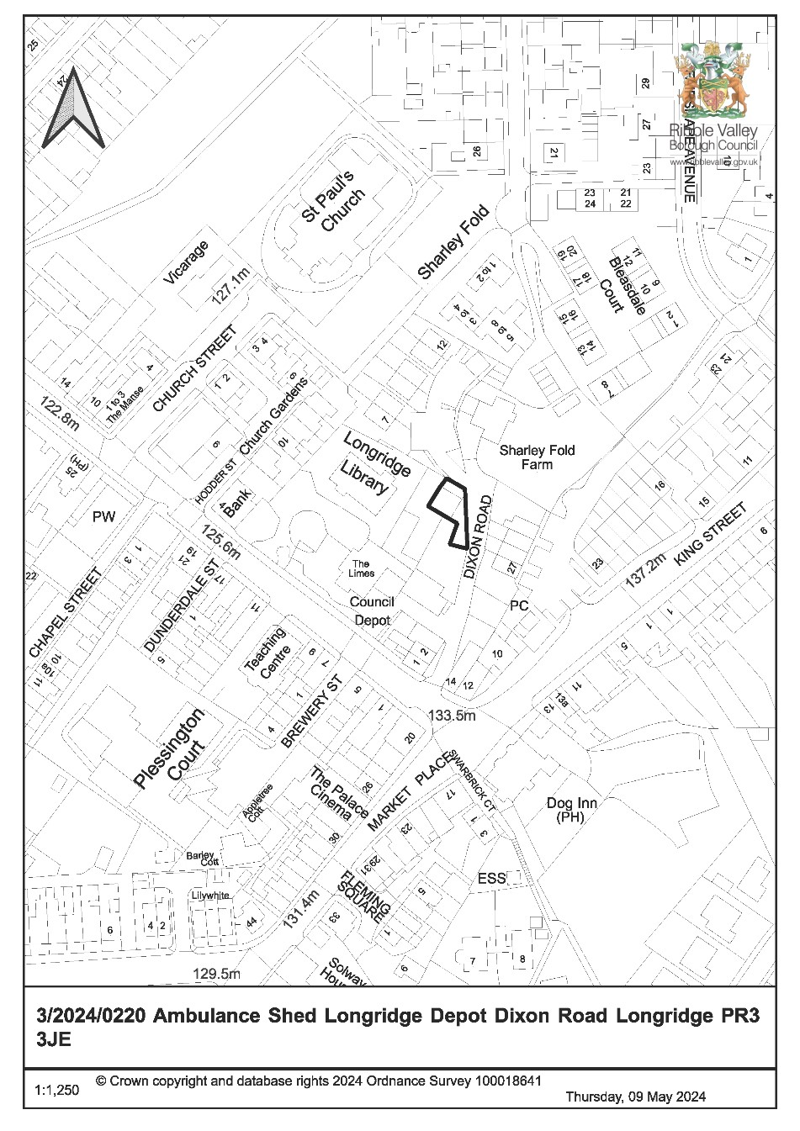

**CONSULTEE RESPONSES/ REPRESENTATIONS MADE:**

**PARISH COUNCIL:**

A consultation response from Longridge Town Council was received on 12th April 2024 stating that the application was not valid at the time of meeting. No further comments have been received.

**LANCASHIRE COUNTY COUNCIL HIGHWAYS:**

A response from Lancashire County Council Highways was received on 23rd April 2024 with no objection being raised subjection to the imposition of a condition to restrict delivery times.

**ADDITIONAL REPRESENTATIONS:**

No additional representations have been received.

# 1. Site Description and Surrounding Area

1.1 The site relates to an existing Ambulance Shed associated with the Ribble Valley Borough Council owned Longridge Depot located to the western side of Dixon Road within the defined settlement limits of Longridge, as well as the designated Longridge Conservation Area. To the north-east of the proposal site is Sharley Fold Farm, a Grade II Listed Building, with the listing entry for the property reading as follows:

*House, ‘1619 | A S’ on lintel. Sandstone rubble with stone slate roof. 2 storeys. To the right of the modern porch is a 3-light double chamfered mullioned window with hood. At the far left of the façade, beyond a modern window, is a similar window. On the 1st floor are 2 3-light rebated and chamfered mullioned windows, with a 2-light chamfered window to the right of the porch. The studded plank door, with chamfered surround and triangular head, is now within the porch. Gable stack, the right hand one being of stone. Wing at rear, with an outshut against its south-west wall.*

# 2. Proposed Development for which consent is sought

2.1 The application seeks consent for the proposed replacement of the existing asbestos roof with plastisol coated steel roofing sheets along with the replacement of the existing timber doors with two plastisol roller shutter doors.

3. **Relevant Planning History**

No relevant planning history,

# 4. Relevant Policies

*Ribble Valley Core Strategy (Adopted Version)*

Key Statement DS1 – Development Strategy

Key Statement DS2 – Presumption in Favour of Sustainable Development

Key Statement EN5 – Heritage Assets Key Statement DMI2 - Transport Considerations

Policy DMG1 – General Considerations

Policy DMG2 – Strategic Considerations

Policy DMG3 – Transport and Mobility

Policy DME4 – Protecting Heritage Assets

National Planning Policy Framework

National Planning Practice Guide

Planning (Listed Buildings and Conservation Areas) Act

# 5. Assessment of Proposed Development

5.1 Principle:

5.1.1 The proposal relates to an existing building located within the defined settlement of Longridge.

5.1.2 The submitted Hertiage Statement notes that the existing roof covering to the building is no longer fit for purpose and has reached its end of serviceable lifespan, whilst also containing asbestos. It is therefore proposed that the existing roof sheets be removed and replaced with steel roofing sheets similar in both colour and appearance to that of the existing.

5.1.3 The existing sliding timber doors to the principal elevation are also rotten and subsequently need replacing to ensure safe and secure use of the building. The proposal therefore also includes the replacement of these doors with roller shutter doors of the same colour.

5.1.4 In view of the above, the works proposed are considered to be acceptable in principle subject to an assessment of the material planning considerations.

5.2 Impact upon Listed Building(s) and Character/ appearance of Conservation Area

5.2.1 The proposal site is located close to Sharley Fold a Grade II Listed Building as well as within the designated Longridge Conservation Area.

5.2.2 With regards to proposals for development affecting Listed Buildings, Section 66 of the Planning (Listed Buildings and Conservation Areas) Act 1990 states that:

“*In considering whether to grant planning permission for development which affects a listed building or its setting, the local planning authority shall have special regard to the desirability of preserving the building or its setting or any features of special architectural or historic interest which it possesses.”*

With reference to making decisions on applications for development in Conservation Areas, Section 72 of the Planning (Listed Building and Conservation Areas) Act 1990 states that:

“*… special attention shall be paid to the desirability of preserving or enhancing the character or appearance of that area.”*

This guidance is reiterated in Key Statement EN5 of the Ribble Valley Core Strategy which stipulates that all development proposals should respect and safeguard the character, appearance, and significance of all Conservation Areas.

Furthermore, Policy DME4 of the Ribble Valley Core Strategy states that ‘*proposals within, or affecting views into or out of, or affecting the setting of a Conservation Area will be required to conserve and where appropriate enhance its character and appearance’.*

5.2.3 The proposed replacement roof would comprise of steel roofing sheets similar in colour and appearance to the existing roof covering, while the proposed roller shutter doors to the front elevation would also be the same colour as the existing timber sliding doors.

5.2.4 In this context, it is not anticipated that the proposed alterations to the external appearance of the existing structure would result in any significant undue harm upon the historic character of the surrounding area above that which already exists.

5.2.5 The proposal would therefore satisfy the requirements of Section 66 and 72 of the Planning (Listed Buildings and Conservation Areas) Act 1990 and Key Statement EN5 and Policy DME4 of the Ribble Valley Core Strategy.

5.3 Residential amenity:

5.3.1 A number of residential properties are sited directly to the east of the proposal site, separated by the highway of Dixon Road, with the rear elevations of these dwellings having a direct interface with the proposed development.

5.3.2 Despite this, the proposal comprises alterations to an existing structure, including a replacement roof and access doors, with the height and footprint of the building remaining unchanged. There is also no proposal for the use of the site to intensify.

5.3.3 As such, it is not considered that the proposal would result in any measurable undue impact upon the existing amenities of any nearby residents that would significantly exceed that of the existing and thus warrant the refusal to grant planning permission.

5.4 Landscape and Ecology:

5.4.1 It is noted that there are a number of mature trees within close proximity to the proposal site. Whilst it is not anticipated that the proposed development would result in any significant direct impact upon these trees, should the application be approved, it is considered appropriate to attach a condition to the accompanying decision notice to ensure that the trees are protected during the construction phase of the development.

5.5 Highways:

5.5.1 Lancashire County Council Highways have been consulted on the proposed development and raised no objection. However, given there are dwellings sited along Dixon Road, beyond the proposal site, it is advised that additional care be taken not to obstruct the access during the construction works.

5.5.2 The Local Highway Authority have therefore recommended a condition be attached to any subsequent approval restricting the hours of delivery to between 9:30am and 2:30pm Monday-Friday in order to avoid peak traffic on the surrounding highway network.

5.5.3 However, given the nature of the development and its relatively small scale, it is not considered necessary to restrict delivery times in this particular instance.

1. **Observations/Consideration of Matters Raised/Conclusion:**

* 1. The proposal would not result any undue impact upon the amenity of any neighbouring residents, nor is it considered that the proposal would be harmful to the historic character of the adjacent Grade II Listed Building or Longridge Conservation Area, ecology, or highway safety.

* 1. As such, for the above reasons and having regard to all material considerations and matters raised, the application is recommended for approval.

**RECOMMENDATION:** That planning permission be APPROVED subject to the following conditions:

*Time Scale for Implementation of Consent*

1. The development must be begun not later than the expiration of three years beginning with the date of this permission.

REASON: Required to be imposed by Section 51 of the Planning and Compulsory Purchase Act 2004.

*Approved Plans and Documents*

1. Unless explicitly required by condition within this consent, the development hereby permitted shall be carried out in complete accordance with the proposals as detailed on drawings:

Location Plan (1:1250)

Proposed Plans (dated 7th March 2024)

REASON: For the avoidance of doubt and to clarify which plans are relevant to the consent.

*Materials*

1. The materials to be used on the external surfaces of the development hereby approved as indicated within the application form and on drawing(s) ‘Proposed Plans’ (dated 7th March 2024) shall be implemented as indicated.

REASON: In order that the Local Planning Authority may ensure that the materials to be used are appropriate to the locality and respond positively to the inherent character of the area.

*Ecology*

1. During the construction period, all trees to be retained shall be protected in accordance with British Standards BS 5837:2012 or any subsequent amendment to the British Standard.

REASON: To protect trees/ hedging or landscape and visual amenity value on and adjacent to the site or those likely to be affected by the proposed development hereby approved.

BACKGROUND PAPERS

<https://webportal.ribblevalley.gov.uk/planningApplication/36276>