Agenda Item 5a

RECOMMENDATION FOR PLANNING AND DEVELOPMENT COMMITTEE

**APPROVAL**

**DATE: 27 JUNE 2024**

**REF: EP**

**CHECKED BY: LH**

**APPLICATION REF: 3/2024/0274**

GRID REF: SD 369072 434193

**DEVELOPMENT DESCRIPTION:**

ADVERTISEMENT CONSENT FOR REGULARISATION OF APPLICATION OF LOGO AND

LETTERS ON THE GABLE END OF THE BUILDING, TWO HOARDINGS ATTACHED TO THE

RAILINGS AROUND THE OUTSIDE SEATING AREA, ONE HOARDING ATTACHED TO THE

WIRE FENCE AND THREE HOARDINGS INSIDE THE SHELTERS. LANGHO SPORTS AND

SOCIAL CLUB, DEWHURST ROAD, LANGHO BB6 8AF

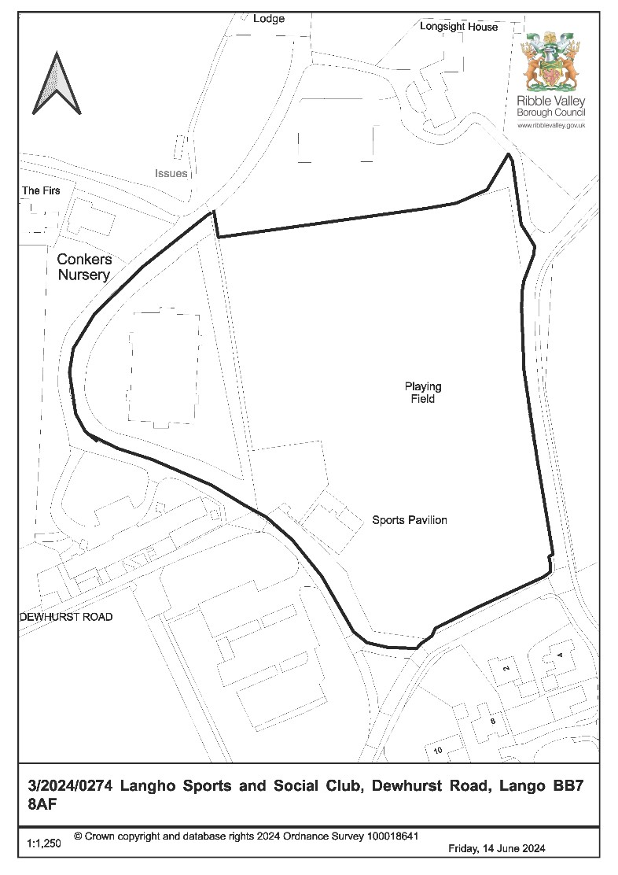

**CONSULTEE RESPONSES/ REPRESENTATIONS MADE:**

**PARISH COUNCIL:**

Wilpshire Parish Council have objected to the proposal on the grounds that some of the hoardings are intrusive in nature due to their large size.

Billington and Langho Parish Council are in support of the application as the Football Club provides excellent sports provision for many youngsters and adults and will substantially benefit from a local sponsorship like Conkers Nursery to support the progression of the club. The name of the club on the wall of the building looks very smart.

**LOCAL HIGHWAYS AUTHORITY (LCC HIGHWAYS):**

No objection

**ADDITIONAL REPRESENTATIONS:**

At the time of writing this report representations from six households have been received objecting to the application on the following grounds:

* The signs are in contravention with the club’s lease which is governed by a protective covenant.
* The introduction of the signs impacts on the open space designation.
* The signs are unsightly, dominating and not in keeping with the area.
* The signs detract from the rural feel of the area.
* There is additional signage within the site, not included within the retrospective application, that doesn’t benefit from planning consent.
* The works were carried out without prior consent in breach of the club’s lease agreement with RVBC.

# Introduction

1.1 Members will note that the application is being brought before Committee given the land falls within the ownership of Ribble Valley Borough Council.

# Site Description and Surrounding Area

2.1 The site relates to existing grass pitches, car parking and pavilion used by Langho Football Club located off the Rydings to the south of the A59 Longsight Road. The application relates to an area of designated open space outside of the defined settlement limits of Langho approximately 1 kilometre to the North-west of Langho village centre. There is residential housing around the site largely to the south. Kemple View rehabilitation centre, the sanctuary of healing and Longsight stables are also located nearby.

# Proposed Development for which consent is sought

3.1 This application seeks retrospective consent for the installation of various advertisement signs within the grounds of Langho Football Club. A breakdown of the signage is as follows:-

* White acrylic lettering and logo on the south-facing gable end of the pavilion building.
* Two hoardings attached to the railings around the outside seating area (one facing east measuring 2.43m x 0.77m, one facing north measuring 3m x 0.8m)
* One hoarding attached to the wire perimeter fence measuring 9.2m x 1m
* Three hoardings inside the dug-out shelters measuring 2.4m x 0.8m

* 1. None of the signs are to be illuminated.

* 1. The application is seeking consent for five years, beginning with the date on which the signs were erected (09/06/2023) which is the typical timeframe for how long an express consent lasts for (although a local planning authority has discretion and can grant consent for a longer or shorter period).

# Relevant Planning History

**3/2023/0664:** Construction of two dugout shelter buildings to replace the existing temporary shelters. (approved with conditions).

**3/2020/0315:** Applications for full consent. Construction of an all-weather football pitch with boundary fencing and floodlights and an extension of existing car park. (refused).

# Relevant Policies

**Ribble Valley Core Strategy**

Key Statement DS1: Development Strategy

Key Statement DS2: Sustainable Development

Policy DMG1: General Considerations

Policy DMG2: Strategic Considerations

Policy DMB3: Recreation and Tourism Development

Policy DMB4: Open Space Provision

National Planning Policy Framework (NPPF)

National Planning Practice Guidance

The Town and Country Planning (Control of Advertisements) (England) Regulations 2007 (the Regulations)

# Assessment of Proposed Development

6.1 Principle of Development:

6.1.1 The Regulations require local planning authorities to determine applications for advertisement consent in the interests of amenity and public safety only. Factors relevant to amenity include the general characteristics of the locality, including the presence of any feature of historic, architectural, cultural or similar interest. Relevant factors relevant to public safety include highway safety, any obscuring of traffic signs or any hinderance to the operation of a security or surveillance device.

6.2 Impact upon Amenity:

6.2.1 Given the considerable distance between the proposed signage and neighbouring receptors, and the lack of any illumination proposed, there is not considered to be any adverse impact on residential amenity.

6.2.2 The various signs currently face the playing field/football pitches, with the exception of the lettering on the gable end of the football club building. The signs are widely spaced across the site, and read against existing paraphernalia such as buildings, fencing, football posts and dugouts.

6.2.3 The signs are of varying sizes, the largest being the perimeter fence hoarding, which measures 9.2 metres by 1m in size. All of the signs are primarily green and white in colouring.

6.2.4 The content on the advertising signs is deemed appropriate for the setting. The signs only make reference to the football club itself and the adjacent conkers nursery, which is the club’s sponsor.

6.2.5 Given the vast, open nature of the field all of the signs read as proportionate additions within the setting, when viewed both individually and collectively. It is not considered that they dominate the open space in any way nor are they considered to result in visual clutter. Their siting and external appearance is considered to satisfy policy DMG1 (amenity) of the Ribble Valley Core Strategy. The site does not fall within the defined National Landscape (formerly Area of Outstanding Natural Beauty) or Conservation Area, and there are no special landscape or heritage features nearby that would be affected.

6.2.6 In addition, they are not considered to conflict with policy DMB3 of the Core Strategy, which supports the expansion of recreational and leisure facilities, or policy DMB3, which resists development proposals resulting in a loss of public open space including private playing fields which are in recreational use. The proposed signage does not result in the loss of the open public space and is therefore acceptable in this respect.

6.3 Public Safety

6.3.1 There are no highways safety concerns given the distance between the proposed signage and the highway and the lack of any illumination proposed. Their siting

and external appearance is considered to satisfy policy DMG1 (highway safety) of the Ribble Valley Core Strategy. Nor would the proposals impact upon any security or surveillance devices.

6.4 Other Matters

6.4.1 There is a section 106 agreement on the application site that restricts the use of the land so that it remains as public open space. This application does not seek to change the use of the land and the introduction of the signs does not prevent the use of the site for recreational purposes nor does it prevent members of the public using the space.

6.4.2 The granting of any advertisement consent does not give the applicant the automatic right to display the advertisements should they result in a breach of any section 106 agreement or similar land agreement. However this would be a matter for the Council’s Legal Department to investigate on behalf of RVBC as landowner.

6.4.3 Concerns have been raised over additional signage not included within this application that does not benefit from any consent.

6.4.4 There is a directional sign at the entrance to the club car park which does not benefit from consent. This was investigated last year, but it was deemed to be functional, acceptable from an amenity and safety perspective and have no impact upon the use of the public open space. As such it was decided by officers that it would not be expedient to take any further action.

6.4.5 There was, until recently, a third hoarding sign attached to the veranda. This was raised with the applicant’s planning agent during the course of the current application and this hoarding has subsequently been removed.

# Observations/Consideration of Matters Raised/Conclusion

7.1 It is not considered that there is any unacceptable harm arising from the proposed signage in terms of either amenity or public safety, nor would the proposed signage conflict with the use of the land as a recreational / playing field facility. The signs are deemed appropriate within this context. Therefore, the application is recommended for approval subject to conditions.

RECOMMENDATION: That the application be APPROVED subject to the following conditions:

1. Unless explicitly required by condition within this consent, the development hereby permitted shall be retained in complete accordance with the proposals as detailed on drawings:

1034220 Conkers Nursery Signage (signs 9 -13)

Location Plan 03-May-2025

Proposed Site Plan (untitled) showing the location of the 7 signs

REASON: For the avoidance of doubt and to clarify which plans are relevant to the consent hereby approved.

1. The advertisements hereby permitted shall be non-illuminated at all times.

REASON: In the interests of amenity.

1. The advertisements hereby permitted shall be removed from the site on or before 9th June 2028 and the site restored to its former condition to the full satisfaction of the Local Planning Authority unless a further advertisement consent has been expressly granted by the Authority.

REASON: In the interests of amenity.

INFORMATIVE: The applicant is reminded that in addition to the conditions stipulated above, the advertisements hereby permitted are required to comply with the five standard conditions in Schedule 2 of the Town and Country Planning (Control of Advertisements) (England) Regulations 2007 which are as follows:-

1. No advertisement is to be displayed without the permission of the owner of the site or any other person with an interest in the site entitled to grant permission.

1. No advertisement shall be sited or displayed so as to—

* 1. endanger persons using any highway, railway, waterway, dock, harbour or aerodrome

(civil or military);

* 1. obscure, or hinder the ready interpretation of, any traffic sign, railway signal or aid to navigation by water or air; or
  2. hinder the operation of any device used for the purpose of security or surveillance or for measuring the speed of any vehicle.

1. Any advertisement displayed, and any site used for the display of advertisements, shall be maintained in a condition that does not impair the visual amenity of the site.

1. Any structure or hoarding erected or used principally for the purpose of displaying advertisements shall be maintained in a condition that does not endanger the public.

1. Where an advertisement is required under these Regulations to be removed, the site shall be left in a condition that does not endanger the public or impair visual amenity.

BACKGROUND PAPERS

[Planning Application - Ribble Valley Borough Council](https://webportal.ribblevalley.gov.uk/site/scripts/planx_details.php?appNumber=3%2F2024%2F0274)