RECOMMENDATION FOR PLANNING AND DEVELOPMENT COMMITTEE

REFUSAL

DATE: 30 MAY 2024
REF: SK
CHECKED BY: LH

APPLICATION REF: 3/2024/0318

GRID REF: SD 374035 441822

DEVELOPMENT DESCRIPTION:

REGULARISATION OF UNAUTHORISED CHANGE OF USE FROM DWELLING (USE CLASS C3) TO SHORT-TERM HOLIDAY LET (SUI GENERIS) FOR A TEMPORARY PERIOD OF FIVE YEARS. 29 CASTLE VIEW, CLITHEROE BB7 2DT
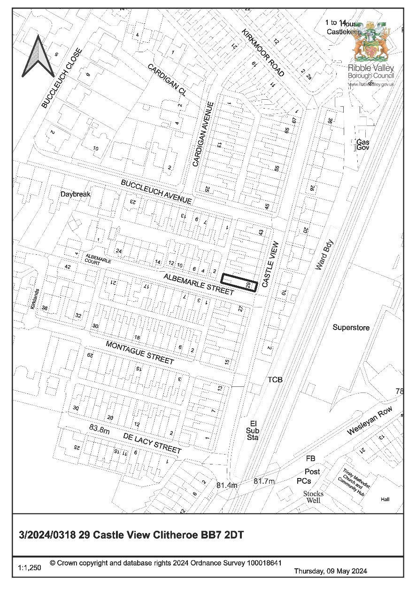
CONSULTEE RESPONSES/ REPRESENTATIONS MADE:

PARISH COUNCIL:

At the time of writing this report no representations from Clitheroe Town Council have been received in respect of the proposal.

RVBC ENVIRONMENTAL HEALTH:

Ribble Valley Environmental Health Team have stated that they have received noise complaints in respect of the usage of the property, as such, should consent be granted they request that the following condition be imposed:

Prior to any further use of the premises for the purposes of short-term holiday accommodation (sui generis), a Validation Test of the sound attenuation works shall be carried out, and the results submitted to and approved by the LPA. Such Validation Test shall:

- be carried out by a competent person in accordance with an approved method statement.
- meet the required airborne and impact noise insulation levels as described under the Building Regulations Part E resistance to the passage of sound.
- demonstrate that the noise insulation levels in the Resistance to the Passage of sound have been achieved.
- In undertaking the acoustic assessment, the applicant shall adhere to the methodology in Annex B of the Building Regulations Part E resistance to the passage of sound.
- The assessment needs to be made between the premises and any structurally adjoining
property i.e. any property sharing an adjoining wall.

If these levels have not been achieved, irrespective of the sound attenuation work already approved, a further scheme will be required incorporating the recommendations of an acoustic consultant to achieve the specified noise levels. The scheme of works shall be submitted to and approved in writing by the LPA, installed before use of the development begins and thereafter retained. The approved scheme shall be fully implemented and completed prior to occupation of the site.

Reason: To safeguard the living conditions of residents particularly with regard to the effects of noise.

LOCAL HIGHWAYS AUTHORITY (LHA):

The Local Highways Authority have raised no objection to the proposal stating the following:

Lancashire County Council acting as the Local Highway Authority does not raise an objection regarding the proposed development and are of the opinion that the proposed development will not have a significant impact on highway safety, capacity or amenity in the immediate vicinity of the site subject to the following conditions being stated on any approval.

Site Access/ Internal Layout

The proposed holiday let is located off Castle View which is an unclassified road subject to a
20mph speed limit. The LHA have reviewed the supporting documents and are aware that no offstreet car parking spaces will be provided for the proposed 4 bed holiday let. For the site to comply with the LHAs parking guidance as defined within the Joint Lancashire Structure Plan, the LHA would expect the site to provide a minimum of 3 car parking spaces.

Despite the shortfall in parking, the LHA have no objection to the proposal. This is because a shortfall in parking at the site is a pre-existing situation with the dwelling expected to provide 2
car parking spaces given the number of bedrooms. Therefore, it is considered that an additional shortfall in parking would not have a detrimental impact upon highway safety, should three car parking spaces be required on-street. This is because there have been no reported collisions recorded within the vicinity of the site in the last five years and the site is located in a sustainable location in the centre of Clitheroe, approximately 375m away from the train station and bus interchange which serves a range of destinations.

Therefore, given these factors and the proposed holiday let is likely to generate similar levels of traffic than its existing use, the LHA have no objection to the proposal subject to cycle storage facilities being provided.

ADDITIONAL REPRESENTATIONS:

At the time of the writing of this report 49 letters of representation have been received objecting on the following grounds:

- Inadequate parking provision in the area
- Additional vehicles visiting the property
- Noise and disturbance associated with the use of the property being of detriment to nearby residential amenities
- Use of the property for holiday purposes is not appropriate to the character of the area
- Anti-social behaviour

1. Introduction

1.1 In addition to the significant number of representations received, the application is being brought to Committee following a call-in request from Councillor Jonathan Hill, with impacts on the local area, noise disturbance, parking and detrimental impacts(s) upon residential amenities cited as the reason for the call-in.

2. Site Description and Surrounding Area

2.1 The application relates to a four-bedroomed two-storey end of terrace property located on Castle View, Clitheroe. The site lies within the defined settlement limits of Clitheroe, the property is located on the corner junction of Castle View and Albemarle Street, being located in a predominantly residential area typified by two-storey terraced and terraced bungalow type dwellings.

3. Proposed Development for which consent is sought

3.1 The application seeks retrospective consent for the change of use from a dwelling to that of a ‘holiday-let’ for a temporary period of five years. The submitted details propose no external alterations to the building nor alterations to the existing site configuration, with the supporting information stating that the holiday-let use generates part-time employment for one individual.

4. Relevant Planning History

No planning history directly relevant to the determination of the application.

5. Relevant Policies

Ribble Valley Core Strategy

Key Statement DS1 – Development Strategy
Key Statement DS2 – Sustainable Development
Key Statement DMI2 – Transport Considerations
Key Statement EC1 – Business and Employment Development
Key Statement EC3 – Visitor Economy

Policy DMB1 – Supporting Business Growth
Policy DMB3 – Recreation and Tourism Development
Policy DMG1 – General Considerations
Policy DMG2 – Strategic Considerations
Policy DMG3 – Transport & Mobility

National Planning Policy Framework (NPPF)

6. Assessment of Proposed Development

6.1 Principle of Development:

6.1.1 Given the proposal seeks retrospective consent for the creation of a new unit of holiday accommodation, Key Statement EC3 and Policies DMB1 and DMB3 are primarily, but not solely, engaged in respect of assessing the acceptability of the principle of the development and its alignment or potential conflict with the aims and objectives of the Ribble Valley Corey Strategy.

6.1.2 Key Statement EC3 lends general support for the creation of additional holiday accommodation stating that ‘Proposals that contribute to and strengthen the visitor economy of Ribble Valley will be encouraged, including the creation of new accommodation and tourism facilities through the conversion of existing buildings or associated with existing attractions. Significant new attractions will be supported, in circumstances where they would deliver overall improvements to the environment and benefits to local communities and employment opportunities’.

6.1.3 In respect of ‘Supporting Business Growth and the Local Economy’ Policy DMB1 states the following:

Proposals that are intended to support business growth and the local economy will be supported in principle. development proposals will be determined in accord with the core strategy and detailed policies of the LDF as appropriate. the borough council may request the submission of supporting information for farm diversification where appropriate. The expansion of existing firms within settlements will be permitted on land within or adjacent to their existing sites, provided no significant environmental problems are caused and the extension conforms to the other plan policies of the LDF.

The council in accord with its vision and key statements wishes to create the right environment for business growth whilst ensuring development is sustainable.

6.1.4 In respect of the creation of new holiday accommodation within the borough, Policy DMB3 is also generally supportive of proposals that seek to enhance the range of tourism and visitor facilities within the borough stating that:

Planning permission will be granted for development proposals that extend the range of tourism and visitor facilities in the borough. This is subject to the following criteria being met:

- The proposal must not conflict with other policies of this plan;
- The proposal must be physically well related to an existing main settlement or village or to an existing group of buildings, except where the proposed facilities are required in conjunction with a particular countryside attraction and there are no suitable existing buildings or developed sites available;
- The development should not undermine the character, quality or visual amenities of the plan area by virtue of its scale, siting, materials or design;
- The proposals should be well related to the existing highway network. It should not generate additional traffic movements of a scale and type likely to cause undue problems or disturbance. where possible the proposals should be well related to the public transport network;
- The site should be large enough to accommodate the necessary car parking, service areas and appropriate landscaped areas; and
- The proposal must take into account any nature conservation impacts using suitable survey information and where possible seek to incorporate any important existing associations within the development. failing this then adequate mitigation will be sought.

6.1.5 In respect of the above, both policies DMB1 and DMB3 and Key Statement EC3 are generally supportive of the creation of new holiday accommodation. However, the first criterion of Policy DMB3 requires that proposals should not result in conflict with the inherent criterion of the policy itself, but additionally should not result in any conflict with other policies within the development plan.

6.1.6 Policy DMB1 contains a similar inherent policy criterion requiring that proposals should not result in conflict with Policy DMG1 and that such proposals will also be assessed against their compatibility with other policies within the adopted development plan.

6.1.7 As such and taking account of the above matters, notwithstanding other development management considerations, it is considered that the principle of the development would align broadly with the aims and objectives of both Key Statement EC3 and Policies DMB1 and DMB3 of the Ribble Valley Core Strategy.

6.1.8 However, members will note that if the development results in identified conflict with the adopted development plan, either through direct conflict with the inherent criterion of Policies DMB1 or DMB3 or by virtue of conflict with other policies within the development plan, the general support normally afforded by both Policies DMB1 and DMB3 is considered to be fully disengaged and could not be engaged in support of the development.

6.2 Impact upon Residential Amenity and Character of the Area

6.2.1 Given the proposal seeks retrospective consent for a change of use from that of a C3 Dwellinghouse to that of commercial tourism accommodation, consideration must be given in respect of the compatibility of the proposed use with that of the character of the immediate area and as to whether the introduction of such a use will result in any undue impacts upon the character of the area or nearby residential amenities.

6.2.2 The submitted details propose that the ‘holiday let’ will be four-bedroomed, with the submitted supporting information stating that the property can accommodate up to 8 persons, with the property providing for three double bedrooms and a twin bedroom.

6.2.3 In respect of matters of potential ‘occupancy levels’ and impacts resultant from such levels. In determining a recently dismissed appeal received by the authority, also for the change of use from a dwelling to short-term let holiday accommodation (APP/T2350/W/23/3325820), the Inspector, in reaching their conclusions concluded that:

‘the numbers of people occupying the property would be over and above that expected from other dwellings in this location. In addition, the use of the property as a holiday let would result in a more disruptive pattern of occupation than if it was used as a private domestic dwelling. This would not be satisfactorily controlled by condition and therefore would harm the living conditions of neighbouring properties’.

6.2.4 With the Inspector further concluding, when considered whether occupancy levels could be controlled via the imposition of condition(s), that ‘it would be very difficult to enforce such a condition, or prevent other people that are not resident, visiting the building’. As such, the authority does not consider that there are any mechanisms that could reasonably be put in place to limit the occupation of the premises to 8 occupants via the imposition of planning conditions.

6.2.5 In respect of the above, when taking account of the scope and extent of accommodation proposed, which could accommodate up to 8 guests/occupants at any one time, it is considered that the intensity of the use and associated level of occupancy, particularly when the premises would be fully booked, would give rise to a use that fails to be ‘sympathetic to existing and proposed land uses in terms of its size, intensity and nature’ as required by Policy DMG1.

6.2.6 Further to the above, the proposed use would possess and generate an unsympathetic level of associated activities, a level of occupancy atypical for the area and result in the introduction of a disruptive pattern of occupation which would be considered anomalous compared that of the nearby and adjacent C3 residential dwellings.
6.2.7 In this respect it cannot be considered, particularly when taking account of the quiet residential nature of the street typified by normal activities associated with the residential occupancy of private domestic dwellings, that the proposed use would be ‘sympathetic’ to the inherent character of the immediate area.

6.2.8 Taking account of the above, the proposal would be of significant detriment to the residential character of the immediate area, particularly insofar that such associated activities and occupancy levels would not be commensurate with and would significantly exceed the level of activities and occupation associated with the nearby dwellings when occupied on a normally family basis as categorised by use class C3.

6.2.9 As such and taking account of the above matters, it is considered that the proposed development, by virtue of its identified conflict with Policy DMG1, is also in direct conflict with Policies DMB1 and DMB3 insofar that the proposal fails to accord with ‘the provisions of Policy DMG1’ and is in ‘conflict with other policies’ within the development plan. As such the general ‘in principle’ support afforded to such proposals by virtue of Policies DMB1 and DMB3, in this instance, is considered fully disengaged.

6.3 Visual Amenity/External Appearance

6.3.1 The proposed development does not involve nor propose any external alterations to the application building or associated site configuration. As such, the proposal does not raise any significant direct conflicts with Policy DMG1 insofar that there will be no measurable significant harm to the visual amenities of the area resultant from the proposed development.

6.4 Landscape and Ecology:

6.4.1 No implications resultant from the proposal nor any measurable conflict(s) with Key Statement EN4, nor Policies DME1, DME2 or DME3 of the Ribble Valley Core Strategy.

6.5 Highway Safety and Accessibility:

6.5.1 The submitted details do not propose any dedicated parking provision to serve the development proposed, with the upper occupancy limit of the accommodation being able to accommodate 8 individuals. As such, when taking account of a potential worst-case scenario, and should patrons arrive on an individual basis, this could generate 8 motor-vehicles being required to be assimilated into the immediate area utilising existing limited on-street parking provision.

6.5.2 It is noted that the Local Highways Authority have raised no objection to the proposal. However, the authority is of the view that the quantum of vehicular activity that will be generated by the use, particularly when fully occupied (8 occupants), is likely to result in vehicular parking requirements and additional traffic movements that are likely to have undue impacts on the local area.

6.5.3 In this respect the proposal is considered to be in direct conflict with criterions 4 and 5 of Policy DMB3 which requires that such developments ‘should not generate additional traffic movements of a scale and type likely to cause undue problems or disturbance’ and that the site ‘should be large enough to accommodate the necessary car parking’ to serve the development proposed.

6.5.4 Given the above identified conflict with Policy DMB3 criterion(s) 4 and 5, further conflict with Policy DMG3 is also resultant in that the proposal fails to ‘provide adequate car-parking’ as required by the policy.

6.5.5 As such and taking account of the above, the proposed development is considered to be indirect conflict with Policies DMB3 and DMG3 of the Ribble Valley Core Strategy insofar that the development fails to provide adequate levels of parking provision to adequately accommodate the likely upper limits of patron occupancy associated with the proposed use.

7. Observations/Consideration of Matters Raised/Conclusion

7.1 For the reasons outlined above, the proposed development is considered to be in direct conflict with the aims and objectives of Policies DMG1, DMB1 and DMB3 of the Ribble Valley Core Strategy insofar that the use fails to be sympathetic to existing adjacent residential land uses in terms of intensity and nature. It is further considered that the proposed use, by virtue of its level of occupancy, associated activities and divergent disruptive pattern of occupation, compared to that of neighbouring residential development, would be of significant detriment to the residential character of the immediate area and the residential amenities of existing nearby residential occupiers.

7.3 It is further considered that the proposed the proposed development would be indirect conflict with Policies DMB3 and DMG3 of the Ribble Valley Core Strategy insofar that the development fails to provide adequate levels of parking provision to adequately accommodate the occupancy levels and parking requirements associated with the proposed usage of the property.

RECOMMENDATION: That the application be REFUSED for the following reason(s):

- The proposal is considered to be in direct conflict with the aims and objectives of Policies DMG1, DMB1 and DMB3 of the Ribble Valley Core Strategy insofar that the use fails to be sympathetic to existing adjacent residential land uses in terms of intensity and nature. It is further considered that the proposed use, by virtue of its level of occupancy, associated activities and divergent disruptive pattern of occupation, compared to that of neighbouring residential development, would be of significant detriment to the residential character of the immediate area and the residential amenities of existing nearby residential occupiers.

- The proposed development is considered to be indirect conflict with Policies DMB3, DMG1 and DMG3 of the Ribble Valley Core Strategy insofar that the development fails to provide adequate levels of parking provision to adequately accommodate the occupancy levels and parking requirements associated with the proposed usage of the property and associated activities.

BACKGROUND PAPERS

https://webportal.ribblevalley.gov.uk/site/scripts/planx_details.php?appNumber=3%2F2024%2F
0318

