RIBBLE VALLEY BOROUGH COUNCIL
Development Department
Council Offices, Church Walk, Clitheroe, Lancashire, BB7 2RA
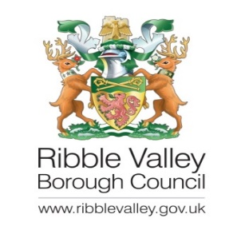
__________________________________________________________________________
please ask for:
direct line:
planning fax:
my ref:
your ref:
date:
Emily Pickup
01200 425111

3/2024/0354

26 June 2024

Dear Sir,

TOWN AND COUNTRY PLANNING (GENERAL PERMITTED DEVELOPMENT) ORDER 2015 PART 6 PRIOR NOTIFICATION OF AGRICULTURAL AND FORESTRY BUILDINGS AND ROADS

Proposal: Prior notification for concrete agricultural track 80m long and 4m wide.
Location: Hall Barns Farm Knowles Brow Hurst Green BB7 9PT.

I refer to your application, made under Schedule 2, Part 6 of the Town and Country Planning (General Permitted Development) Order 2015 and received on 17th April 2023, in which you request the council’s determination as to whether prior approval is required for the above proposal.

It is the Council’s position that the development proposed does not constitute permitted development under Part 6 of the Town and Country Planning (General Permitted Development) Order 2015, Schedule 2, Part 6 for the following reason(s):

Given part of the development falls within the curtilage of the Grade II Listed Barn and the plans indicate that the new hardstanding would interface with the barn elevations, it is considered that prior approval is required in respect of siting and design. Insufficient information has been provided to be able to assess the impact on the significance of the Grade II Listed Building, including any removal of historic fabric, as such prior approval is refused and the proposal as submitted is considered to require planning permission and listed building consent.
Accordingly, the Council have resolved that your application is REFUSED.

For a full assessment of the application please refer to the Officer’s Delegated Report.

Please contact Emily Pickup if you require any further information.
Yours faithfully
Nicola Hopkins
NICOLA HOPKINS - DIRECTOR OF ECONOMIC DEVELOPMENT AND PLANNING

P.T.O.
Mr Alec Hough
B & J Hough & Sons
Hall Barns Farm
Knowles Brow
Hurst Green
BB7 9TP

