RECOMMENDATION FOR PLANNING AND DEVELOPMENT COMMITTEE
APPROVAL

DATE: 19 SEPTEMBER 2024
REF: SK
CHECKED BY: LH

APPLICATION REF: 3/2024/0372

GRID REF: SD 374361 441971

DEVELOPMENT DESCRIPTION:

PROPOSED INSTALLATION OF 113 SOLAR PANELS TO SOUTH-WEST-FACING ROOF
PITCH OVER THE MAIN PEDESTRIAN ENTRANCE, THE NORTH-WEST-FACING ROOF
PITCH OVER THE UNDERGROUND CAR PARK AND THE SOUTH-EAST FACING ROOF
PITCH FACING THE REAR GARDEN AREA. RIBBLE VALLEY BOROUGH COUNCIL OFFICES, CHURCH WALK, CLITHEROE BB7 2RA
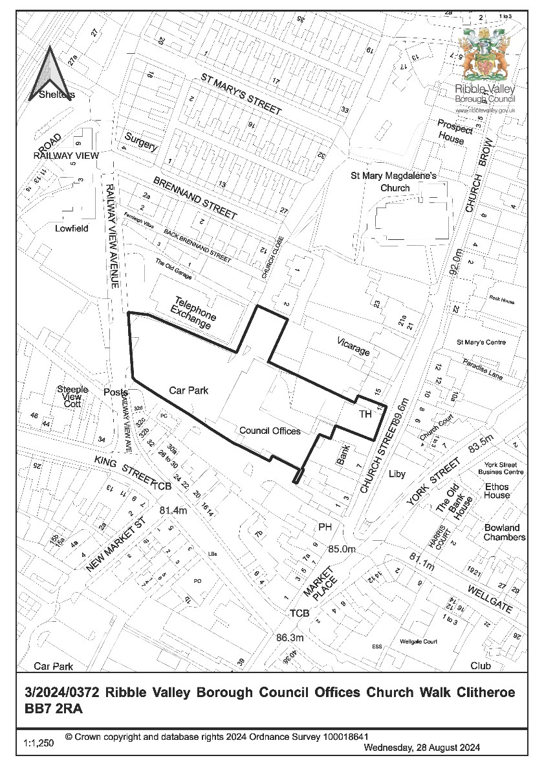
CONSULTEE RESPONSES/ REPRESENTATIONS MADE:

PARISH COUNCIL:

Clitheroe Town Council have raised no objections to the proposal.

ADDITIONAL REPRESENTATIONS:

One letter of representation has been received raising the following concerns:

- No cost benefit analysis has been undertaken
- Queries in relation to the cost of proposed works
- Queries in relation to the expected benefits and timescales for the benefits being achieved • Queries in relation to the lifespan of the proposed panels

1. Introduction

1.1 Members will note that the application is being brought before Committee given the application is made on behalf of Ribble Valley Borough Council with the property to which the application relates also falling within the ownership of the authority.

2. Site Description and Surrounding Area

2.1 The application relates to the Ribble Valley Borough Council Offices located on Church Walk, Clitheroe. The building is located within the designated Clitheroe Conservation Area, also being located within the Main Centre Boundary of the Settlement.

2.2 The building is also located within and is considered to affect the setting of a number of Grade II listed building as follows:

- 3 and 5 Church Street (List Entry: 1072377) Grade II
- 1 Church Street (List Entry: 1318126) Grade II
- White Lion Hotel (List Entry: 1164091) Grade II
- Mytton house and Number 13 (List Entry: 1072329) Grade II
- 15 Church Street (List Entry: 1362178) Grade II

3. Proposed Development for which consent is sought

3.1 The application seeks consent for the installation of 113 solar panels to be accommodated in mounted arrays on the northwest, southwest and southeast (inward facing) roof slopes of the Council Office building. The individual panels will measure approximately 1.75m by 1m, being mounted on a raised bracket system that will result in the panels being raised approximately 100mm above the existing roof surface.

4. Relevant Planning History

No recent planning history directly relevant to the determination of the application.

5. Relevant Policies

Ribble Valley Core Strategy

Key Statement DS1: Development Strategy
Key Statement DS2: Sustainable Development
Key Statement EN3: Sustainable Development and Climate Change
Key Statement EN4: Biodiversity and Geodiversity
Key Statement EN5: Heritage Assets

Policy DMG1: General Considerations
Policy DMG2: Strategic Considerations
Policy DME2: Landscape & Townscape Protection
Policy DME3: Site and Species Protection and Conservation
Policy DME4: Protecting Heritage Assets
Policy DME5: Renewable Energy

Planning (Listed Buildings and Conservation Areas) Act
National Planning Policy Framework (NPPF)

6. Assessment of Proposed Development

6.1 Principle of Development:

6.1.1 The proposal seeks consent for the installation of solar renewable technologies upon an existing building. As such, consideration must be given in respect of the compatibility of the proposal with that of the climate change and energy consumption reduction aspirations within the borough as embodied within the currently adopted development strategy.

6.1.2 In relation to matters of climate change and sustainable forms of development, both Key Statement EN3 and Policy DME5 are primarily engaged for the purposes of assessment. With Key Statement EN3 requiring that ‘all development will be required to demonstrate how it will contribute towards reducing the Borough's carbon footprint’. With Key Statement EN3 further stating ‘all development should optimise energy efficiency by using new technologies and minimising the use of energy’.

6.1.3 With Policy DME5 (Renewable Energy) reading as follows:

‘The Borough Council will support the development of renewable energy schemes, providing it can be shown that such developments would not cause unacceptable harm to the local environment or local amenity. In assessing proposals, the Borough Council will have particular regard to the following issues:

- The immediate and wider impact of the proposed development on the landscape, including its visual impact and the cumulative impacts of development.
- The measures taken to minimise the impact of the proposals on residential amenity
- The potential benefits the proposals may bring
- The visual impact of the proposals, including design, colour and scale
- The degree to which nuisance caused by noise and shadow flicker to nearby residential amenities, agricultural operations, recreational areas or the function of the countryside can be minimised
- National or local targets for generating energy from renewable sources and for reducing carbon emissions as specified within policy DMG1
- The potential impact on biodiversity

The council will require decentralised and renewable or low carbon energy in new developments to meet national standards development proposals within or close to the AONB, sites of special scientific interest, special areas of conservation and special protection areas, notable habitats and species, local nature reserves, biological heritage sites or designated heritage assets and their setting will not be allowed unless:

- The proposals cannot be located outside such statutory designated areas
- It can be demonstrated that the objectives of the designation of the area or site will
- Any adverse environmental impacts as far as practicable have been mitigated

Outside these areas renewable energy schemes will be considered to be appropriate in principle subject to other policies in the plan.

6.1.4 In respect of the above policy considerations/criterion, the application relates to the installation of renewable technologies that will contribute to the reduction of the ‘Boroughs Carbon Footprint’ with the information submitted in support of the application stating that ‘the solar PV system will provide the offices with a level of 20.9% self-sufficiency, avoiding 13,784kg/year CO2 emissions. The PV system is also expected to save £1,042,898 of public money over a 25-year period, that would otherwise be spent on power taken from the grid’. As such the proposal would align with the overall strategic aims of Key Statement EN3 of the Ribble Valley core Strategy.

6.1.5 With the proposed development further aligning with the aims and objectives of Policy DME5 insofar that it would provide demonstrable benefits in relation to the reduction of the carbon footprint in the operation(s) and performance of the existing building.

6.1.6 As such and taking account of the above matters, it is not considered that the principle of the installation of solar panels upon the building, notwithstanding other development management considerations, would result in any significant measurable adverse conflict with Key Statement EN3 nor Policy DME5 of the Ribble Valley Core Strategy in relation to matters of climate change, sustainable forms of development and the use of or implementation of renewable technologies.

6.2 Visual Amenity, External Appearance, and Impact(s) upon Clitheroe Conservation Area:

6.2.1 The application building is located within the designated Clitheroe Conservation Area, also being within and affecting the setting of a number of listed building as follows:

- 3 and 5 Church Street (List Entry: 1072377) Grade II
- 1 Church Street (List Entry: 1318126) Grade II
- White Lion Hotel (List Entry: 1164091) Grade II
- Mytton house and Number 13 (List Entry: 1072329) Grade II
- 15 Church Street (List Entry: 1362178) Grade II

6.2.2 As such, in assessing the proposal, regard must be given to the statutory duties imposed on the authority in respect of the preservation and enhancement of such assets. In this respect, at a local level, Key Statement EN5 and Policy DME4 are primarily, but not solely, engaged for the purposes of assessing likely impacts upon designated heritage assets resultant from the proposed development.

6.2.3 In this respect Key Statement EN5 states that:

There will be a presumption in favour of the conservation and enhancement of the significance of heritage assets and their settings. The Historic Environment and its Heritage Assets and their settings will be conserved and enhanced in a manner appropriate to their significance for their heritage value; their important contribution to local character, distinctiveness and sense of place; and to wider social, cultural and environmental benefits.

This will be achieved through:

- Recognising that the best way of ensuring the long-term protection of heritage assets is to ensure a viable use that optimises opportunities for sustaining and enhancing its significance.
- Keeping Conservation Area Appraisals under review to ensure that any development proposals respect and safeguard the character, appearance and significance of the area.
- Considering any development proposals which may impact on a heritage asset or their setting through seeking benefits that conserve and enhance their significance and avoids any substantial harm to the heritage asset.
- Requiring all development proposals to make a positive contribution to local distinctiveness/sense of place.
- The consideration of Article 4 Directions to restrict permitted development rights where the exercise of such rights would harm the historic environment

6.2.4 With Policy DME4 stating, in respect of development within conservation areas or those affecting the listed buildings or their setting, that development will be assessed on the following basis:

1: CONSERVATION AREAS

Proposals within, or affecting views into and out of, or affecting the setting of a conservation area will be required to conserve and where appropriate enhance its character and appearance and those elements which contribute towards its significance. This should include considerations as to whether it conserves and enhances the special architectural and historic character of the area as set out in the relevant conservation area appraisal. development which makes a positive contribution and conserves and enhances the character, appearance and significance of the area in terms of its location, scale, size, design and materials and existing buildings, structures, trees and open spaces will be supported.

In the conservation areas there will be a presumption in favour of the conservation and enhancement of elements that make a positive contribution to the character or appearance of the conservation area.

2: LISTED BUILDINGS AND OTHER BUILDINGS OF SIGNIFICANT HERITAGE INTEREST

Alterations or extensions to listed buildings or buildings of local heritage interest, or development proposals on sites within their setting which cause harm to the significance of the heritage asset will not be supported. Any proposals involving the demolition or loss of important historic fabric from listed buildings will be refused unless it can be demonstrated that exceptional circumstances exist.

6.2.5 Policy DMG1 is also engaged in concert with Key Statement EN5 and Policy DME4 insofar that the policy sets out general Development Management considerations, with the policy having a number of inherent criterion that are relevant to the assessment of the current proposal, which state:

In determining planning applications, all development must:

DESIGN
- Be of a high standard of building design which considers the 8 building in context principles (from the CABE/English Heritage building on context toolkit.
- Be sympathetic to existing and proposed land uses in terms of its size, intensity and nature as well as scale, massing, style, features and building materials.
- Consider the density, layout and relationship between buildings, which is of major importance. particular emphasis will be placed on visual appearance and the relationship to surroundings, including impact on landscape character, as well as the effects of development on existing amenities.

AMENITY

1. Not adversely affect the amenities of the surrounding area.

ENVIRONMENT

3. All development must protect and enhance heritage assets and their settings.

6.2.6 In respect of visual impacts or impacts upon the character and visual amenities of the designated Clitheroe Conservation Area. The submitted details propose the installation of 113 solar panels to be accommodated on the northwest, southwest and southeast (inward facing) roof slopes of the Council Offices. Those located on the southwest and northwest facing roof slopes are those which are likely to be afforded a high degree of visibility from the public realm, also being afforded significant visibility on approach from multiple viewpoints within the designated Clitheroe Conservation Area.

6.2.7 It is considered that the introduction of solar panelling, to this degree and quantum, would normally be considered to represent and result in the introduction of a discordant, incongruous and anomalous introduction into the roofscape within the Clitheroe Conservation Area.

6.2.8 However, whilst the panels will be visible within the Conservation Area and be read in context with nearby built-form associated with the designation, the building upon which the panels are to be mounted is not considered to be part of the historic fabric of the Conservation Area with the Council Offices being of a more recent and modern construction and appearance. With the modern appearance of the building acting to mitigate the likely perceived visual impact of the panels and their introduction into the area.

6.2.9 As such, taking account of the above matters, it is not considered that the proposed development raises any significant direct conflict(s) with Key Statement EN5 or Policies DMG1 and DME4 of the Ribble Valley Core Strategy, nor any significant measurable conflicts with the aims, objectives and requirements of Sections 16 and 66 of the Planning (Listed Buildings and Conservation Areas) Act 1990 nor Paragraphs 205 and 208 of the National Planning Policy Framework. Particularly In respect of measurable adverse impacts upon the character or visual amenities of the designated Clitheroe Conservation Area or the significance or character of the setting of nearby designated heritage assets.

6.3 Impact(s) upon Residential Amenities:

6.3.1 Given the proposal seeks consent for the installation of a significant number of solar panels upon an existing building, consideration must be given in respect for the potential for the proposal to result in undue impacts upon nearby existing residential amenity. Taking account of the siting of the panels and taking account of the absence of any immediate nearby residential receptors that are likely to be directly affected by the installation of the panels it is not considered the proposal will result in any adverse impacts upon nearby residential amenity.

6.3.2 Taking account of the above, the proposal raises no significant measurable conflict with Policy DMG1 of the Ribble Valley Core Strategy which seeks to protect against development(s) that will result in measurable adverse impacts upon nearby existing or future residential amenities.

6.4 Landscape and Ecology:

6.4.1 Given the proposal involves works to multiple areas of the existing roof, the application has been accompanied by a Bat Survey Report and Method Statement. The submitted report concludes that no evidence was recorded to suggest the building accommodates significant or low conservation value roosts with no bats having been recorded emerging from the building.

6.4.2 As such and taking account of the above, the proposal does not raise any significant measurable conflict(s) with Policies DME1, DME2 nor DME3 of the
Ribble Valley Core Strategy which seek to protect against adverse impacts upon habitat, biodiversity, ecology or protected species and species of conservation concern.

7. Observations/Consideration of Matters Raised/Conclusion

7.1 For the reasons outlined above, the application is recommended for approval insofar that the proposal will not result in any significant adverse impacts, nor will the proposal result in significant measurable conflicts with the aims and objectives of the Ribble Valley Core Strategy that would warrant the refusal to grant planning permission in this instance.

RECOMMENDATION: That the application be APPROVED subject to the imposition of the following condition(s):

- The development hereby approved must be begun not later than the expiration of three years beginning with the date of this permission.

REASON: Required to be imposed by Section 51 of the Planning and Compulsory Purchase Act 2004.

- Unless explicitly required by condition within this consent, the development hereby permitted shall be carried out in complete accordance with the proposals as detailed on drawings:

Proposed Plan: Sheet 2
Proposed Elevations: Sheet 4
Site Location Map: Sheet 5
Details DWG: Sheet 6
PV Module Dimensions

REASON: For the avoidance of doubt and to clarify which plans are relevant to the consent hereby approved.

BACKGROUND PAPERS

https://webportal.ribblevalley.gov.uk/site/scripts/planx_details.php?appNumber=3%2F2024%2F 0372

