RECOMMENDATION FOR PLANNING AND DEVELOPMENT COMMITTEE

**APPROVAL**

|  |  |
| --- | --- |
| **DATE:** | **28 November 2024** |
| **REF:** | **LW** |
| **CHECKED BY:** | **LH** |

**APPLICATION REF: 3/2024/0465**

GRID REF: SD 359961 437763

**DEVELOPMENT DESCRIPTION:**

INSTALLATION OF 2.4M HIGH WIRE MESH PERIMETER SECURITY FENCE AND GATES INCLUDING ELECTRONICALLY CONTROLLED SLIDING VEHICULAR GATE TO BARNACRE ROAD.

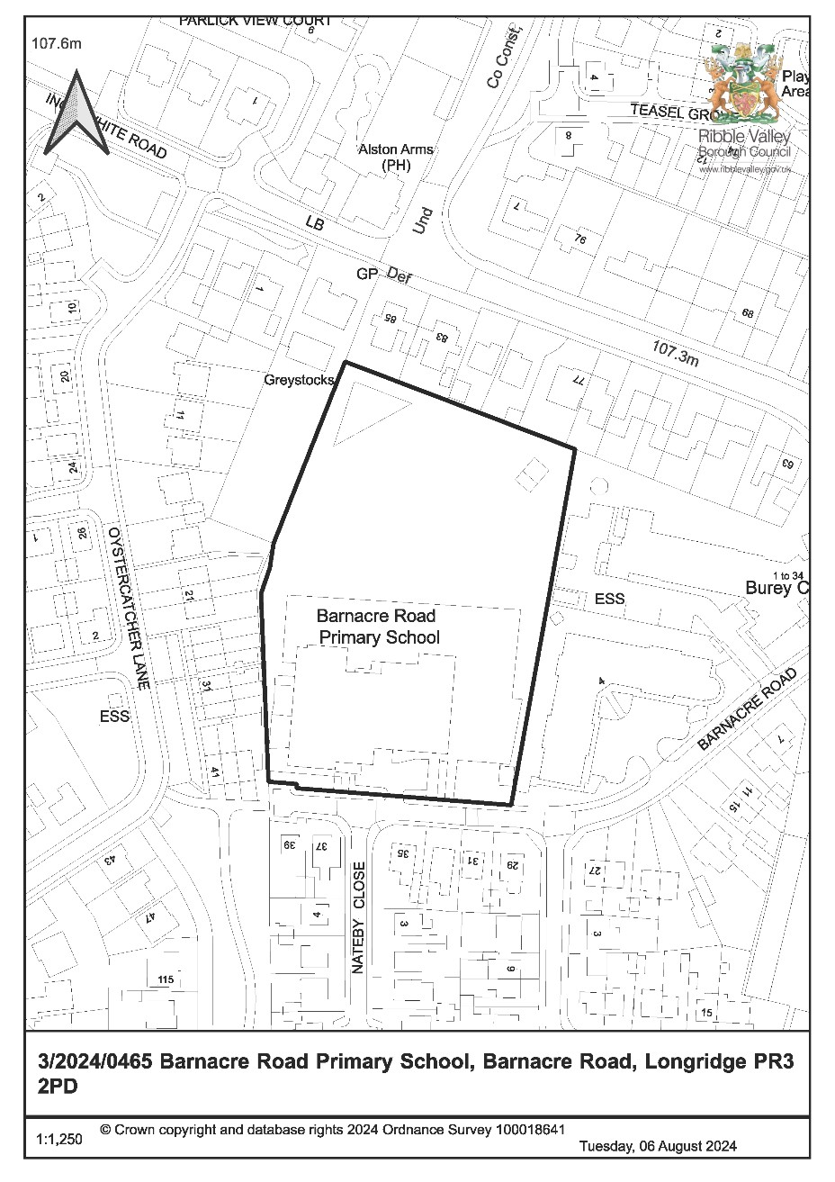

**CONSULTEE RESPONSES/ REPRESENTATIONS MADE:**

**PARISH COUNCIL:**

A consultation response from Longridge Town Council was received on 23rd August 2024 with the following comments:-

* The fence is too high
* The density and style of the mesh makes it appear ‘wall-like’
* The fence is being sited too close to a footpath

**LANCASHIRE COUNTY COUNCIL HIGHWAYS:**

A consultation response from Lancashire County Council (LCC) Highways was received on 18th July 2024 raising no objection to the proposed development.

**PRESTON CITY COUNCIL**

A consultation response from Preston City Council was received on 8th August 2024 raising no objections.

**ADDITIONAL REPRESENTATIONS:**

Letters of representation have been received from 11 households objecting to the proposed development. In addition, a petition letter has been received on behalf of 4 households and another petition letter has been received on behalf of 3 households. The issues raised within these objections can be summarised as below:

* Loss of views;
* Overbearing impact;
* Lack of justification for the proposed development;
* Impact on trees and habitat;
* Financial implications on property values;
* Noise disturbance caused by electric gate.

One letter of support has also been received, for reasons relating to security and safeguarding.

# 1. **Site Description and Surrounding Area**

1.1 The application relates to the boundary surrounding Barnacre Road Primary School, located to the north of Barnacre Road. The site to which the application relates is located within the defined settlement limits of Longridge and directly adjacent the boundary with Preston City Council. The area surrounding the site is primarily residential in character.

# 2. **Proposed Development for which consent is sought**

2.1 The application seeks consent for the erection/ installation of new perimeter fencing to enclose the land associated with Barnacre Road Primary School. The existing section of fencing installed to the eastern boundary of the site, adjacent Longridge Hall and Longridge Lodge is proposed to be retained, while new 2.4m high wire mesh perimeter fencing is proposed to be installed to the remaining boundary.

2.2 To the southern boundary of the site, adjacent Barnacre Road, 8 wire mesh gates are also proposed, including an electronically controlled sliding vehicular gate.

2.3 The proposed fencing design has been amended since the initial submission of the application to incorporate a less dense wire mesh.

# 3. **Relevant Planning History**

3/2021/1147: Provision of two timber units to Barnacre Road Primary School (Approved).

3/2021/0414: Installation of timber shelter on school playing field (Approved).

4. **Relevant Policies**

# Ribble Valley Core Strategy (Adopted Version)

Key Statement DS1 – Development Strategy

Key Statement DS2 – Presumption in Favour of Sustainable Development Key Statement DMI2 - Transport Considerations

Policy DMG1 – General Considerations

Policy DMG2 – Strategic Considerations

Policy DMG3 – Transport and Mobility

Policy DME1 – Protecting Trees and Woodlands

*National Planning Policy Framework*

# National Planning Practice Guide

## 5. Assessment of Proposed Development

5.1 Principle:

5.1.1 The proposal relates to the erection of new perimeter fencing to enclose the land associated with Barnacre Road Primary School, located within the defined settlement area of Longridge.

5.1.2 The submitted supporting statement states that the fencing is required for pupil welfare reasons, with several children presenting a flight risk and often seeking ways to exit the school site via neighbouring gardens. The lack of existing fencing also offers minimal security to the school site, allows intruders to access the site and thus presenting significant safeguarding concerns.

5.1.3 It is therefore proposed to erect new perimeter fencing to enclose the school grounds in order to secure the site.

5.1.4 In view of the proposal being functional development in association with an existing school site, the proposed development is acceptable in principle subject to an assessment of the material planning considerations.

5.2 Residential amenity:

5.2.1 Given the proposal seeks consent for the installation of a new perimeter fence within close proximity to existing nearby residential receptors, consideration must be given in respect to whether the proposed fencing would result in any

undue impact upon nearby residential amenities by virtue of overbearing impact or significant loss of outlook, natural light or privacy.

5.2.2 In this respect, Policy DMG1 of the Ribble Valley Core Strategy is engaged which requires that development proposals must take ‘account of the effects on existing amenities’ and should not ‘adversely affect the amenities of the surrounding area’.

5.2.3 The submitted details propose the installation of perimeter wire mesh fencing at a height of 2.4m adjacent to the rear boundaries of the properties situated to the eastern side of Oystercatcher Lane and southern side of Inglewhite Road. The proposal would also be sited along the common boundary with Burley Court and adjacent the residential properties situated to the opposite side of Barnacre Road.

5.2.4 Despite this, the proposed fencing would remain in excess of 16m from Burley Court, and a minimum of 8m and 5m from the residential properties along Inglewhite Road and Oystercatcher Lane respectively. The proposed fencing and gates to the front of the site would also be sited approximately 15m from residential properties along Barnacre Road, separated by the public highway.

5.2.5 In view of these separation distances and taking into account the level of transparency inherent to the fencing proposed, it is not considered that the installation would significantly reduce daylight or outlook from the main dwellinghouses of these neighbouring residential receptors or their associated gardens to a degree that would warrant the refusal to grant planning permission.

5.2.6 Furthermore, the loss of a view from a private property is not a material planning consideration, nor is the reduction in private property value, and it is not considered that the proposed vehicular gate would result in any significant degree of noise disturbance.

5.2.7 Taking account of the above matters, the proposal does not raise any significant direct conflict with Policy DMG1 of the Ribble Valley Core Strategy which seeks to protect existing and future residential amenities from undue negative impacts.

5.3 Visual amenity:

5.3.1 It is acknowledged that the fencing arrangement would be afforded a high level of visibility from the adjacent public realm along Barnacre Road. However, the proposed fencing would be read largely in context with the existing Barnacre Road Primary School and associated playing field/ buildings and reflects that which is commonly seen along the boundaries of school grounds.

5.3.2 The impact on the public realm would also be immediate to the site frontage along Barnacre Road, as opposed to having a wider impact upon the surrounding area and the design of the fencing has been amended since the initial submission of the application to incorporate a less dense wire mesh, further reducing the visual impacts of the proposal.

5.3.3 Taking account of the above and given the level of visual permeability inherent to the fencing provisions, it is not considered that its presence would result in

any significant detrimental impact upon the character or visual amenities of the area that would warrant the refusal of the application.

5.3.4 Accordingly, and taking account of the above, the proposal does not raise any direct conflicts with Policy DMG1 of the Ribble Valley Core Strategy insofar that there will be no significant undue harm upon the visual amenities of the area resultant from the proposed development.

5.4 Landscape and Ecology:

5.4.1 It is noted that a number of mature trees are sited within close proximity to the northern, eastern and western boundaries of the site, adjacent the common boundaries with Burley Court and the residential properties along Inglewhite Road and Oystercatcher Lane.

5.4.2 An Arboricultural Impact Assessment has been submitted, dated 25th September 2024. No trees are required to be removed to facilitate the development, with some crown raising required to achieve clearance of the fencing. Should the mitigation measures outlined within the Arboricultural Method Statement and Tree Protection Plan be adhered to, then the installation of the fencing would not result in any adverse impacts.

5.4.3 In view of the above, should the application be approved, it is considered appropriate to attach a condition to ensure that the works are carried out in strict accordance with the submitted Arboricultural Impact Assessment, Arboricultural Method Statement and Tree Protection Plan.

5.4.4 It is noted that concerns have been raised in respect to disturbance of habitat, however given the nature of the proposed development and the minimal impacts upon trees identified, it is not considered that the proposal would result in any significant adverse impact upon local habitat or wildlife populations

5.4.5 In view of the above, no significant harm to landscape and ecology have been identified. Accordingly, and taking account of the above, the proposal does not raise any direct conflicts with Policy DME1 of the Ribble Valley Core Strategy.

5.4.6 The development is exempt from having to achieve the mandatory Biodiversity Net Gain requirement as it is subject to the de minimis exception.

5.5 Highways:

5.5.1 The proposal will result in new vehicular access gates onto Barnacre Road. LCC Highways have been consulted on the proposed development and raise no objection. The Local Highway Authority are of the opinion that the proposed development would not have a significant impact on highway safety, capacity or amenity in the immediate vicinity of the site.

5.5.2 However, the Highways Officer notes that the proposal site is located within a residential area and therefore a condition restricting construction delivery times to outside school drop-off and pick-up times is considered appropriate in the interest of highway safety.

1. **Observations/Consideration of Matters Raised/Conclusion:**

* 1. The proposal would not result in any undue impact upon the amenity of any neighbouring residents, nor is it considered that the proposal would be significantly harmful to the visual amenities of the surrounding area, ecology, or highway safety. Furthermore, there are benefits from the scheme in terms of school security and pupil safeguarding which have also been considered.

* 1. As such, for the above reasons and having regard to all material considerations and matters raised, the application is recommended for approval.

**RECOMMENDATION:**

That planning permission be APPROVED subject to the following conditions:

# Time Scale for Implementation of Consent

1. The development must be begun not later than the expiration of three years beginning with the date of this permission.

REASON: Required to be imposed by Section 51 of the Planning and Compulsory Purchase Act 2004.

# Approved Plans and Documents

2. Unless explicitly required by condition within this consent, the development hereby permitted shall be carried out in complete accordance with the proposals as detailed on drawings:

Location Plan (1:1250)

Site Plan (dwg no. 10638-P-01 Rev 00)

Fencing Elevation (dwg no. S910638-P-04)

Gate Elevation (dwg no. S910638-P-03)

REASON: For the avoidance of doubt and to clarify which plans are relevant to the consent.

# Materials

3. The materials to be used on the external surfaces of the development hereby approved as indicated within the application form and on drawing(s) ‘Fencing Elevation’ (dwg no. S910638-P-04) and ‘Gate Elevation’ (dwg no. S910638-P-03) shall be implemented as indicated.

REASON: In order that the Local Planning Authority may ensure that the materials to be used are appropriate to the locality and respond positively to the inherent character of the area.

# Ecology

4. All tree works/ tree protection shall be carried out in strict accordance with the submitted Arboricultural Impact Assessment (Report No. 2026_AIA.01), Arboricultural Method Statement (Report No. 2026_AMS.01), Tree Protection Plan (dwg no. 2026_AIA.TPP.01) and British Standard BS 5837:2012.

REASON: To protect trees/ hedging of landscape and visual amenity value on and adjacent to the site or those likely to be affected by the proposed development hereby approved.

# Highways

5. During the construction phase of the boundary fencing/gates hereby permitted there shall be no deliveries to site or removal of existing materials from site before 9:30am and between 3:00pm and 4:00pm Monday to Friday during school term time.

REASON: In the interest of protecting residential amenity and to ensure the safe operation of the Highway for the duration of the construction phase of the development.

BACKGROUND PAPERS

<https://webportal.ribblevalley.gov.uk/planningApplication/36518>