Agenda Item 5c

RECOMMENDATION FOR PLANNING AND DEVELOPMENT COMMITTEE

**APPROVAL**

**DATE: 9 JANUARY 2025**

**REF: EP**

**CHECKED BY: LH**

**APPLICATION REF: 3/2024/0612**

GRID REF: SD 376854 435018

**DEVELOPMENT DESCRIPTION:**

PROPOSED CHANGE OF USE AND COVERSION OF SINGLE-STOREY GARAGE/WORKSOP TO TWO-STOREY, TWO-BEDROOM HOLIDAY LET, INCLUDING NEW PITCHED ROOF.

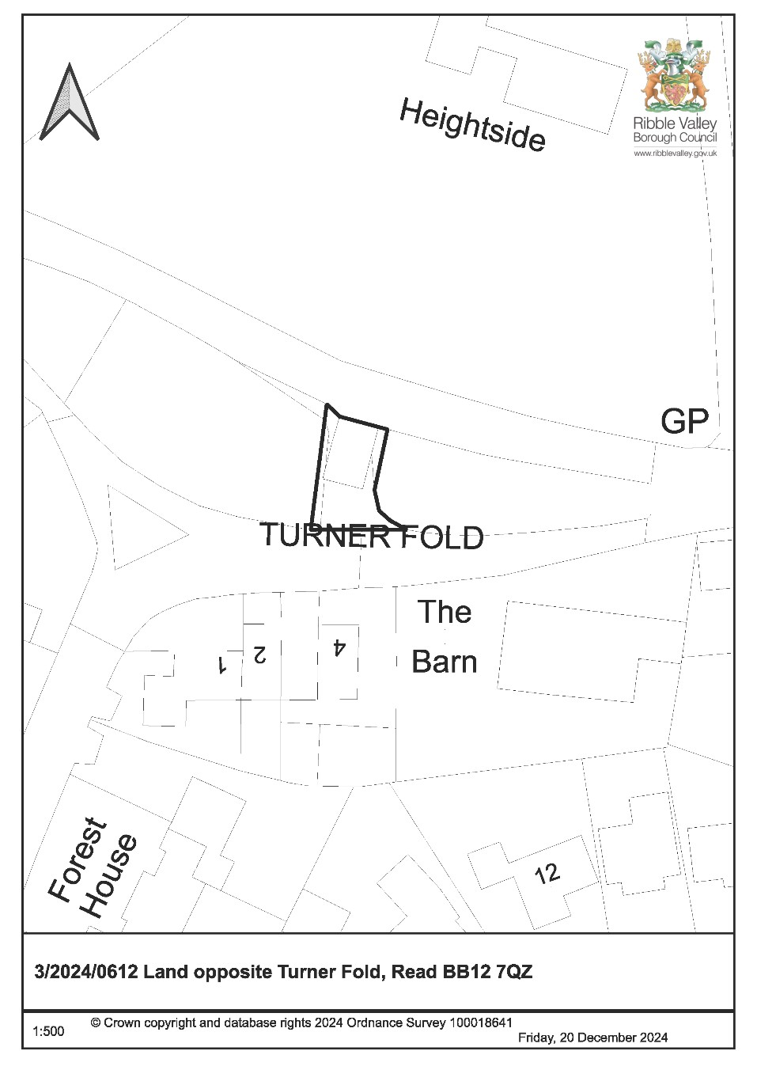

**CONSULTEE RESPONSES/ REPRESENTATIONS MADE:**

**PARISH COUNCIL:**

No representations received in respect of the application.

**LCC HIGHWAYS:**

LCC Highways raised some initial comments on the application, requesting additional details in respect to the visibility splays. They also queried 2 car parking spaces that were shown outside the neighbouring No.3 Turner Fold. These parking spaces have since been omitted from the plans as they were not part of the proposal.

Visibility splay plans have since been received and further comments from LCC confirm these are acceptable.

**ADDITIONAL REPRESENTATIONS:**

One letter of support has been received on the basis that the development will improve the outlook of the area and will encourage tourism development to the village.

Members will additionally note that a ward councillor has requested that this application is determined by Planning and Development committee for the following reasons:

* The proposed development would result in a departure from planning policy as the site is outside of the settlement boundary.
* Potential impact on residential amenity.
* Concerns over car parking, traffic and drainage.

# 1. Site Description and Surrounding Area

1.1 The application relates to a small parcel of land, located outside of any defined settlement limits, accommodating a detached garage/workshop. The surrounding area is predominantly residential in nature and the application site itself does not fall on any designated land.

# 2. Proposed Development for which consent is sought

2.1 The application seeks consent for the change of use of the existing garage structure to accommodate a 2 bedroomed holiday let.

2.2 There are various alterations proposed to accommodate the conversion, including an increase in the height of the structure, the addition of a pitched roof and the insertion of new doors and windows.

2.3 The application also seeks consent for the alteration of the existing driveway, to provide additional parking which will serve both the holiday let and the opposite neighbouring property, No.3 Turner Fold.

3. **Relevant Planning History**

No recent planning history.

# 4. Relevant Policies

**Ribble Valley Core Strategy**

Key Statement DS1: Development Strategy

Key Statement DS2: Sustainable Development

Key Statement EC3: Visitor Economy

Key Statement DMI2: Transport Considerations

Policy DMG1: General Considerations

Policy DMG2: Strategic Considerations

Policy DMG3: Transport & Mobility

Policy DMB1: Supporting Business Growth and the Local Economy Policy DMB3: Recreation and Tourism Development

Planning (Listed Buildings and Conservation Areas) Act

National Planning Policy Framework (NPPF)

# 5. Assessment of Proposed Development

5.1 Principle of Development:

5.1.1 Core Strategy Key Statement EC3, which relates to the visitor economy, stipulates that proposals that contribute to and strengthen the visitor economy of Ribble Valley will be encouraged, including the creation of new accommodation and tourism facilities through the conversion of existing buildings.

5.1.2. The proposal is for the conversion of an existing building, that is falling into a state of disrepair. The development therefore complies with KS EC3.

5.1.3 The application site is outside of Read settlement boundary. In accordance with Policy DMG2, development outside of the settlement boundary is allowed when used for small scale tourism or recreational purposes, providing they are appropriate to the rural area.

5.1.4 The proposal is for a two-bedroomed holiday let, which is considered small scale. Although outside of the settlement boundary, the site is immediately adjacent to it, being in close proximity to existing dwellings and other built form. The proposal is therefore not considered inappropriate to the area.

5.1.5 Policy DMB3 states that tourism development will be supported, subject to the following criteria.

1. *The proposal must not conflict with other policies of this plan;*
2. *The proposal must be physically well related to an existing main settlement or village or to an existing group of buildings, except where the proposed facilities are required in conjunction with a particular countryside attraction and there are no suitable existing buildings or developed sites available;*
3. *The development should not undermine the character, quality or visual amenities of the plan area by virtue of its scale, siting, materials or design;*
4. *The proposals should be well related to the existing highway network. It should not generate additional traffic movements of a scale and type likely to cause undue problems or disturbance. Where possible the proposals should be well related to the public transport network;*
5. *The site should be large enough to accommodate the necessary car parking, service areas and appropriate landscaped areas; and*
6. *The proposal must take into account any nature conservation impacts using suitable survey information and where possible seek to incorporate any important existing associations within the development. Failing this then adequate mitigation will be sought.*

5.1.6 The application site is immediately adjacent to the settlement boundary and is well related to existing facilities including highway networks. The proposed twobedroomed accommodation will result in a small increase in visitor traffic, but not to a degree that would be inappropriate to the area and car parking is available at the site.

5.1.7 Based on the above assessment, the proposed development is considered acceptable in principle subject to other material planning considerations, including impact on the visual amenity of the area and nature conservation.

5.2 Impact upon Residential Amenity:

* + 1. The application site is directly opposite a row of terraced cottages, No.1-No.4 Turner Fold. As such, consideration must be given into any adverse impact as a result of the change of use and associated alterations.

* + 1. Firstly, there are a number of new glazed openings proposed on the principal elevation of the holiday let. These new openings will directly face the properties on Turner Fold, however, there is a suitable separation distance of approximately 21 metres between habitable windows, to mitigate any significant perception of overlooking or loss of privacy. In addition, the glazed openings at first floor are well above ground level and would therefore offer limited opportunity for overlooking.

* + 1. Secondly, the height of the existing garage will be altered to accommodate a firstfloor level within the holiday let. The existing sloping roof will be removed and relaced with a pitched roof. The overall height increase is approximately 1 metre to the ridge. Due to the separation distance between the building and the neighbouring receptors, it is not considered there would be any substantial sense of overbearing or any loss of light created resultant that would warrant refusal.

* + 1. Lastly, in respect to the change of use, it is expected that there will be an increase in activity resultant. Development of this nature has the potential to cause noise disturbance for neighbouring properties. However, given the small scale of the proposal, it is not expected that any noise impact would be to a degree that would be of detriment to the neighbouring receptors along Turner Fold.

* + 1. Consequently, the proposed development is acceptable from a residential amenity perspective in line with Policy DMG1 of the Core Strategy.

5.3 Visual Amenity/External Appearance

* + 1. As part of the conversion of the garage building, there are various external alterations proposed. Given the siting of the holiday let, fronting Turner Fold, the development will be afforded high levels of visibility. Therefore, careful consideration must be given into the impact of the proposal upon the character of the area.

* + 1. The existing garage building is comprised of stone, red facing brickwork with elements of wooden cladding and a corrugated metal roof. As existing, the structure does not integrate well into the street scene and would not be considered a positive feature. It is proposed that the structure will be faced almost entirely in stone with some elements of timber cladding and powder coated aluminium windows. The proposed materials are consistent with other properties in the vicinity and would therefore integrate sufficiently into the area.

* + 1. The proposed alterations to the roof, to accommodate a pitch, will increase the structures visual prominence. However, the existing sloping, corrugated metal roof is a poor design, and the pitched roof holiday let will benefit from architectural details that the existing building lacks. It is therefore considered that the proposal will contribute positively to the character of the area and will result in visual improvement of the overall street scene.

* + 1. The principal elevation of the holiday let will benefit from a considered window fenestration, that is not overly domestic in appearance. The proposed holiday let will therefore read more as a utilitarian structure, similar to the existing arrangement, and not a separate detached dwelling.

* + 1. As such, the proposed development will contribute positively to the character of the area without causing visual harm in compliance with Policy DMG1 and DMB3 of the Core Strategy.

5.4 Landscape and Ecology:

* + 1. A bat survey was conducted at the application site with various visits taking place on dates between July and September 2024. The survey concluded that there was no evidence of bats roosting within the building itself, and no further surveys are required. As low numbers of bats were recorded in the area, a precautionary approach to development should be taken and, in the event bats are discovered, work should cease immediately.

* + 1. An arboricultural constraints appraisal has been conducted at the site. No trees are proposed for removal, and it is not expected that the works will have any adverse impact on trees, but the works should be carried out in accordance with the Tree Protection measures outlined in the report.

5.5 Highway Safety and Accessibility:

* + 1. The proposed development involves the widening of the existing parking area that currently serves the garage structure to accommodate 4 parking spaces.

* + 1. It is understood that the existing parking area at the front of the garage is utilised by one of the neighbouring properties opposite on Turner Fold. It has been agreed between the neighbour and applicant that said parking area will be retained for use by the neighbouring receptor. As such, 2 parking spaces proposed will serve the holiday let, whilst the other 2 will remain available for the neighbour.

* + 1. LCC Highways were consulted in relation to the proposal and raised some initial queries regarding the parking arrangements at the site and requested plans outlining the required visibility splays.

* + 1. A plan displaying the required visibility splays has been provided and sent to LCC Highways for review and has been deemed acceptable from a highway safety perspective. As such the development satisfies policies DMG3 and DM12 of the Core Strategy.

# 6. Observations/Consideration of Matters Raised/Conclusion

6.1 For the reasons outlined above the proposed development is considered to meet the relevant Core Strategy policies as such is recommended for approval.

RECOMMENDATION: That the application is recommended for approval subject to the following conditions.

1. The development must be begun not later than the expiration of three years beginning with the date of this permission.

REASON: Required to be imposed by Section 51 of the Planning and Compulsory Purchase Act 2004.

1. Unless explicitly required by condition within this consent, the development hereby permitted shall be carried out in complete accordance with the proposals as detailed on drawings:

Proposed Elevations and Plans 2352-PR01 C

Extent of Demolition Plan 2352-PR02

Block Plan and Location Plan BLP01

Existing and Proposed Site Sections SS01 A

Visibility Plan 4472-F01

Arboricultural Constraints Appraisal Prepared by Bowland Tree Consultancy LTD

REASON: For the avoidance of doubt and to clarify which plans are relevant to the consent hereby approved.

1. The materials to be used on the external surfaces of the development as indicated on the Application Form hereby approved and as contained within the submitted information shall be implemented in accordance with the approved details.

REASON: In order that the Local Planning Authority may ensure that the materials to be used are appropriate to the locality and respond positively to the inherent character of the area.

1. Notwithstanding the provisions of The Town and Country Planning (Use Classes) (Amendment) (England) Order 2015, or any equivalent Order following the revocation and re-enactment thereof (with or without modification), the holiday unit hereby approved shall only be used as short-term holiday accommodation and for no other purpose.

REASON: For the avoidance of doubt, and to avoid an over-intensive use and to ensure that the development remains compatible with the character of the area and the intensity and frequency of usage remains proportionate to the use hereby approved.

1. The holiday unit hereby approved shall not be let to or occupied by the owner, any one person or group of persons for a combined total period exceeding 3 months in any one calendar year and in any event shall not be used as a unit of permanent accommodation or any individual(s) sole place of residence.

The owner shall maintain a register of all guests of the accommodation hereby approved at all times and shall be made available for inspection by the Local Planning Authority on request. For the avoidance of doubt the register shall contain the name and address of the owner and the main guest who made the booking together with dates of occupation.

REASON: The permission relates to the provision of holiday accommodation. The condition is necessary to define the scope of the permission hereby approved and to ensure that the development promotes sustainable tourism and contributes to the area's economy.

1. During the construction period, all trees to be retained shall be protected in accordance with British Standard BS 5837:2012 or any subsequent amendment to the British Standard.

REASON: To protect trees/hedging of landscape and visual amenity value on and adjacent to the site or those likely to be affected by the proposed development hereby approved.

1. Prior to first use of the development hereby permitted, the car parking shown on the approved plans shall be provided and paved in a bound and porous material. Surface water shall be collected prior to being deposited onto the adjoining highway Turner Fold.

Reason: In the interests of highway safety.

1. Prior to first use of the development hereby permitted a secure cycle store for 2 bicycles shall be provided and maintained thereafter for that purpose.

Reason: To support sustainable travel.

1. The visibility splays shown on the submitted drawing shall be maintained with all vegetation, walls, fences, etc shall be kept below 1m high in perpetuity.

Reason: In the interests of highway safety.

BACKGROUND PAPERS

<https://webportal.ribblevalley.gov.uk/planningApplication/36665>