

TREE WORK ASSESSMENT

DATE INSPECTED: |  |  |  |  |  |  |  | 30 August 2024
TPO: | 111 – 1991 Brockhall
CONSERVATION AREA: |  |  |  |  | No
APPLICATION NO: |  |  |  | 3/2024/0670
SPECIES: |  | Ash
BS5837 CAT: |  |  | U |  |  | ASSESSOR: |  |  | A Shutt
 |  |  |  |  |  | SIGNATURE: |  |  | LH
VISUAL TREE ASSESSMENT / COMMENTS

8 Ash trees have succumbed to Hymenoscyphus fraxineus (Ash Dieback) and require immediate removal. Verbal consent was given on the date of inspection due to the trees dangerous condition. Landowner is replacement planting with 8 oak and 8 horse chestnut they have self-cultivated.

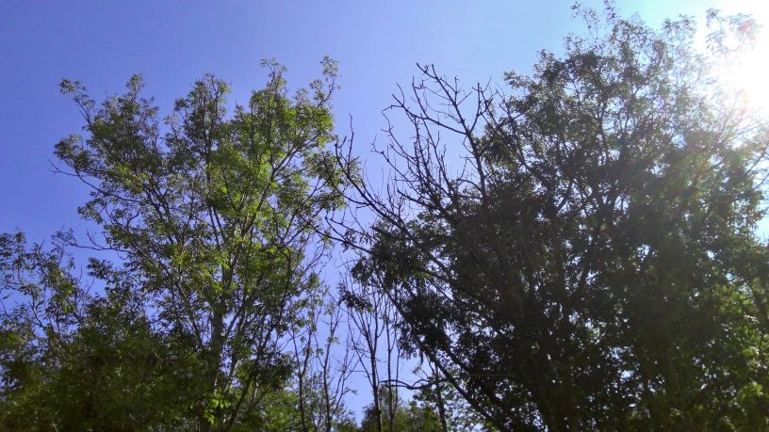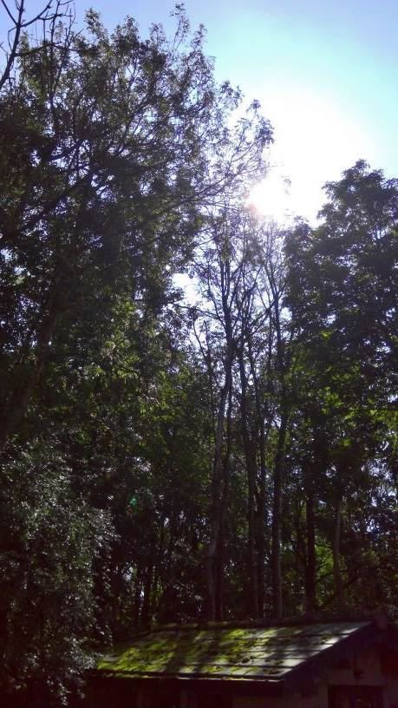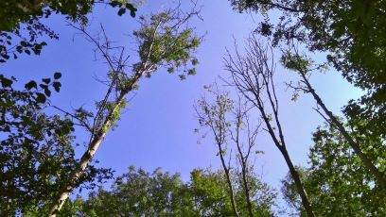

RELATED ISSUES: | YES |  | NO |  |  |  |  | YES | NO
Planning Application |  |  |  |  | Highway issue |  |  |  | 
Statutory Undertaker |  |  |  |  | Damage to property (proven) |  |  |  | 
Health & safety issues |  |  |  |  | Nuisance |  |  |  | 
Other (describe)* |  |  | 
AMENITY EVALUATION: |  | YES |  | NO
Carried out |  | N/A |  | N/A
Necessary |  | N/A |  | N/A

Application works appropriate? | YES 
Why?

Trees are dead or dying due to Hymenoscyphus fraxineus, replacement planting will be conditioned as per landowner’s suggestions.

Alternative works more appropriate? | NO 
Describe Alternative Works:

