Agenda Item 5e
RECOMMENDATION FOR PLANNING AND DEVELOPMENT COMMITTEE

REFUSAL

DATE: 9 JANUARY 2025
REF: SK
CHECKED BY: LH

APPLICATION REF: 3/2024/0851

GRID REF: SD 373644 436723

DEVELOPMENT DESCRIPTION:

RETROSPECTIVE PLANNING APPLICATION FOR THE RETENTION OF A SINGLE
DWELLING HOUSE AND ASSOCIATED PARKING, SOFT AND HARD LANDSCAPING AND
ASSOCIATED WORKS. 4A WISWELL LANE, WHALLEY BB7 9AF
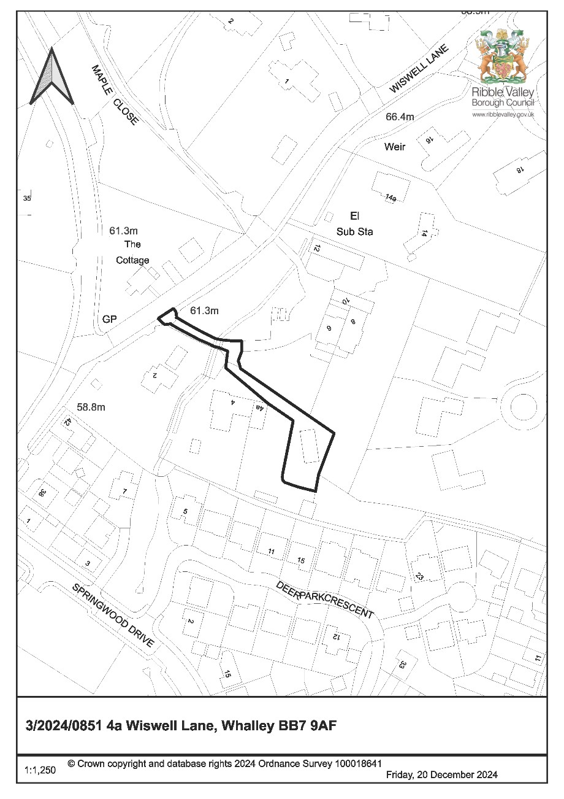
CONSULTEE RESPONSES/ REPRESENTATIONS MADE:

PARISH COUNCIL:

No representations received in respect of the proposal.

LOCAL HIGHWAYS AUTHORITY (LANCASHIRE COUNTY COUNCIL HIGHWAYS):

The Local Highways Authority have raised concerns regarding the proposal stating the following:

Summary:
Lancashire County Council acting as the Local Highway Authority raises concerns over the proposed development as it will result in an increase to the traffic flow at the access point to the site off Wiswell Lane.

Site Access:
The proposal will utilise an existing private access track which leads onto Wiswell Lane, which is an unclassified road subject to a 30mph speed limit. The access onto Wiswell Lane is approximately 3.5m wide and onsite observations noted that the access has a limited visibility splay due to the existing boundary walls which appear to be over 1m tall and vegetation situated at either side of the access.

In 2018 in response to planning applicant 3/2018/1017, which proposed to increase the number of dwellings within the land of 4A Wiswell Lane from one dwelling to 3 the local highway authority raised concerns over the intensification of the use of a substandard access.

Since 2018, planning permission was granted for one additional dwelling on the site under application 3/2020/0006. However, this did not address the concerns previously raised regarding the intensification of the use of the access.

The current proposal will result in 3 separate dwellings on the wider site, 4A, the dwelling approved under application 3/2020/0006 and the retention of the proposal. Increasing the number of dwellings using the access onto Wiswell Lane. There are also 6 existing dwellings which currently use the private access track to access Wiswell Lane. With the proposal, there would be a total of 9 dwellings using the private access track which is also limited in width and does not support two-way movement, along with the access which does not meet current standards.

Whilst there are two access's for the private access track, the one closest to 4A Wiswell is the most preferred access to use due to its positioning and width in comparison to the other access. On-site observations did not note any formalised one-way system on the private access track.

In line with the LHA's guidance the access onto Wiswell Lane should be at least 5.5m wide for at least 5m into the site to accommodate safe and efficient two-way traffic flow for residents and emergency vehicles. However, the access from Wiswell Lane is considerably narrower than this required width and therefore is substandard. The LHA are aware that the access falls within thirdparty ownership which precludes any potential improvements to the access. There is also a concern that the access's visibility is unlikely to meet current standards.

Internal Layout:
The LHA has reviewed drawing number 6180 P01 titled Proposed Site Plan and are aware that the dwelling complies with the LHAs parking standards as defined in the Joint Lancashire Structure Plan. Supplementary to this a swept path analysis has been included within the Highway Technical Note (Appendix A) provided by the applicant showing that vehicle can turn within the site. While this option is technically possible, implementing it successfully in practice may be challenging due to the limited space available within the parking area. Given the limited width of the private access track and the nature of the access onto Wiswell Lane entering and exiting the site in forward gear is essential.

Conclusion:
While the proposal intends to utilise the existing access onto Wiswell Lane, it presents challenges due to the substandard width and limited visibility. Historical concerns raised by the local highway authority regarding the intensification of use have not been fully addressed. The addition of further dwellings exacerbates these issues. Although the internal layout complies with parking standards and demonstrates vehicle manoeuvrability within the site, the practical implementation remains challenging given the limited space and the critical necessity for vehicles to enter and exit in forward gear. Comprehensive improvements to the access are constrained by third-party ownership, further consideration to meet the Local Highway Authority's guidance and ensure safe and efficient traffic flow for all residents would be beneficial.

ADDITIONAL REPRESENTATIONS:

One letter of representation has been received in support of the application. With the representation further stating that the Highways Technical Report contains errors and fails to mention all the houses which use the access road, namely 4, 4a, 4b, 6, and 8 Wiswell Lane (5 houses).

Introduction, Site Description and Surrounding Area

1.1 The application is being brought to Committee as the applicant is a local councillor.

1.2 The application relates to a single storey timber-clad dwelling that has been erected to the east of 4A Wiswell lane without the benefit of planning permission. The site area previously formed part of the residential curtilage of 4A Wiswell Lane, with the site being bounded on all sides by residential built-form and associated garden areas. The site is accessed off Wiswell Lane by way of a private access track that currently serves a number of other residential properties.

Proposed Development for which consent is sought

2.1 The application seeks retrospective consent for the erection of a single storey timber-clad two-bedroom dwelling with associated car-parking area and associated residential curtilage.

2.2 The dwelling has been erected on land that the applicant claims form part of the former residential curtilage of 4A Wiswell Lane that was subsequently physically subdivided for 4A by virtue of the installation of an access track to serve a proposed development located to the southeast.

Relevant Planning History

2023/0180: Erection of single storey dwelling with solar panels on the roof and air source heat system together with landscaped (patio) areas (amendments to planning permission 3/2021/0991). (Refused)

2022/0992: Non Material Amendment of 3/2021/0991. Proposed increase in size of the study, still within the overall footprint of the site. Remove skylight in the lounge and replace with obscure window. (refused)

2021/1250: Discharge of Condition 4 (Landscaping) and 7 (Construction Management
Plan) of planning application 3/2021/0991. (Approved)

2021/0991: Revisions to the proposed single storey dwelling of the previously approved application (3/2020/0006), amendments include roof overhang to south facing terrace/walkway and west facing patio. Internal reconfigurations, inclusion of study, amendment to entrance lobby, additional rooflight to living room, solar panels located on the roof and inclusion of air source heat recovery system. The application boundary has been revised to exclude the existing bungalow. The proposal also includes the construction of one double garage. (Approved)

Relevant Policies

Ribble Valley Core Strategy

Key Statement DS1: Development Strategy
Key Statement DS2: Sustainable Development
Key Statement EN3: Sustainable Development and Climate Change
Key Statement EN4: Biodiversity and Geodiversity
Key Statement DMI2: Transport Considerations

Policy DMG1: General Considerations
Policy DMG2: Strategic Considerations
Policy DMG3: Transport & Mobility
Policy DME1: Protecting Trees & Woodland
Policy DME2: Landscape & Townscape Protection
Policy DME3: Site and Species Protection and Conservation
Policy DME5: Renewable Energy
Policy DME6: Water Management

National Planning Policy Framework (NPPF)

Assessment of Proposed Development

5.1 Principle of Development:

5.1.1 The site to which the application relates is located within the defined settlement limits of Whalley (Principal Settlement) being located within a predominantly residential area.

5.1.2 In relation to matters regarding the locational and spatial aspirations for new residential housing growth within the borough, both Key Statement DS1 and Policy DMG2 are primarily engaged for assessing the acceptability/suitability of the principle of residential development in this location. In this respect, with regards to the creation of new residential planning units within principal and Tier 1 settlements, Policy DMG2 (Strategic Considerations) states that:

Development should be in accordance with the core strategy development strategy and should support the spatial vision:

Development proposals in the principal settlements of Clitheroe, Longridge and Whalley and the tier 1 villages should consolidate, expand or round-off development so that it is closely related to the main built-up areas, ensuring this is appropriate to the scale of, and in keeping with, the existing settlement.

5.1.3 In respect of the above policy criterion, the application site is located wholly within the defined settlement limits of Whalley (Principal Settlement). As such, the principle of the redevelopment of the site for residential purposes would fully align with the inherent criterion of Policy DMG2(1), particularly insofar that it is located within defined settlement limits and would represent development that it is closely related to the main built-up area of the settlement to which it relates.

5.1.4 As such and taking account of the above matters, it is not considered that the principle of the redevelopment of the site for residential purposes, notwithstanding other development management considerations, would result in any significant measurable adverse conflict with Policy DMG2 of the Ribble Valley Core Strategy in relation to the locational and spatial aspirations for new housing growth within the borough.

5.2 Impact upon Residential Amenity:

5.2.1 Given the dwelling is located within close proximity of other nearby residential reception, consideration must be given in respect of the potential for the proposal to result in undue impacts upon the residential amenities of nearby residential occupiers.

5.2.2 Taking account of the orientation of the dwelling, its relationship with nearby affected residential receptors and the orientation of habitable rooms windows it is not considered that the proposal will result in any measurable adverse impacts upon residential amenities by virtue of a loss of light, overbearing impact nor loss of privacy by direct over-looking.

5.2.3 As such, and taking account of the above matters, the proposal does not raise any significant direct conflicts with Policy DMG1 which seeks to ensure of adequate standards of residential amenity and protect against development(s) that would result in measurable detrimental impact(s) upon nearby existing residential amenities.

5.3 Visual Amenity/External Appearance

5.3.1 The dwelling that has been erected in single-storey in nature, being clad in timber and benefitting from a proprietary metal-clad roof of a corrugated appearance. A decked area has been constructed which interfaces with the southern elevation of
the building. The dwelling benefits from quad-fold and bi-fold doors to the south and southwest elevation respectively.

5.3.2 The dwelling, by virtue of its siting and proximity to nearby built-form, results in a cramped form of development that fails to respond positively to the inherent pattern of development that is typical to the character of the area.

5.3.3 In respect of the external appearance of the dwelling, the timber-clad nature of the proposal along with its siting and external appearance fails to respond positively to the character or elevational language of the dwellings of which it is read in context with, resulting in the building appearing both incongruous and anomalous being at significant visual odds with nearby built-form.

5.3.4 As such and taking account of the above, it is considered that the proposal results in direct conflict with Policy DMG1 of the Ribble Valley Core Strategy. Particularly insofar that the dwelling, by virtue of its external appearance and site configuration, which fails to respond positively the in inherent pattern of development or character of nearby dwellings found in the vicinity, results in significant measurable adverse impacts upon the character and visual amenities of the area.

5.4 Landscape and Ecology:

5.4.1 Given the application is retrospective in nature with all operational development having been carried out, no assessment can be made in respect of the potential impacts upon habitat, trees nor species of conservation concerns, with no requirement for the applicant to provide mitigation in these respects.

5.4.2 As such and taking account of the above, the proposal does not raise any significant measurable conflict(s) with Policies DME1, DME2 nor DME3 of the Ribble Valley Core Strategy which seek to protect against adverse impacts upon habitat, biodiversity, ecology or protected species and species of conservation concern.

5.5 Highway Safety and Accessibility:

5.5.1 The Local Highways Authority (LHA) have raised concerns in respect of the suitability of the existing access and its ability to accommodate further cumulative vehicular movements concluding that:

While the proposal intends to utilise the existing access onto Wiswell Lane, it presents challenges due to the substandard width and limited visibility. Historical concerns raised by the local highway authority regarding the intensification of use have not been fully addressed.

The addition of further dwellings exacerbates these issues. Although the internal layout complies with parking standards and demonstrates vehicle manoeuvrability within the site, the practical implementation remains challenging given the limited space and the critical necessity for vehicles to enter and exit in forward gear. Comprehensive improvements to the access are constrained by third-party ownership, further consideration to meet the Local Highway Authority's guidance and ensure safe and efficient traffic flow for all residents would be beneficial.

5.5.2 Taking account of the above, the proposal is considered to conflict with the requirements of Key Statement DMI2 and Policy DMG3 of the Ribble Valley Core Strategy insofar that it has not been adequately demonstrated that the existing access and internal access track can accommodate further cumulative vehicular movements without resulting in detriment to the safe operation of the immediate highway.

Observations/Consideration of Matters Raised/Conclusion

6.1 For the reasons outlined above, the application is recommended for refusal insofar that the proposal result in an adverse impacts upon the character and visual amenities of the area. Particularly by virtue of the creation of a discordant and anomalous pattern of development. Furthermore the development would intensify use of an existing unsafe access onto Wiswell Lane.

RECOMMENDATION: That the application be REFUSED for the following reasons:

- The proposal results in direct conflict with Policy DMG1 of the Ribble Valley Core Strategy insofar that the dwelling, by virtue of its external appearance and site configuration, which fails to respond positively the in inherent pattern of development or character of nearby dwellings found in the vicinity, results in significant measurable adverse impacts upon the character and visual amenities of the area.

- The proposal is considered to conflict with the requirements of Key Statement DMI2 and Policy DMG3 of the Ribble Valley Core Strategy insofar that it has not been adequately demonstrated that the existing access and internal access track can accommodate further cumulative vehicular movements without resulting in detriment to the safe operation of the immediate highway.

BACKGROUND PAPERS

Planning Application - Ribble Valley Borough Council

This page is intentionally left blank

